
Windsurfing: Safety Activity Checkpoints
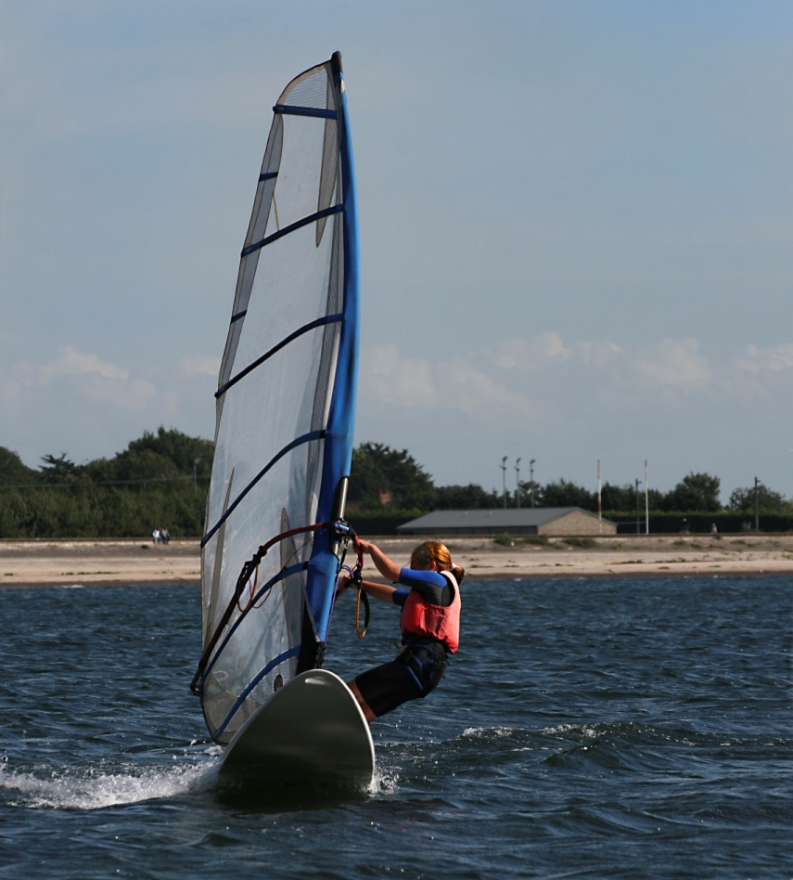
Windsurfing combines surfing and sailing, and is one of the fastest-growing water sports. Expert windsurfers (aka “boardheads”) seek out the challenges and freestyling opportunities that big waves provide, but beginners should windsurf on water with little to no waves. Windsurfing instructors usually begin the instructional process on land to guide students through a startup sequence. The essence of windsurfing is to balance oneself on the sailboard while holding the sail and cruising with the wind; learning how to turn is an advanced skill that takes some windsurfers years to master. Keeping in mind that people learn at different paces, with a good instructor, beginners are often able to learn how to windsurf in a single lesson. Windsurfing is not recommended for Girl Scout Daisies and Brownies.
Caution: Girls are not allowed to do aerial tricks on sailboards.
Know where to windsurf. Ocean, lakes, or even a large pond—in short, bodies of water that have enough wind to hoist the sail. Popular American windsurfing destinations include the Great Lakes and the east and west coasts of the United States. Connect with your Girl Scout council for site suggestions. Also, the International Sailing Federation provides information about windsurfing classes at sailing.org.
Include girls with disabilities. Communicate with girls with disabilities and/or their caregivers to assess any needs and accommodations. Learn more about the resources and information that the National Center on Accessibility and the National Center of Physical Activities and Disabilities provide to people with disabilities.
Basic Windsurfing Gear
- One-piece bathing suit (less cumbersome in the waves than a two-piece)
- Closed-toe hiking/sport sandals with heel strap, water socks or shoes
- Waterproof sunscreen (SPF of at least 15)
- Goggles or glasses guards for girls who require prescriptive eyewear (available at sporting-goods stores)
- Beach towel
- Dry clothing and sunglasses to wear after windsurfing
Specialized Windsurfing Gear
- Participants wear a U.S. Coast Guard–approved life jacket (Type III recommended) that fits according to weight and height specifications. Inspect life jackets to ensure that they are in good condition and contain no tears. Read about Coast Guard life jackets here.
- Wetsuit for warmth and skin protection, especially when water temperature is below 70 degrees Fahrenheit
- At least one graspable and throwable personal flotation device (Type IV buoyant cushion or ring buoy or equivalent) is immediately available for each group on the water
- Sailboards
Prepare for Windsurfing
- Communicate with council and parents. Inform your Girl Scout council and girls’ parents/guardians about the activity, including details about safety precautions and any appropriate clothing or supplies that may be necessary. Follow council procedures for activity approval, certificates of insurance, and council guidelines about girls’ general health examinations. Make arrangements in advance for all transportation and confirm plans before departure.
- Girls plan the activity. Keeping their grade-level abilities in mind, encourage girls to take proactive leadership roles in organizing details of the activity.
- Arrange for transportation and adult supervision. The recommended adult-to-girl ratios are two non-related adults (at least one of whom is female) to every:
- 16 Girl Scout Juniors
- 20 Girl Scout Cadettes
- 24 Girl Scout Seniors
- 24 Girl Scout Ambassadors
Plus one adult to each additional:
- 8 Girl Scout Juniors
- 10 Girl Scout Cadettes
- 12 Girl Scout Seniors
- 12 Girl Scout Ambassadors
- Verify instructor knowledge and experience. Ensure that teacher holds a Windsurfing Instructor Certification from U.S. Sailing Association, or has equivalent certification or documented experience according to your council’s guidelines, as outlined in Volunteer Essentials; the instructor-to-girl ratio is one to four.
- Ensure participants are able to swim. Participants’ swimming abilities are classified and clearly identified (for instance, with colored headbands to signify beginners, advanced swimmers, etc.) at council-approved sites, or participants provide proof of swimming-test certification. In the absence of swimming-test certification, a swim test is conducted on the day of the activity. Consult with your Girl Scout council for additional guidance.
- Compile key contacts. Give an itinerary to a contact person at home; call the contact person upon departure and return. Create a list of girls’ parents/guardian contact information, telephone numbers for emergency services and police, and council contacts—keep on hand or post in an easily accessible location.
- Size up sailboards. Communicate girls’ ages, heights, and weights with windsurfing instructors to ensure the appropriate size equipment is available. Request that sails be the appropriate size (according to weight, height, and ability level) for windsurfers; the larger the sail, the more powerful the sailing capacity. Sailboard decks should be textured (not smooth) to provide traction.
- Select a safe location with a soft, sandy, or muddy bottom. Choose a location that does not have a sharp-edged or rocky bottom, which can be dangerous and cut feet and limbs. The launching area should be easily accessible and clear of overhead power lines.
- Safeguard valuables. Don’t leave personal belongings and valuables unattended in a public place. If working with a windsurfing school or camp, call to inquire about the organization’s storage amenities.
- Prepare for emergencies. If a lifeguard is not on duty, an adult with rescue and resuscitation experience and/or certification is present; at least one adult present has small craft safety certification or equivalent experience. (Both of these qualifications can be held by one person.) Ensure the presence of a waterproof first-aid kit and a first-aider with a current certificate in First Aid, including Adult and Child CPR or CPR/AED, and is prepared to handle cases of near-drowning, immersion hypothermia, and sunburn. If any part of the activity is located 60 minutes or more from Emergency Medical Services response time, ensure the presence of a first-aider (level 2) with Wilderness and Remote First Aid. See Volunteer Essentials for information about first-aid standards and training.
On the Day of Windsurfing
- Get a weather and wind report. Never windsurf on a stormy or extremely windy day. On the day of the windsurf trip or lesson, visit weather.com to determine if weather conditions are appropriate. Windsurfing should be taught in a light breeze (in general, winds should be between 1 to 6 knots, or 1 to 7 miles per hour). Do not windsurf in offshore winds because windsurfers will drift away, making it nearly impossible to steer back to shore; the wind direction should be onshore or sideshore. If weather conditions prevent the windsurfing trip, be prepared with a backup plan or alternative activity.
- Use the buddy system. Divide girls into teams of two. Each person is responsible for staying with her buddy at all times, warning her buddy of danger, giving her buddy immediate assistance if safe to do so, and seeking help when the situation warrants it. If someone in the group is injured, one person cares for the patient while two others seek help.
- Be prepared in the event of a storm with lightning. Exit water immediately, and take shelter away from tall objects (including trees, buildings, and electrical poles). Find the lowest point in an open flat area. Squat low to the ground on the balls of the feet, and place hands on knees with head between them.
Windsurfing Links
- International Sailing Federation: www.sailing.org
- U.S. Sailing Windsurfing Course, how-to information, and safety tips: www.windsurfing.sailingcourse.com/safety.htm
- U.S. Windsurfing Association: www.uswindsurfing.org
- U.S. Windsurfing directory of windsurfing schools: www.uswindsurfing.org/shop_main.php
Windsurfing Know-How for Girls
- Stay with the board. If remaining in the water while taking a break from windsurfing, stay near the board. Lifeguards become concerned if they see a windsurf board “missing” a windsurfer.
- Troubleshoot exhaustion. In the case of fatigue while in the water (and in light winds), raise the sail down over the back of the board, position leg on top of the sail to prevent it from falling off the board, and paddle (or walk, if water is shallow enough) back to shore. U.S. Sailing provides instructions.
- A heads-up on head protection. In the instance of losing balance on the board, before falling into the water, push the sail away from your body, so that the sail doesn’t strike your head. If unable to push the sail away from the body, make a fist and use your arm as a shield to protect your head.
Windsurfing Jargon
- Centerboard: A retractable device on entry-level sailboards that, when down, keeps the board steady and from going sideways to aid with balancing and sailing upwind
- Jibe: To change direction so that the sail is flown on the opposite side by turning away from the wind
- Mast: The straight pole that holds the sail up from the deck of a sailboard (the height of which can be tuned for different body weights)
- Skeg (aka fin): The small plastic or wood appendage attached to the underside rear of the sailboard that keeps it going straight
- Starboard: The right-hand side of the sailboard

