
White-Water Rafting: Safety Activity Checkpoints
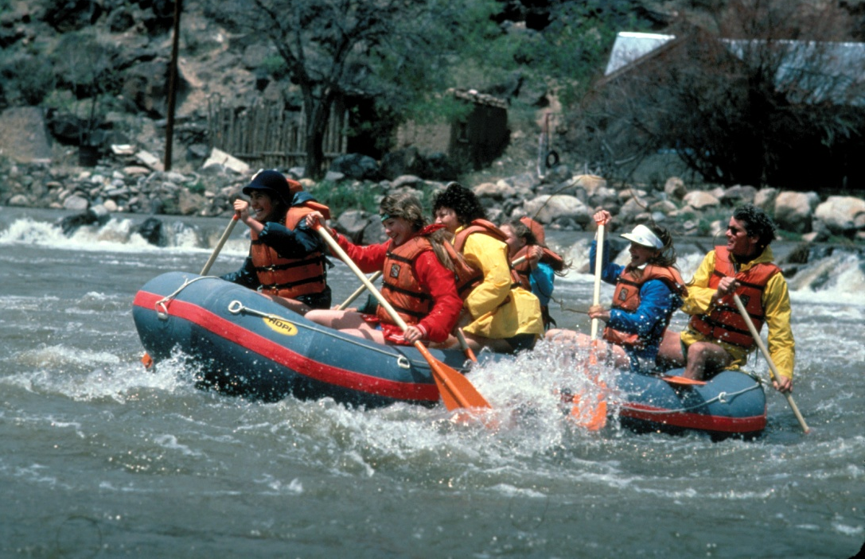
White-water rafting is especially popular among adventure seekers, but is enjoyable for general outdoor lovers as well. The level of rafting difficulty is measured by white-water classification, which ranges from classes I to VI—Class I represents water with very few rough areas that are suitable for beginners; Class VI rapids are considered to be extremely dangerous and generally impassable. Rafts come in a variety of styles and lengths, the most common of which are between 11 and 20 feet in length and typically seat four to twelve rafters. It’s nearly impossible to stay dry while white-water rafting, so it’s important to dress for the water temperature, rather than the air temperature. If the water is cold, wear a wetsuit; on cool days with cool water, wear a wetsuit and a paddle jacket. Avoid wearing cotton because it makes the wearer cold when the clothes get wet. White-water rafting is not recommended for Girl Scout Daisies; Class III and Class IV whitewater is not recommended for Brownies; Class IV whitewater is not recommended for Juniors.
Caution: You must seek council permission for activities with uncontrollable and highly changeable environment conditions, such as unclassified rivers and some watercraft trips; girls are never allowed on Class V and above whitewater.
Know where to raft. Rafters may take advantage of scores of American and international rivers suitable for white-water rafting, so long as the proper equipment, instructions, and safety precautions are used. Rafting is done only on water that has been approved by your Girl Scout council or that has been run and rated, and on whitewater only up to Class IV difficulty, as defined by the American Version of the International Scale of River Difficulty. The American Whitewater Association provides information about American and some international river locations, classes, and levels. Also, Rafting America offers suggestions for global rafting locations. Connect with your Girl Scout council for site suggestions.
Include girls with disabilities. Communicate with girls with disabilities and/or their caregivers to assess any needs and accommodations. Learn more about the resources and information that Wilderness Inquiry and Splore provide to people with disabilities.
White-Water Rafting Gear
Basic Gear
- Layered clothing that’s easily changeable depending on temperatures (wool, nylon, or polypropylene under a jacket and pants made of coated materials to repel water); also take a change of dry clothing (store in waterproof bag)
- Closed-toe hiking/sport sandals with heel strap, water socks or shoes, or other nonslip footwear (no flip-flops)
- Waterproof sunscreen (SPF of at least 15)
- Sunglasses
- Flashlight (and extra batteries)
- Whistle
- Emergency repair kit: duct tape or electrical tape, screwdriver, pliers
- Emergency survival packet: waterproof matches, emergency food supplies, lightweight blanket
- Throw bag, throw line
- Compass
- Knife
- Dry (waterproof) bag (to keep personal belongings dry)
Specialized Gear
- Participants wear a U.S. Coast Guard–approved life jacket (Types III and V) that fits according to weight and height specifications. Inspect life jackets to ensure that they are in good condition and contain no tears. Read about Coast Guard life jackets here.
- Safety helmet (with flexible, plastic shell, chin strap, and openings for drainage) when white-water rafting in Class II waters or higher
- Wetsuit when water is colder than 70 degrees Fahrenheit
- Paddles (Select the appropriate size and style for the activity)
- Bailer (a bucket used to remove water from a boat)
- Foot pump
- Emergency sound device, such as a fog horn or sounding flares
- At least one graspable and throwable personal flotation device (Type IV buoyant cushion or ring buoy or equivalent) is immediately available for each group on the water
Prepare for White-Water Rafting
- Communicate with council and parents. Inform your Girl Scout council and girls’ parents/guardians about the activity, including details about safety precautions and any appropriate clothing or supplies that may be necessary. Follow council procedures for activity approval, certificates of insurance, and council guidelines about girls’ general health examinations. Make arrangements in advance for all transportation and confirm plans before departure.
- Girls plan the activity. Keeping their grade-level abilities in mind, encourage girls to take proactive leadership roles in organizing details of the activity.
- Ensure participants are able to swim. Participants’ swimming abilities are classified and clearly identified (for instance, with colored headbands to signify beginners, advanced swimmers, etc.) at council-approved sites, or participants provide proof of swimming-test certification. In the absence of swimming-test certification, a swim test is conducted on the day of the activity. Consult with your Girl Scout council for additional guidance.
- Arrange for transportation and adult supervision. Ensure that at least two adults are in each raft. The recommended adult-to-girl ratios are two non-related adults (at least one of whom is female) to every:
- 12 Girl Scout Brownies
- 16 Girl Scout Juniors
- 20 Girl Scout Cadettes
- 24 Girl Scout Seniors
- 24 Girl Scout Ambassadors
Plus one adult to each additional:
- 6 Girl Scout Brownies
- 8 Girl Scout Juniors
- 10 Girl Scout Cadettes
- 12 Girl Scout Seniors
- 12 Girl Scout Ambassadors
- Verify instructor knowledge and experience. At least one guide with documented experience according to your council’s guidelines, as outlined in Volunteer Essentials. Ensure that the guide knows the American Whitewater International Scale of River Difficulty, Universal River Signals, and Safety Code. All rafters are instructed in how to float through rapids, breathe while swimming in rapids, and swim to shore.
- Compile key contacts. Give an itinerary to a contact person at home; call the contact person upon departure and return. Create a list of girls’ parents/guardian contact information, telephone numbers for emergency services and police, and council contacts—keep on hand or post in an easily accessible location.
- Select durable rafts that are appropriate size for rafting group. Make sure each raft is of heavy-duty construction and has at least four air compartments, an adequate number of large D-rings securely attached to the sides, and snug hand lines along the sides. Ensure that weight and capacity are not exceeded.
- Research water conditions. Consider weather and water conditions, weight of passengers, and equipment. Also make sure of the following:
- Craft weight and capacity are not exceeded (some crafts clearly display maximum capacity).
- You are knowledgeable of the difficulty of the water run and the International Scale of River Difficulty.
- You are aware of possible changes in river level and weather and their effects on the run’s level of difficulty.
- Respect the environment. Make sure rafting on white-water or semiprotected waters meets the Safety Code of American Whitewater.
- File a float plan. If participating in an extensive rafting trip, file a float plan with local authorities that includes names of people on board, destination, raft description, times of departure and return, and additional details about routes and marine communications. The Coast Guard provides an electronic, printable form.
- Prepare for emergencies. If a lifeguard is not on duty, an adult with rescue and resuscitation experience and/or certification is present; at least one adult has small-craft safety certification or equivalent experience. (Both of these qualifications can be held by one person.) Ensure the presence of a waterproof first-aid kit and a first-aider with a current certificate in First Aid, including Adult and Child CPR or CPR/AED, who is prepared to handle cases of near-drowning, immersion hypothermia, and sunburn. If any part of the activity is located 60 minutes or more from Emergency Medical Services response time, ensure the presence of a first-aider (level 2) with Wilderness and Remote First Aid. See Volunteer Essentials for information about first-aid standards and training.
On the Day of White-Water Rafting
- Get a weather report. Never go white-water rafting on a stormy day. On the day of the activity, consult weather.com or other reliable sources of weather reporting to determine if outdoor conditions, water temperature, and river conditions are appropriate. If weather conditions prevent the trip, be prepared with a backup plan or alternate activity.
- Use the buddy system. Girls are divided into teams of two. Each girl chooses a buddy and is responsible for staying with her buddy at all times, warning her buddy of danger, giving her buddy immediate assistance if safe to do so, and seeking help when the situation warrants it. If someone in the group is injured, one person cares for the patient while two others seek help.
- Be prepared in the event of a storm with lightning. Exit water immediately and take shelter away from tall objects (including trees, buildings, and electrical poles). Find the lowest point in an open flat area. Squat low to the ground on the balls of the feet, and place hands on knees with head between them. During storms, if shore cannot be reached, secure all loose gear, keep a sharp lookout for other rafts and obstructions, and stay low.
White-Water Rafting Links
- American Canoe Association: www.americancanoe.org
- American Whitewater: www.americanwhitewater.org
- International Rafting Federation: www.intraftfed.com
- Rafting America: www.raftingamerica.com
- Whitewater Rescue Institute: www.whitewaterrescue.com
White-Water Rafting Know-How for Girls
- Build arm strength and stamina. White-water rafting can be a tiring sport, especially if participants are doing the bulk of the paddling. Before going rafting, make sure that your body (especially your arms) is in good physical condition. To build stamina, do push-ups and briskly walk or run.
- Learn paddling techniques. Before a rafting activity, learn about various paddling maneuvers, such as punching and high siding. Watch an ehow video to see how they’re done.
White-Water Rafting Jargon
- Eddie: Water flowing upstream behind a rock or other obstacle; eddies often provide a safe place to get out of a current
Strainer: An opening where water is able to flow through, but a solid object such as a raft cannot; a strainer is considered highly dangerous and is usually formed by rocks piled atop each other, or trees on banks, with water flowing through them

