
Waterskiing and Wakeboarding:
Safety Activity Checkpoints
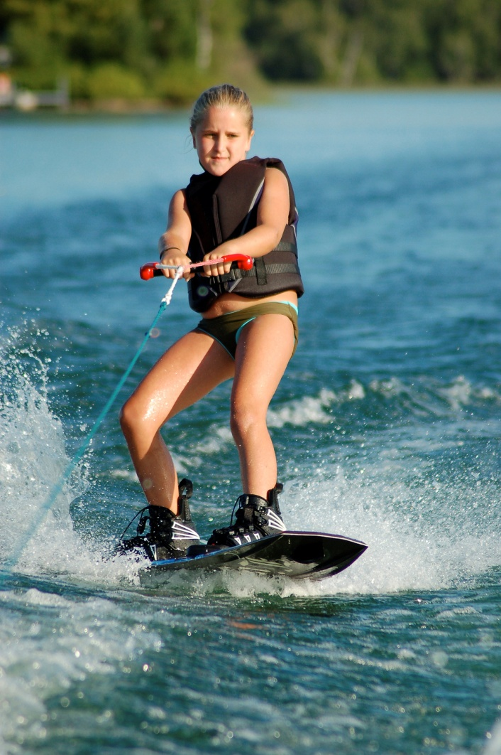
Similar to surfing, learning to stand up on waterskis or a wakeboard (a single board resembling a snowboard) is one of the sport’s primary challenges, especially for beginners. Waterskiing requires thorough instruction and practice; key elements of successful waterskiing include balance, a strong grip, and proper-fitting skis/board and bindings. Beginners must learn the waterski position: knees bent and together, leaning back with weight on the balls of the feet, head up, arms straight, and skis pointing forward. To prevent injuries, waterskiers must learn (contrary to instinct) to release the towline as soon as they begin to lose their balance. Skiers either wear one board (called slalom) or two skis (called combo); barefoot waterskiing is an advanced skill. Wakeboarding is not recommended for Girl Scout Daisies and Brownies.
Caution: Girls are not allowed to operate motorized boats without council permission; girls are not allowed to do aerial tricks on waterskis or wakeboards.
Know where to waterski and wakeboard. Wide-open bodies of water such as a lake are ideal. Connect with your Girl Scout council for site suggestions.
Include girls with disabilities. Communicate with girls with disabilities and/or their caregivers to assess any needs and accommodations. Visit USA Water Ski for information about amenities for waterskiers with disabilities.
Waterskiing and Wakeboarding Gear
Basic Gear
- One-piece bathing suit (less cumbersome than a two-piece)
- Waterproof sunscreen (SPF of at least 15)
- Goggles for girls who require glasses or contact lenses (available at sporting-goods stores; if prescription goggles are too expensive for girls to purchase, make sure girls test non-prescription goggles to assure proper fit over prescriptive eyewear)
- Beach towel
- Dry clothing and sunglasses to wear after surfing
Specialized Gear
- Participants wear a U.S. Coast Guard–approved life jacket (Type III recommended) that fits according to weight and height specifications. Inspect life jackets to ensure that they are in good condition and contain no tears. Read about Coast Guard life jackets here.
- Wetsuit is recommended for warmth and skin protection, especially when water temperature is below 70 degrees Fahrenheit
- Ski lines (tow lines) are at least 75 feet long; a single handle is used on the ski line
- Wakeboard or rounded (not pointed) skis that are appropriate to the skill and size of the skier
- Foot bindings appropriate for skier’s weight and skiing speed
- At least one graspable and throwable personal flotation device (Type IV buoyant cushion or ring buoy or equivalent) is immediately available for each group on the water
- Lifeboat
Prepare for Waterskiing or Wakeboarding
- Communicate with council and parents. Inform your Girl Scout council and girls’ parents/guardians about the activity, including details about safety precautions and any appropriate clothing or supplies that may be necessary. Follow council procedures for activity approval, certificates of insurance, and council guidelines about girls’ general health examinations. Make arrangements in advance for all transportation and confirm plans before departure.
- Girls plan the activity. Keeping their grade-level abilities in mind, encourage girls to take proactive leadership roles in organizing details of the activity.
- Arrange for transportation and adult supervision. In addition to the boat driver, ensure that a boat has at least one more adult observing the skier(s), and that another adult is on shore to help supervise girls waiting to ski. The recommended adult-to-girl ratios are two non-related adults (at least one of whom is female) to every:
- 16 Girl Scout Juniors
- 20 Girl Scout Cadettes
- 24 Girl Scout Seniors
- 24 Girl Scout Ambassadors
Plus one adult to each additional:
- 8 Girl Scout Juniors
- 10 Girl Scout Cadettes
- 12 Girl Scout Seniors
- 12 Girl Scout Ambassadors
- Verify instructor and boat-driver knowledge and experience. Ensure that the adult or instructor is certified by USA Water Ski, or possesses equivalent certification or documented experience according to your council’s guidelines, as outlined in Volunteer Essentials. Confirm that the boat driver has an appropriate license, and is skilled in operating the craft; USA Water Ski offers a Trained Boat Driver course.
- Ensure participants are able to swim. Participants’ swimming abilities are classified and clearly identified (for instance, with colored headbands to signify beginners, advanced swimmers, etc.) at council-approved sites, or participants provide proof of swimming-test certification. In the absence of swimming-test certification, a swim test is conducted on the day of the activity. Consult with your Girl Scout council for additional guidance.
- Check the boat safety features. Make sure the boat has sufficient power to tow the skier(s), and is equipped with a side-angle rearview mirror, fire extinguisher, paddle, horn, bailing device, two gas tanks (for outboard motors), mooring ropes (extra line), boarding ladder, and throw bag.
- Prepare for emergencies. If a lifeguard is not on duty, an adult with rescue and resuscitation experience and/or certification is present. Ensure the presence of a waterproof first-aid kit and a first-aider with a current certificate in First Aid, including Adult and Child CPR or CPR/AED, and is prepared to handle cases of near-drowning, immersion hypothermia, and sunburn. If any part of the activity is located 60 minutes or more from emergency medical services, ensure the presence of a first-aider (level 2) with Wilderness and Remote First Aid. See Volunteer Essentials for information about first-aid standards and training.
- Compile key contacts. Give an itinerary to a contact person at home; call the contact person upon departure and return. Create a list of girls’ parents/guardian contact information, telephone numbers for emergency services and police, and council contacts—keep on hand or post in an easily accessible location.
On the Day of Waterskiing or Wakeboarding
- Get weather and wind report. Never waterski on a stormy, foggy, or excessively windy day. On the day of the waterskiing trip or lesson, visit weather.com to determine if weather conditions are appropriate. If weather conditions prevent the waterskiing activity, be prepared with a backup plan or alternative activity.
- Review rescue tips. U.S. Sailing provides instructions on small-boat capsize recovery.
- Keep track of waterskiers. Use a list or checkboard system to stay aware of waterskiers’ whereabouts.
- Use the buddy system. Girls are divided into teams of two. Each person chooses a buddy and is responsible for staying with her buddy at all times, warning her buddy of danger, giving her buddy immediate assistance if safe to do so, and seeking help when the situation warrants it.
- Be prepared in the event of a storm with lightning. Exit water immediately, and take shelter away from tall objects (including trees, buildings, and electrical poles). Find the lowest point in an open flat area. Squat low to the ground on the balls of the feet, and place hands on knees with heads between them. During storms, if shore cannot be reached, keep a sharp lookout for other boats and obstructions.
Waterskiing and Wakeboarding Links
- USA Water Ski: www.usawaterski.org
- U.S. Coast Guard’s Boating Safety Division: www.uscgboating.org
Waterskiing and Wakeboarding Know-How for Girls
- Start the learning process on land. Before entering the water, simulate the waterskiing process on a sandy beach. Wearing the skis and holding onto a water-ski handle, ask a partner to pull you around.
- Stay behind the boat. It’s dangerous to curve around to the side of the boat. Also, skiing outside the wake is an advanced technique.
- Communicate with hand signals. Learn how to communicate while waterskiing on adventure.howstuffworks.com.
- Learn by watching. Videotape other Girl Scouts who are learning how to waterski, and watch the footage to learn how to improve performance.
- Prevent hand blisters. Some waterskiers get blisters from the pressure of holding onto the rope handle; wearing gloves or taping hands can help. Learn how on waterskimag.com.
Waterskiing and Wakeboarding Jargon
- Boom: A pole, used as a training device for beginners, that extends horizontally from the center of the boat to out and over the side of the boat
- Cannonball: The starting waterski position—in the water, tuck up as small as possible, with hands and towline handle around legs (bend knees and shift weight to the back of skis, so the front tips of the skis poke out of the water)

