
Tubing: Safety Activity Checkpoints
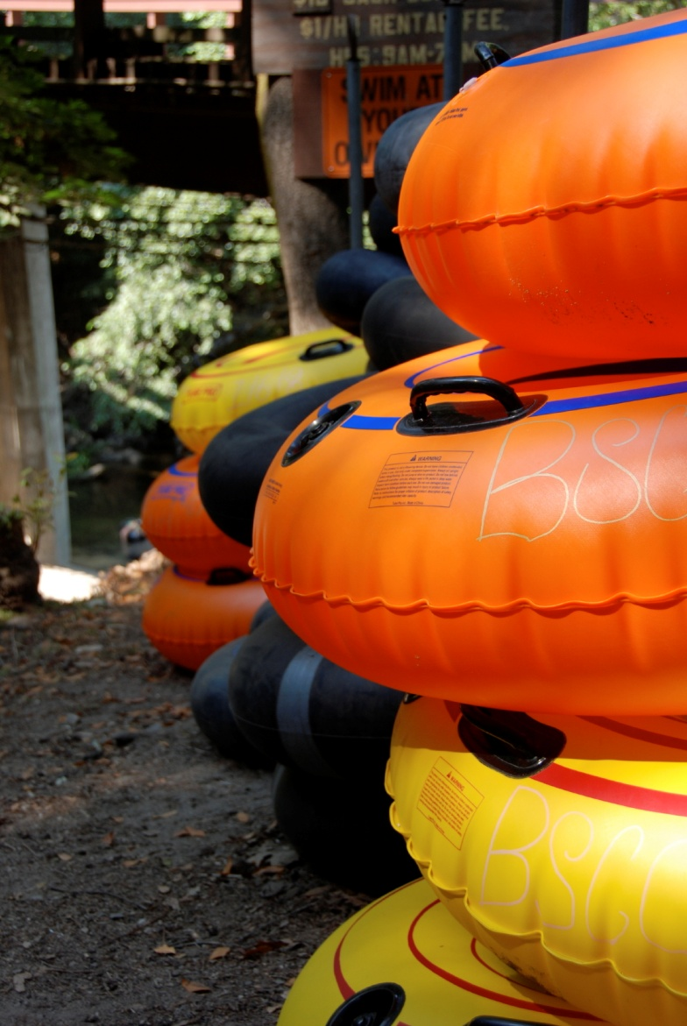
Tubing involves floating down a river or other body of water in a doughnut-shaped inner tube. Tubing is popular both as a relaxing leisurely activity (in slow-moving waters) and as an adventurous recreational activity in faster-paced rivers. As a safety precaution, keep in mind that tubes occasionally flip, causing tubers to sometimes fall out of their tubes as they travel over rapids and through rough patches of water. As river tubing is often a one-way trip, ensure to arrange transportation from the tubing final destination. If participating in speed-boat tubing, be sure to take safety precautions that comply with small-craft safety guidelines.
Caution: Girls are not allowed to operate motorized boats without council permission.
Know where to go tubing. Lakes or rivers. Connect with your Girl Scout council for site suggestions. Also, River Tubing USA provides a list of Tubing Outfitters in the United States and Canada.
Include girls with disabilities. Communicate with girls with disabilities and/or their caregivers to assess any needs and accommodations. Learn more about the resources and information that the National Center on Accessibility and the National Center of Physical Activities and Disabilities provide to people with disabilities.
Tubing Gear
Basic Gear
- One-piece bathing suit (less cumbersome than a two-piece)
- Closed-toe sport sandals with heel strap, water socks or shoes (no flip-flops)
- Waterproof sunscreen (SPF of at least 15)
- Beach towel
- Dry clothing and sunglasses to wear after tubing
Specialized Gear
- Participants wear a U.S. Coast Guard–approved life jacket (Type III recommended) that fits according to weight and height specifications. Inspect life jackets to ensure that they are in good condition and contain no tears. Read about Coast Guard life jackets here.
- Wetsuit (recommended when water is colder than 70 degrees Fahrenheit)
- Tube
- Tube cover or skin (optional)
- At least one graspable and throwable personal flotation device (Type IV buoyant cushion or ring buoy or equivalent) is immediately available for each group on the water.
Prepare for Tubing
- Communicate with council and parents. Inform your Girl Scout council and girls’ parents/guardians about the activity, including details about safety precautions and any appropriate clothing or supplies that may be necessary. Follow council procedures for activity approval, certificates of insurance, and council guidelines about girls’ general health examinations. Make arrangements in advance for all transportation and confirm plans before departure.
- Girls plan the activity. Keeping their grade-level abilities in mind, encourage girls to take proactive leadership roles in organizing details of the activity.
- Arrange for transportation and adult supervision. One adult will be the lead tuber; another adult will be the sweep tuber. The lead adult knows firsthand the hazards and rapids on any river to be tubed. The recommended adult-to-girl ratios are two non-related adults (at least one of whom is female) to every:
- 6 Girl Scout Daisies
- 12 Girl Scout Brownies
- 16 Girl Scout Juniors
- 20 Girl Scout Cadettes
- 24 Girl Scout Seniors
- 24 Girl Scout Ambassadors
Plus one adult to each additional:
- 4 Girl Scout Daisies
- 6 Girl Scout Brownies
- 8 Girl Scout Juniors
- 10 Girl Scout Cadettes
- 12 Girl Scout Seniors
- 12 Girl Scout Ambassadors
- Verify instructor knowledge and experience. One adult must be certified in American Red Cross Small Craft Safety, Moving Water module from the American Red Cross, have experience in teaching and/or supervising tubing activities, or have documented experience according to your council’s guidelines, as outlined in Volunteer Essentials.
- Ensure participants are able to swim. Participants’ swimming abilities are classified and clearly identified (for instance, with colored headbands to signify beginners, advanced swimmers, etc.) at council-approved sites, or participants provide proof of swimming-test certification. In the absence of swimming-test certification, a swim test is conducted on the day of the activity. Consult with your Girl Scout council for additional guidance.
- All participants are instructed before beginning to tube. Girls receive instruction on how to float through rapids, how to breathe while swimming in rapids, and how to swim to shore. There is only one person to a tube, and tubes that are tied together are secured very snugly, with no slack between the tubes. Avoid long, dangling ropes that can get snagged on various obstructions.
- Research river condition. Never go whitewater tubing on water that has not been run and rated. No tubing is taken on whitewater more difficult than Class II, as defined by the American Version of the International Scale of River Difficulty. Be aware of possible changes in river level and its effects on the run’s level of difficulty; American Whitewater provides a National Whitewater Inventory.
- Respect the environment. Make sure tubing on whitewater or semi-protected waters meets the Safety Code of American Whitewater.
- Prepare for emergencies. If a lifeguard is not on duty, an adult with rescue and resuscitation experience and/or certification is present. Ensure the presence of a waterproof first-aid kit and a first-aider, who is prepared to handle cases of near-drowning and immersion hypothermia. See Volunteer Essentials for information about first-aid standards and training.
- Compile key contacts. Give an itinerary to a contact person at home; call the contact person upon departure and return. Create a list of girls’ parents/guardian contact information, telephone numbers for emergency services and police, and council contacts—keep on hand or post in an easily accessible location.
On the Day of Tubing
- Get a weather report. Never go tubing on a stormy day. On the day of the activity, consult weather.com or other reliable sources to assess weather and river conditions and water and air temperature. If weather conditions prevent the trip, be prepared with a backup plan or alternative activity.
- Safeguard valuables. Don’t leave personal belongings and valuables unattended in a public place.
- Use the buddy system. Girls are divided into teams of two. Each person chooses a buddy and is responsible for staying with her buddy at all times, warning her buddy of danger, giving her buddy immediate assistance if safe to do so, and seeking help when the situation warrants it.
- Be prepared in the event of a storm with lightning. Exit water immediately, and take shelter away from tall objects (including trees, buildings, and electrical poles). Find the lowest point in an open flat area. Squat low to the ground on the balls of the feet, and place hands on knees with heads between them. During storms, if shore cannot be reached, keep a sharp lookout for boats and other obstructions.
Tubing Links
- American Whitewater: www.americanwhitewater.org
- River Tubing USA: www.rivertubing.info
- Whitewater Rescue Institute: www.whitewaterrescue.com
Tubing Know-How for Girls
- Know the river flow. Be careful about where you roll out of a tube. If tubing in fast-moving water, the under-surface current may catch you off guard. Do not get out of a tube where the flow of water is fastest—just above the riverbed, where there is little resistance to flow.
- Put on your “explorers’ cap.” Create exploration games to see who can locate the most interesting nature gems, such as caves and peculiar plants.
Tubing Jargon
- Aquifer: A layer of underground rock or sand that stores and transports water
- Swallet hole: A hole in land through which a stream delivers surface water to aquifer (considered the opposite of a spring)

