
Trip/Travel Camping: Safety Activity Checkpoints
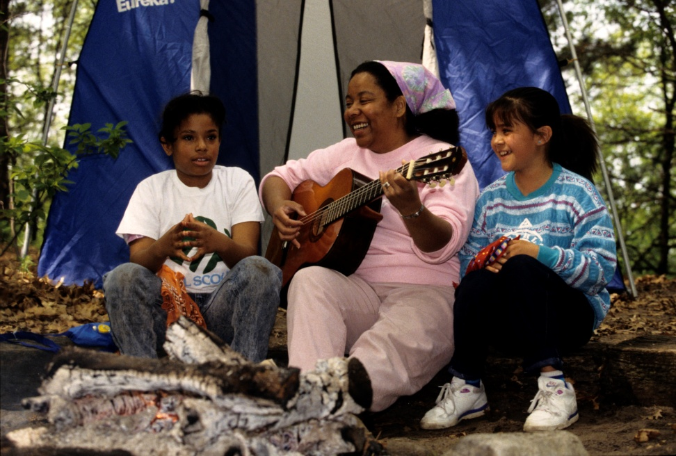
Travel camping (using campsites as a means of accommodations) is planned and carried out by a group of girls and adults who are experienced campers. The group travels by foot or human power and uses motorized or non-motorized transportation to move from one site to another over a period of three or more nights. Motorized transportation is usually a bus, van, or automobile but may also be an airplane, boat, bicycle, or train, or a combination of vehicles. When preparing for and conducting the trip, use other Safety Activity Checkpoints (such as “Canoeing,” “Backpacking,” and “Outdoor Cooking”) to aid trip-planning. Trip/travel camping is not recommended for Daisy Girl Scouts and Brownies.
Caution: Girls are not allowed to use firearms unless 12 years and older and with council permission; girls are never allowed to hunt or go on high-altitude climbs. Girls are also never allowed to ride all-terrain vehicles or motor bikes.
Know where to trip/travel camp. Girl Scout camps, state and national forests and parks, public and private campingfacilities, and/or by canoeing down a scenic river, riding horseback, backpacking into backcountry, and so on. Connect with your Girl Scout council for site suggestions and for non-council locations.
Include girls with disabilities. Communicate with girls with disabilities and/or their caregivers to assess any needs and accommodations. Learn more about the resources and information that Global Explorers and Wilderness Inquiries provide to people with disabilities.
Trip/Travel Camping Gear
Basic Gear
- Clothing that can be layered depending on the temperature, and waterproof jacket or poncho
- Hat, gloves, and thermal underwear for cool temperatures
- Socks with sturdy shoes, hiking boots, or sneakers (no sandals, flip-flops, or bare feet)
- Waterproof sunscreen (SPF of at least 15)
- Sunglasses
- Towels and basic personal hygiene supplies (shampoo, soap, comb, and so on)
- Backpack
- Insect repellent
Specialized Gear
- Flame-resistant tent (no plastic tents)
- Compass
- Sleeping bag (stuffed with filler appropriate for the anticipated temperature)
- Mosquito netting where necessary
- Cooking supplies (pots, pans, utensils)
- Cooler for food storage
- Portable cook stoves whenever possible (to reduce the use of firewood)
- Flashlight and other battery-powered lights (no candles, kerosene lamps, portable cook stoves, heaters, or other open-flame devices are used inside tents)
- Lantern fueled by propane, butane, kerosene, or gas (for outdoor use)
- Water purifier
Prepare for Trip/Travel Camping
- Communicate with council and parents. Inform Girl Scout council and parents/guardians about the activity, including details about safety precautions and any appropriate clothing or supplies that may be necessary. Follow council procedures for activity approval, certificates of insurance, and council guidelines about girls’ general health examinations. Make arrangements in advance for all transportation and confirm plans before departure.
- Girls plan the activity. Keeping their grade-level abilities in mind, encourage girls to take proactive leadership roles in organizing details of the activity. Encourage girls to plan routes, activities, and rules for group living.
- Arrange for transportation and adult supervision. The recommended adult-to-girl ratios are a minimum of two non-related adults (at least one of whom is female) to every:
- 16 Girl Scout Juniors
- 20 Girl Scout Cadettes
- 24 Girl Scout Seniors
- 24 Girl Scout Ambassadors
Plus one adult to each additional:
- 8 Girl Scout Juniors
- 10 Girl Scout Cadettes
- 12 Girl Scout Seniors
- 12 Girl Scout Ambassadors
- Verify instructor knowledge and experience. The lead trip/travel adult or instructor possesses knowledge, skills, and experience in the following areas:
- Outdoor leadership
- Progression and readiness
- Trip planning in a girl-led environment
- Safety management
- First aid, CPR, safety, handling emergency situations
- Judgment and maturity
- Program activities specific to the trip
- Group dynamics and management
- Supervision of girls and adults
- Participation in similar trips
- Familiarity with the area in which the trip is conducted
- Physical fitness and skills necessary to lead the group
Adults selected as chaperones for the trip are trained or have documented experience according to your council’s guidelines, as outlined in Volunteer Essentials, in the following areas:
- Travel or trip camping skills
- Group management and group dynamics
- Mode of transportation
- Site orientation
- First aid and CPR
- Emergency procedures
- Minor maintenance for equipment and vehicles, as appropriate
- Compile key contacts. Give an itinerary to a contact person at home; call the contact person upon departure and return. Create a list of girls’ parents/guardian contact information, telephone numbers for emergency services and police, and council contacts—keep on hand or post in an easily accessible location. Also know the location of the nearest landline telephone in case cellular phones do not receive reception. In addition, girls and adult participants carry a card and wear an identifying bracelet or similar device that contains name, council name, and emergency-contact phone number.
- Ensure the safety of sleeping areas. Separate sleeping and bathroom facilities are provided for adult males; many councils make exceptions for girls’ fathers. Ensure the following:
- Each participant has her own bed. Parent/guardian permission must be obtained if girls are to share a bed.
- Adults and girls never share a bed.
- It is not mandatory that an adult sleep in the sleeping area (tent, cabin, or designated area) with the girls. If an adult female does share the sleeping area, there should always be two unrelated adult females present.
- Verify adults’ transportation credentials. Verify the following adult certifications and standards:
- For trips by small craft, the lead adult is currently certified as an instructor as specified in the Safety Activity Checkpoints for the particular mode of transportation, is certified in Small Craft Safety from the American Red Cross, or has equivalent certification or documented experience and skill in the supervision of similar trips.
- For trips that involve swimming, an adult currently certified in basic lifeguarding or the equivalent is present.
- Each driver of motorized transportation is at least 21 years old and holds a valid operator’s license appropriate to the vehicle. The Girl Scout council checks the operator’s driving record.
- Any adult drives no more than six hours in one day, with rest breaks every two hours. There is a relief driver for trips of more than six hours. The relief driver holds a valid operator’s license for the vehicle operated, and her or his driving record is checked. Plan to drive only in daylight hours.
- If a trailer is used, it is in compliance with all state, local, and federal regulations for the areas of travel. The assigned driver is experienced in pulling a trailer. No girls or adult leaders ride in the trailer.
- No caravanning is allowed. Each driver must have information about route and destination in addition to cell-phone numbers of other drivers.
- Arrange a pre-trip orientation. Ensure that girl and adult participants receive information about first-aid procedures, emergency and rescue procedures, environmental awareness, program plans for mode of travel and geographic area, and operational procedures (water purification, food preparation, camping equipment, sanitation, and food-storage procedures).
- Girls share resources. Encourage girls to make a list of the gear and supplies, and then determine which can be shared. Support girls in creating a checklist of group and personal equipment and distribute to group members.
- Be prepared for primitive campsites. If camping in primitive areas with little to no modern conveniences, observe these standards:
- Choose and set up campsite well before dark.
- Use a previously established campsite if available.
- Make sure the campsite is level and located at least 200 feet from all water sources and below tree line.
- Avoid fragile mountain meadows and areas of wet soil.
- Avoid camping under dead tree limbs.
- Use existing fire rings if a fire is necessary.
- If a latrine is not available, use individual cat holes—holes for human waste that are at least 200 feet away from the trail and known water sources—to dispose of human waste (visit www.lnt.org for more information).
- Do dishwashing and personal bathing at least 200 feet away from water sources.
- Store food well away from tents and out of reach of animals. Where necessary, hang food at least 10 feet high from a rope stretched between two trees. If the site is in bear country, check with local authorities on precautions to take.
- See that garbage, tampons, sanitary supplies, and toilet paper are carried out.
- Compile contact information. In addition to a list of girls’ parents’ and guardian contact information, compile list of telephone numbers for all emergency care and council contacts to post in easily accessible location.
- Take safety precautions. Search-and-rescue procedures for missing persons are written out in advance, reviewed, and practiced by girls and adults. A fire drill is practiced on the site, particularly from the sleeping area. Methods of communication with sources of emergency care, such as hospitals, and park and fire officials, are known and arranged in advance. Ensure that there are written procedures to follow if a group member needs to be removed from the trip. The group communicates with the contact person at home or the council office about the progress of the trip. Phone numbers and exact locations of medical assistance and emergency help are carried on the trip. File a copy of the complete trip plan with the council office.
- Prepare for emergencies. Ensure the presence of a waterproof first-aid kit and a first-aider with a current certificate in First Aid, including Adult and Child CPR or CPR/AED, who is prepared to handle cases from extremes of temperature, such as heat exhaustion, heat stroke, frostbite, cold exposure, and hypothermia, as well as sprains, fractures, and altitude sickness. If any part of the activity is located 60 minutes or more from emergency medical services, ensure the presence of a first-aider (level 2) with Wilderness and Remote First Aid. A vehicle is available or an ambulance is on call at all times to transport an injured or sick person. See Volunteer Essentials for information about first-aid standards and training.
On the Day of the Trip/Travel Camping
- Get a weather report. On the morning of the camping trip, check weather.com or other reliable weather sources to determine if conditions are appropriate. If severe weather conditions prevent the camping trip, be prepared with a backup plan or alternate activity. Write, review, and practice evacuation and emergency plans for severe weather with girls.
- Use the buddy system. Girls are divided into teams of two. Each girl chooses a buddy and is responsible for staying with her buddy at all times, warning her buddy of danger, giving her buddy immediate assistance if safe to do so, and seeking help when the situation warrants it. If someone in the group is injured, one person cares for the patient while two others seek help.
- Respect the environment and keep the campsite clean. Use the principles of minimal-impact camping. Store garbage in insect- and animal-proof containers with plastic inner linings, and cover it securely when there is a campsite garbage-pickup service. When there is no garbage-pickup service, remove garbage from campsite in plastic bags and discard, as appropriate. Recycle whenever possible. Do not bury food; carry out grease and fuel canisters. Do not remove natural materials such as leaves or branches.
Trip/Travel Camping Links
- American Camp Association: www.acacamps.org
- Go Camping America: www.gocampingamerica.com
- Leave No Trace: www.lnt.org
- National Camp Association: www.summercamp.org
- Automobile Association of America (AAA): http://www.aaa.com
Trip/Travel Camping Know-How for Girls
- Map your course. What can you explore on your camping trip? Research region histories, maps, and nearby attractions.
- Document your trip. Before going on the camping trip, divvy up travel-log and documentation duties among girls. Who could be in charge of photography, video, and writing about your shared journeys?
Trip/Travel Camping Jargon
- Bear- or animal-proof campsite: A site that doesn’t attract animals and involves hanging food and toiletries at least 15 feet off the ground and 10 feet from a tree trunk to keep food away from animals when no building or vehicle is available for storage
- Minimal-impact camping: A philosophy of respect for the natural environment that involves reducing environmental impacts, which affect all indigenous members of the land community, and sociological impacts, which affect recreational users of the area

