
Theme Parks: Safety Activity Checkpoints
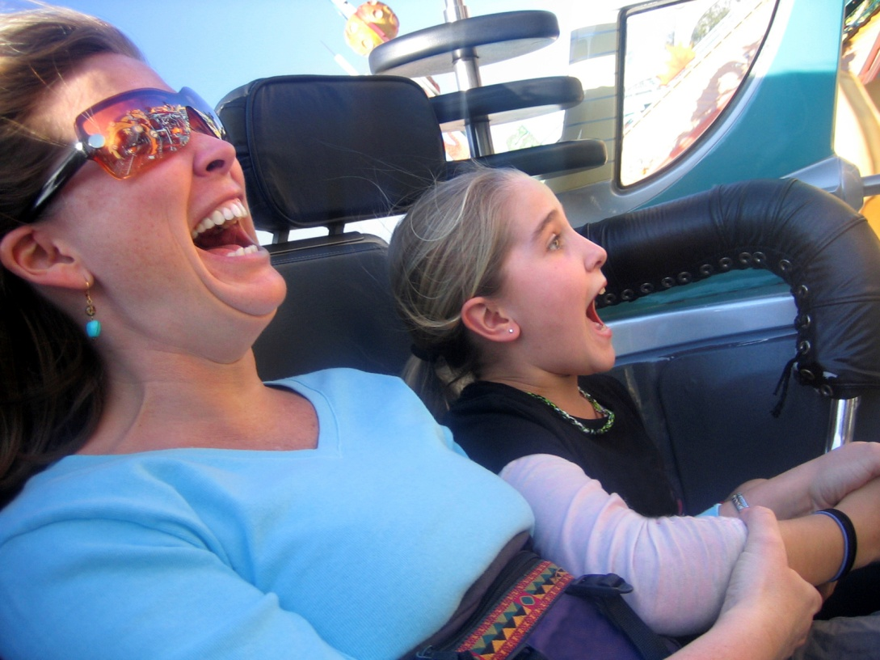
Roller coasters have come a long way since the first coaster—built as a means of transporting coal down a Pennsylvania mountain—was invented in 1872. Much like architects who try to win the “world’s tallest building” recognition, roller-coaster designers and theme parks try to outdo records for largest, fastest, and tallest amusement-park ride. To ensure a safe theme-park experience, it’s important to communicate with girls about ride and crowd safety, and to encourage girls to act responsibly. Search for U.S. theme parks by state at About.com. Remember that some theme parks have height restrictions for Girl Scout Daisies and Brownies.
Caution: Girls are not allowed to operate motorized vehicles, such as go-carts, without council permission.
Include girls with disabilities. Communicate with girls with disabilities and/or their caregivers to assess any needs and accommodations. Learn more about the resources and information that theme parks and Disabled World provide to people with disabilities.
Theme Park Gear
Basic Gear
- Casual and comfortable clothing suitable for the weather (long, flowing garments are not worn)
- Sunscreen (SPF of at least 15) and sunglasses on sunny or hazy days
- All hats, glasses, purses, and other such items are secured during the ride or not taken on a ride
- Comfortable walking shoes that provide good traction
Prepare for the Theme Park Activity
- Communicate with council and parents. Inform your Girl Scout council and girls’ parents/guardians about the activity, including details about safety precautions and any appropriate clothing or supplies that may be necessary. Follow council procedures for activity approval, certificates of insurance, and council guidelines about girls’ general health examinations. Make arrangements in advance for all transportation and confirm plans before departure.
- Girls plan the activity. Keeping their grade-level abilities in mind, encourage girls to take proactive leadership roles in organizing details of the activity.
- Arrange transportation and adult supervision. The recommended adult-to-girl ratios are two non-related adults (at least one of whom is female) to every:
- 6 Girl Scout Daisies
- 12 Girl Scout Brownies
- 16 Girl Scout Juniors
- 20 Girl Scout Cadettes
- 24 Girl Scout Seniors
- 24 Girl Scout Ambassadors
Plus one adult to each additional:
- 4 Girl Scout Daisies
- 6 Girl Scout Brownies
- 8 Girl Scout Juniors
- 10 Girl Scout Cadettes
- 12 Girl Scout Seniors
- 12 Girl Scout Ambassadors
- Ensure safety of theme-park rides. Obtain full information about the rides and other activities and evaluate them for safety. Discuss with the park manager or safety officer safety procedures, maintenance programs, insurance coverage, and other matters of concern. Verify in advance that the park carries liability insurance.
- Select a safe location. Inspect the site to be sure it is free of potential hazards, and make sure emergency medical care, first-aid equipment and supplies are easily accessible. In the event of illness or accident, notify the nearest park attendant.
- Encourage girls to plan the trip. Girls and adults determine the appropriate time of day and length of the visit to the theme park.
- Compile key contacts. Give an itinerary to a contact person at home; call the contact person upon departure and return. Create a list of girls’ parents/guardian contact information, telephone numbers for emergency services and police, and council contacts—keep on hand or post in an easily accessible location.
- Dress appropriately for the activity. Make sure girls and adults avoid wearing dangling earrings, bracelets, and necklaces that may become entangled in rides.
- Be prepared in the case of an emergency. Ensure the presence of a first-aid kit and a first-aider with a current certificate in First Aid, including Adult and Child CPR or CPR/AED. See Volunteer Essentials for information about first-aid standards and training.
On the Day of the Theme Park Activity
- Get a weather report. On the morning of the activity, check weather.com or other reliable weather sources to determine if conditions are appropriate, and make sure that the ground is free of ice. If severe weather conditions prevent the activity, be prepared with a backup plan or alternate activity, or postpone the activity. Write, review, and practice evacuation and emergency plans for severe weather with girls. In the event of a storm, take shelter away from tall objects (including trees, buildings, and electrical poles). Find the lowest point in an open flat area. Squat low to the ground on the balls of the feet, and place hands on knees with head between them.
- Use the buddy system. Girls are divided into teams of two. Each girl chooses a buddy and is responsible for staying with her buddy at all times, warning her buddy of danger, giving her buddy immediate assistance if safe to do so, and seeking help when the situation warrants it. If someone in the group is injured, one person cares for the patient while two others seek help.
- Review plans upon arrival. Adults obtain a copy of the park guide—to facilitate the visit and gain important information on park policies and the location of restrooms and the first-aid station. Adults pay special attention to any safety tips or warnings and share this information with the girls. Adults discuss plans for the visit with girls, and set a place to meet in case of separation from the group.
- Girls respect theme-park rules and take general safety precautions. Each girl is instructed to consider her own personal limitations with regard to rides: how she is affected by height, speed, movement, flashing lights. Theme parks have policies and signs restricting access to certain rides because of height, weight, or other criteria. Adults instruct girls to look for and comply with all safety-related signs and instructions given by ride operators. In extremely hot weather, girls go on rides and do other outdoor activities in the morning and late afternoon hours, and go inside for meals, stage shows, and so on during the warmest time of the day. On rides, girls and adults remain seated and always keep their arms and legs inside the car at all times. Seat belts or restraint bars are always used and are never removed during rides. Any unsafe conditions, such as slippery floors, broken seat belts, and nonfunctioning exit signs are reported to the nearest park attendant.
- Keep track of girls’ whereabouts. Conduct a head count before and after activities. Ensure that girls know where to go and how to act when confronted by strangers or intruders.
Theme Park Link
- International Association of Amusement Parks and Attractions: www.iaapa.org

