
Swimming: Safety Activity Checkpoints
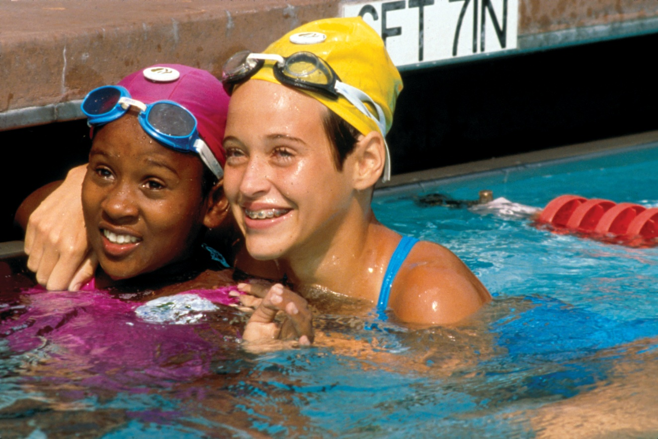
A longtime Girl Scout tradition, swimming is one of the many ways that girls develop athleticism, leadership, and team-building skills. Whether swimming outdoors at camps and competitive events or in indoor pools, safety is one of the keys to having fun in the water. Girls and adults adhere to council requirements for swimming levels—in addition to the requirements of the organization you are working with—to participate in water activities. Consult a local organization such as your local parks and recreation department, YMCA, or American Red Cross for swimming lessons, or locate a swimming instructor in your area at swim.com.
Know where to go swimming. Girl Scout camps, lakes, rivers, pools, and other camping facilities. Connect with your Girl Scout council for site suggestions.
Include girls with disabilities. Communicate with girls with disabilities and/or their caregivers to assess any needs and accommodations. Learn more about the resources and information that USA Swimming Disability Committee and International Federation of Adapted Physical Activity provide to people with disabilities.
Swimming Gear
Basic Gear
- Bathing suit (a one-piece is usually less cumbersome than a two-piece)
- Waterproof sunscreen (SPF of at least 15)
- Sunglasses
- Beach towel
- Dry clothing and sunglasses to wear after swimming
- Goggles, swim cap, and/or nose and ear plugs for girls who need them
Specialized/Rescue Gear
- Participants who are weak swimmers wear a U.S. Coast Guard–approved life jacket (Type III recommended) that fits according to weight and height specifications. Inspect life jackets to ensure that they are in good condition and contain no tears. Read about Coast Guard life jackets here.
- Reaching pole
- Ring buoy or throw bag with firmly attached line approximately 30 feet long
- Rescue tube
- Backboard
- At least one graspable and throwable personal flotation device (Type IV buoyant cushion or ring buoy or equivalent) is immediately available for each group on the water
Prepare for Swimming
- Communicate with council and parents. Inform your Girl Scout council and girls’ parents/guardians about the activity, including details about safety precautions and any clothing or supplies that may be necessary. Follow council procedures for activity approval, certificates of insurance, and council guidelines about girls’ general health examinations. Make arrangements in advance for all transportation and confirm plans before departure.
- Girls plan the activity. Keeping their grade-level abilities in mind, encourage girls to take proactive leadership roles in organizing details of the activity.
- Arrange for transportation and adult supervision. The recommended adult-to-girl ratios are two non-related adults (at least one of whom is female) to every:
- 6 Girl Scout Daisies
- 12 Girl Scout Brownies
- 16 Girl Scout Juniors
- 20 Girl Scout Cadettes
- 24 Girl Scout Seniors
- 24 Girl Scout Ambassadors
Plus one adult to each additional:
- 4 Girl Scout Daisies
- 6 Girl Scout Brownies
- 8 Girl Scout Juniors
- 10 Girl Scout Cadettes
- 12 Girl Scout Seniors
- 12 Girl Scout Ambassadors
- Ensure the presence of watchers. A watcher is a person trained in the use of basic water-rescue equipment and procedures who works under the direction of the lifeguard. American Red Cross Basic Water Rescue certification or equivalent is appropriate. Lifeguards and watchers are stationed at separate posts and stay out of the water, except in emergencies. An American Red Cross Lifeguarding Instructor or American Red Cross Water Safety Instructor (WSI) can provide training in Basic Water Rescue.
Swimming Lifeguards and Watchers Ratios
Number of Swimmers | Lifeguards | Watchers
1–10 | 1 adult | 1*
11–25 | 1 adult | 2*
26–35 | 2 persons, at least 1 is an adult; others may be 16 years of age or older. | 3*
36–50 | 2 persons, at least 1 is an adult; others may be 16 years of age or older. | 4*
*Some states allow watchers to be under the age of 18, but in all states, they must be at least 16 years of age.
These numbers are a minimum. The ratio of lifeguards and watchers to swimmers may need to be increased depending on the number of girls in one area, swimming level and ability, girls with disabilities, age level and ability to follow instructions, type of swimming activity (instruction, recreation), type of swimming area, weather and water conditions, and rescue equipment available. If you are unsure whether your swimming lifeguards and watchers ratios are sufficient, be sure to contact your council.
- Ensure participants are able to swim. Participants’ swimming abilities are classified and clearly identified (for instance, with colored headbands to signify beginners, advanced swimmers, etc.) at council-approved sites, or participants provide proof of swimming-test certification. In the absence of swimming-test certification, a swim test is conducted on the day of the activity. Consult with your Girl Scout council for additional guidance.
- Ensure the presence of lifeguards. For swimming activities in public pools, hotel and cruise-ship pools, and backyard pools, the lifeguards are at least 16 years old and have American Red Cross Lifeguard Training certification or the equivalent. For swimming activities in lakes, slow-moving streams, and rivers, one adult lifeguard (certified in American Red Cross Lifeguard Training plus Waterfront Lifeguard course or the equivalent) is present for every 10 swimmers, plus one watcher. When girls are wading in water more than knee-deep, an adult with American Red Cross Basic Water Rescue certification or with documented experience according to your council’s guidelines, as outlined in Volunteer Essentials. For swimming and wading activities, consult the “Swimming Lifeguards and Watchers Ratios” chart for standards.
- Assess safety of swimming site. Whether using council-owned or -operated swimming sites or using public, loaned, or donated facilities, the swimming site posts that its water quality passes the local health-department tests and sanitation regulations. In addition:
For pools:
- Pool water depths are clearly marked, and shallow areas are marked “no diving.” Diving areas are separate from other swimming areas.
- The facility makes periodic maintenance checks. Maintenance requests are repairs are documented, and records are retained.
- Water pH and chlorine are tested and maintained at safe levels. Tests are documented, and records are retained.
- The decks around the pool are kept clean and clutter-free.
- The surrounding fence and gate or doors are locked when the pool is unsupervised.
For beach and other waterfront areas:
- Hazards are eliminated or clearly marked.
- Girls are instructed to avoid strong currents, sharp drop-offs, quicksand bottoms, rough surf, and other potentially dangerous conditions.
- As best as can be determined, the water is free of dangerous marine life.
- The bottom is relatively free of debris, sharp stones, and shells.
- Swimming, diving, and small-craft areas are separate. They are clearly marked or roped off or both.
- Follow sliding safety standards. The following rules are respected for activities that include slides:
- A watcher signals that the next person may slide when the landing area is clear.
- Only one person may be on the slide at a time.
- Girls slide in a sitting position, never headfirst.
- The landing area is off-limits to other swimmers.
- The water in the slide landing area is at least 4 feet deep.
- Follow diving-area safety standards. The following rules are respected for activities that include diving:
- The diving area is divided from the swimming area by a buoyed line.
- The water in the landing area is a minimum of 10 feet deep for recreational diving boards. The boards are usually 12 to 14 feet long and less than 3 feet above the water’s surface.
- The water in the landing area is a minimum of 12 feet deep for competitive diving boards. The boards are usually 16 feet long and 3 to 10 feet above the water’s surface.
- Diving is restricted to water of sufficient depth and checked in advance for submerged obstructions. Diving is prohibited in waters of unknown depth and conditions.
- Recreational divers do not manipulate the adjustable fulcrum on the springboards. During recreational swimming periods, the adjustable fulcrum is locked in a fixed position, preferably in its most forward position, to reduce the spring of the board.
- The maximum water depth extends 10 feet on each side of the center line of the board. If tides, drought, and similar forces affect the water depth, it is checked each time before diving is permitted.
- Girls do not dive off the side of the board.
- Follow water-park safety standards. When participating in water activities at water parks, adults and girls must:
- Read and follow all park rules and the instructions of lifeguards.
- Know their physical limits. Observe a water ride before going on.
- Not dive. Always know the depth of the water before wading in.
- Not run. Most minor injuries at water parks are caused by slips and falls.
- Use extra care on water slides. They cause a significant number of injuries. See “Follow sliding safety standards.”
- In wave pools, stay away from the walls.
- Prepare for emergencies. Ensure the presence of a waterproof first-aid kit and a first-aider, who is prepared to handle cases of near-drowning and immersion hypothermia. See Volunteer Essentials for information about first-aid standards and training.
- Compile key contacts. Give an itinerary to a contact person at home; call the contact person upon departure and return. Create a list of girls’ parents/guardian contact information, telephone numbers for emergency services and police, and council contacts—keep on hand or post in an easily accessible location.
On the Day of Swimming
- Get a weather report. If swimming outdoors, never swim on a stormy day. On the day of the activity, consult weather.com or other reliable sources to assess temperature and weather and water conditions. If weather conditions prevent the trip, be prepared with a backup plan or alternative activity.
- Safeguard valuables. Don’t leave personal belongings and valuables unattended in a public place.
- Use the buddy system. Girls are divided into teams of two. Each person chooses a buddy and is responsible for staying with her buddy at all times, warning her buddy of danger, giving her buddy immediate assistance if safe to do so, and seeking help when the situation warrants it.
- Be prepared in the event of a storm with lightning. Exit water immediately, and take shelter away from tall objects (including trees, buildings, and electrical poles). Find the lowest point in an open flat area. Squat low to the ground on the balls of the feet, and place hands on knees with heads between them. During storms, if shore cannot be reached, keep a sharp lookout for boats and other obstructions.
- Keep track of girls’ whereabouts. In a controlled waterfront, a checkboard system is used to indicate which girls are in the water and in which swimming area. In crowded areas, a color system is used for identification (for example, non-swimmers, novice swimmers, and skilled swimmers each have a wristband, hair band, or other marker of a different color).
- Monitor time in water. The length of a swimming period is determined by the swimmer’s condition and comfort, weather conditions, and water temperature. Generally, 30-minute swimming periods are sufficient.
- Respect basic swimming rules and safety precautions.
- Girls do not dive into above-ground pools, shallow areas, etc.
- Girls swim in supervised areas only.
- Girls swim only during daylight hours or in a well-lit pool at night.
- Girls do not swim immediately after eating, when overheated, or when tired.
- Girls swim at a safe distance from any diving board.
- Electrical appliances are not used in or near swimming areas.
- Bottles, glass, and sharp objects are not allowed in swimming area.
- An emergency telephone is available, whenever possible.
- Drink water to avoid dehydration.
Swimming Links
- American Red Cross Swimming and Water Safety program: www.redcross.org/portal⇨Preparing and Getting Trained⇨Get Trained⇨Swimming and Water Safety⇨Learn to Swim
- Swim America: www.swimamerica.org
- USA Swimming: www.usaswimming.org
- YMCA Programs for Aquatics: www.ymca.net/programs/programs_for_aquatics.html
- State and national parks and forests (may certify swimmers): www.llbean.com/parksearch/us_search.html
Swimming Know-How for Girls
- Learn swimming strokes. Before you hit the water, read up about the five basic strokes: freestyle, backstroke, breast-stroke, butterfly, and sidestroke.
- Create swimming games. Marco Polo and Find the Penny are popular swimming games. What games can you create?
Swimming Jargon
- Flip turn: A tumbling turn in which the swimmer somersaults and twists her body as she approaches the pool wall, and then pushes off the wall with her feet
- Leg: One-fourth of a relay swum by four swimmers

