
Surfing: Safety Activity Checkpoints
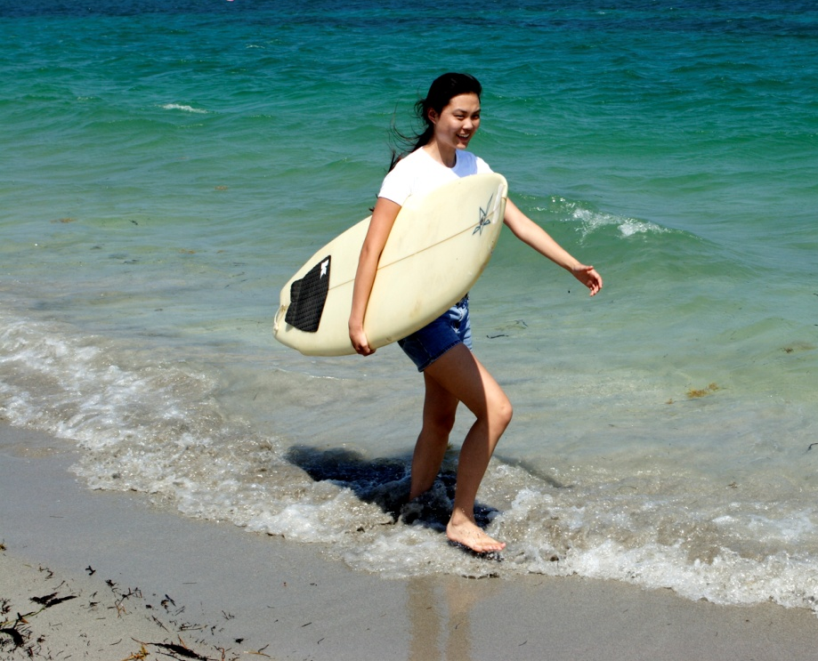
Surfing (also referred to as “surfboarding”) is one of the most challenging water sports, but if a new surfer is well prepared, it can be a safe, rewarding experience that develops balance, agility, strength, and confidence. With proper instruction from an experienced surfing teacher, many first-timers are able to stand up on their boards during the initial two- to four-hour session. Of course, people learn at different paces, but three to four lessons are recommended. Enrolling girls in a surf camp or daylong surfboarding lesson is highly recommended for beginners; be sure to inform the surf school of girls’ ages, heights, and sizes to reserve appropriate surfboards and wetsuits. Surfing is not recommended for Girl Scout Daisies and Brownies.
Know where to surf. The ocean is best, but some rivers and regions along the Great Lakes also can be suitable for surfing so long as the weather is warm. Connect with your Girl Scout council for site suggestions.
Include girls with disabilities. Communicate with girls with disabilities and/or their caregivers to assess any needs and accommodations. Learn more about the resources and information that the Association of Amputee Surfers and International Surfing Association Adapted Surfing provide to people with disabilities.
Surfing Gear
Basic Gear
- One-piece bathing suit (less cumbersome in the waves than a two-piece)
- Waterproof sunscreen (SPF of at least 15)
- Goggles for girls who require glasses or contact lenses (available at sporting-goods stores; if prescription goggles are too expensive for girls to purchase, make sure girls test non-prescription goggles to assure proper fit over prescriptive eyewear)
- Beach towel
- Dry clothing and sunglasses to wear after surfing
Specialized Gear
- Wetsuit is recommended for warmth and skin protection, especially when water temperature is below 70 degrees Fahrenheit (most surf schools rent full-body or partial suits)
- Surfboard (soft-deck longboards are generally recommended for beginners)
- Leash (also referred to as a leg rope; a cord that attaches the surfboard to the surfer’s ankle, so that she doesn’t have to swim too far to catch up to the board after a wipeout; a leash is usually included with a rental surfboard)
- Wax, which is applied to the top or deck of a surfboard for traction (most rental surfboards will be pre-waxed)
- At least one graspable and throwable personal flotation device (Type IV buoyant cushion or ring buoy or equivalent) is immediately available for each group on the water
Prepare for Surfing
- Communicate with council and parents. Inform your Girl Scout council and girls’ parents/guardians about the activity, including details about safety precautions and any appropriate clothing or supplies that may be necessary. Follow council procedures for activity approval, certificates of insurance, and council guidelines about girls’ general health examinations. Make arrangements in advance for all transportation and confirm plans before departure.
- Girls plan the activity. Keeping their grade-level abilities in mind, encourage girls to take proactive leadership roles in organizing details of the activity.
- Ensure participants are able to swim. Participants’ swimming abilities are classified and clearly identified (for instance, with colored headbands to signify beginners, advanced swimmers, etc.) at council-approved sites, or participants provide proof of swimming-test certification. In the absence of swimming-test certification, a swim test is conducted on the day of the activity. Consult with your Girl Scout council for additional guidance.
- Arrange for transportation and adult supervision. The recommended adult-to-girl ratios are two non-related adults (at least one of whom is female) to every:
- 16 Girl Scout Juniors
- 20 Girl Scout Cadettes
- 24 Girl Scout Seniors
- 24 Girl Scout Ambassadors
Plus one adult to each additional:
- 8 Girl Scout Juniors
- 10 Girl Scout Cadettes
- 12 Girl Scout Seniors
- 12 Girl Scout Ambassadors
- Verify instructor knowledge and experience. Although official surfboard-instructor certifications do not yet exist, it’s recommended that surf schools be a member of the National Surf Schools and Instructors Association, Surfing America, or a similar association; ocean lifeguard certifications are recommended. The instructor-to-girl ratio is one to four.
- Compile key contacts. Give an itinerary to a contact person at home; call the contact person upon departure and return. Create a list of girls’ parents/guardian contact information, telephone numbers for emergency services and police, and council contacts—keep on hand or post in an easily accessible location.
- Pick an ability-appropriate site. Make sure the surfing location complements the surfers’ ability levels. Some beaches designate areas for beginners, intermediate surfers, and higher-level surfers. If the surfing location does not designate areas by skill level, verify with the surfing instructor that the location is appropriate for the girls.
- Select a safe location with a soft, sandy, or muddy bottom. Scout out a location that does not have a sharp-edged or rocky bottom, which can be dangerous and can cut feet and limbs. The launching area should be easily accessible and clear of overhead power lines.
- Safeguard valuables. Don’t leave personal belongings and valuables unattended in a public place. If working with a surfboarding school or camp, call ahead to inquire about the company’s storage amenities.
- Prepare for emergencies. Ensure the presence of a waterproof first-aid kit and a first-aider with a current certificate in First Aid, including Adult and Child CPR or CPR/AED, who is prepared to handle cases of near-drowning, immersion hypothermia, and sunburn. If any part of the activity is located 60 minutes or more from emergency medical services, ensure the presence of a first-aider (level 2) with Wilderness and Remote First Aid. See Volunteer Essentials for information about first-aid standards and training.
On the Day of Surfing
- Get a weather and tide report. Never surf on a stormy day. On the morning of the surf trip, determine whether conditions will be appropriate for surfing by searching for regional surf reports on www.surfline.com, www.freetidetables.com, www.17ft.com, and weather.com. If weather conditions prevent the surf trip, be prepared with a backup plan or alternate activity.
- Assess wave heights. Call the surf instructor on the day of the trip to confirm that wave heights are appropriate for girls. Wave heights rely heavily on wind strengths; two- to three-foot waves are recommended for beginners. When waves surpass five feet, it can be difficult to paddle out from the shore.
- Be prepared in the event of a storm with lightning. Exit water immediately and take shelter away from tall objects (including trees, buildings, and electrical poles). Find the lowest point in an open flat area. Squat low to the ground on the balls of the feet, and place hands on knees with head between them.
- Use the buddy system. Girls are divided into teams of two. Each girl chooses a buddy and is responsible for staying with her buddy at all times, warning her buddy of danger, giving her buddy immediate assistance if safe to do so, and seeking help when the situation warrants it. If someone in the group is injured, one person cares for the patient while two others seek help.
Surfing Links
- Surf Safety from Outdoor Safety USA: www.outdoorsafetyusa.com/safety/beach-safety/surf-safety
- Groundswell Society Surf Safety Alliance: www.groundswellsociety.org/surfsafetyalliance
- Surfline Glossary of Terms: www.surfline.com/surfology/surfology_glossary_index.cfm
- Surfing Handbook (tips for beginners and intermediate surfers, plus overviews on ocean safety and gear): www.surfinghandbook.com
- Surfcamp.com: http://surfcamp.com/surfcamps
Surfing Know-How for Girls
- Know how to steer out from the shore. When lying on boards and paddling from the shore and deeper into the water, keep the nose of the surfboard pointed toward the surf, in order to cut through the waves. Being positioned sideways opens up the possibility of getting caught by a wave and tumbled around, like clothing in a washing machine.
- Know the break line. When paddling out from the shore, go around the break line (the point at which waves begin to break) and not through it. This allows other surfers plenty of space.
- Share the waves. Stay out of the way of other surfers, and never take off on a wave in front of another surfer (called “snaking”).
- Hold on to the surfboard. It’s dangerous to other surfers and swimmers to let go of surfboards (all the more reason to use a leash).
Surfing Jargon
- Goofy-footer: A person who surfs with her right foot toward the front of the board, instead of the usual left foot forward, as in, “She surfs goofy”
- Lineup: The area of the water where surfers sit on their boards and wait for waves
- Offshore: Winds that blow from land toward the water and often create good surfing conditions; offshore winds hold up waves so that they break in shallower water

