
Snowshoeing: Safety Activity Checkpoints
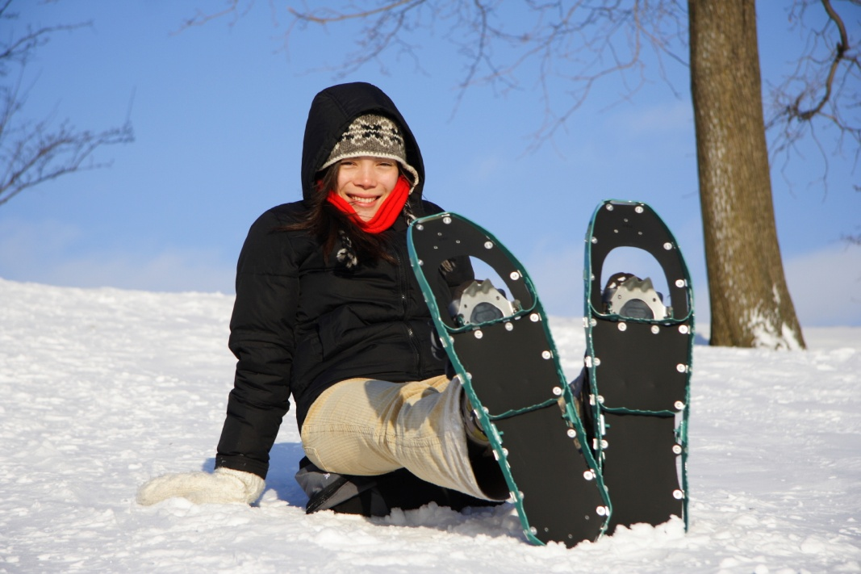
Originating thousands of years ago as a means of trekking through snow, snowshoeing has evolved to become a competitive winter sport. Snowshoes also have evolved to become sophisticated sporting equipment. Traditional snowshoes are made of wood and rawhide lacings, and modern snowshoes are typically constructed from plastic, metal, and other synthetic materials. As for selecting appropriate boots, waterproof boots or snowboarding boots work well, as do waterproofed leather hiking boots for snow hiking, and trail-running shoes work well for snow-running. Contact ski facilities and outdoor equipment stores to inquire about renting snowshoe equipment. Snowshoeing is not recommended for Girl Scout Daisies.
Know where to snowshoe. Snowshoe at Girl Scout camps, national and state parks, Nordic centers (usually located around a ski resort), and ski slopes. Avoid backcountry destinations. Connect with your Girl Scout council for site suggestions. Also, for information about snowshoe events, visit Winter Trails.
Include girls with disabilities. Communicate with girls with disabilities and/or their caregivers to assess any needs and accommodations. Learn more about the resources and information that Snowshoe Mountain provides to people with disabilities.
Snowshoeing Gear
Basic Gear
- Hat
- Thick, water-resistant gloves or mittens
- Heavy, wool insulating socks (avoid cotton socks)
- Layered clothing
- Thermal underwear or long johns
- Sunglasses or ski goggles to protect eyes from bright snow glare
- Water bottle, high-energy food (such as fruits and nuts), sunscreen (SPF of at least 15), and lip balm
- Daypack to carry personal belongings
Specialized Gear
- Windproof, waterproof jacket or parka
- Waterproof boots
- Gaiters (for deep, new snow, so that the snow doesn’t get into your socks and shoes)
- Snowshoes and bindings that fit properly
- For balance, one or two snowshoe poles or ski poles that are proper size for the girls
Prepare for Snowshoeing
- Communicate with council and parents. Inform your Girl Scout council and girls’ parents/guardians about the activity, including details about safety precautions and any appropriate clothing or supplies that may be necessary. Follow council procedures for activity approval, certificates of insurance, and council guidelines about girls’ general health examinations. Make arrangements in advance for all transportation and confirm plans before departure.
- Girls plan the activity. Keeping their grade-level abilities in mind, encourage girls to take proactive leadership roles in organizing details of the activity.
- Arrange for transportation and adult supervision. Ensure that one adult leads and another adult brings up the rear of the group. The recommended adult-to-girl ratios are two non-related adults (at least one of whom is female) to every:
- 12 Girl Scout Brownies
- 16 Girl Scout Juniors
- 20 Girl Scout Cadettes
- 24 Girl Scout Seniors
- 24 Girl Scout Ambassadors
Plus one adult to each additional:
- 6 Girl Scout Brownies
- 8 Girl Scout Juniors
- 10 Girl Scout Cadettes
- 12 Girl Scout Seniors
- 12 Girl Scout Ambassadors
- Verify instructor knowledge and experience. Instruction is given by an adult with experience teaching and/or supervising snowshoeing and has documented experience according to your council’s guidelines, as outlined in Volunteer Essentials.
- Compile key contacts. Give an itinerary to a contact person at home; call the contact person upon departure and return. Create a list of girls’ parents/guardian contact information, telephone numbers for emergency services and police, and council contacts—keep on hand or post in an easily accessible location.
- Select a safe snowshoeing site. Girls are encouraged to plan trip details and include adequate rest periods with opportunities to replenish fluids and eat high-energy foods (such as fruits and nuts). The nature of the terrain, potential hazards (such as an avalanche or frozen lake), mileage, and approximate snowshoeing time are known to all group members in advance. When a latrine is not available, individual cat holes at least 200 feet away from water sources are used to dispose of and bury human waste; tampons, sanitary supplies, and toilet paper are packed out (visit www.lnt.org for more information).
- Map the course. Before snowshoeing, designate a meeting place where girls can contact a supervising adult. The itinerary, with planned departure and return times and names of participants, is left with a contact person. The route is marked on a map. The contact person is advised before the group’s departure and upon its return.
- Ensure girls are prepared for snowshoeing. Girls get in condition by exercising before snowshoeing. Ensure that equipment is appropriate for the type of terrain, the participants’ body weight, and the weight of any backpack.
- Prepare for emergencies. Ensure the presence of a waterproof first-aid kit and a first-aider with a current certificate in First Aid, including Adult and Child CPR or CPR/AED, who is prepared to handle cases of frostbite, cold exposure, hypothermia, sprains, fractures, and altitude sickness. Search-and-rescue procedures are written out in advance. Emergency transportation is available; if any part of the activity is located 60 minutes or more from emergency medical services, ensure the presence of a first-aider (level 2) with Wilderness and Remote First Aid. See Volunteer Essentials for information about first-aid standards and training.
On the Day of Snowshoeing
- Get a weather report. On the morning of the activity, check weather.com or other reliable weather sources to determine if conditions are appropriate. Xcski.org provides reports about snow conditions by region. If severe weather conditions prevent the activity, be prepared with a backup plan or alternate activity, or postpone the activity. Write, review, and practice evacuation and emergency plans for severe weather with girls.
- Use the buddy system. Girls are divided into teams of two. Each girl chooses a buddy and is responsible for staying with her buddy at all times, warning her buddy of danger, giving her buddy immediate assistance if safe to do so, and seeking help when the situation warrants it. If someone in the group is injured, one person cares for the patient while two others seek help.
- Girls are instructed in basic snowshoeing techniques. Adults are aware of each girl’s ability. Practice sessions are scheduled for beginners.
- Be prepared in the case of an emergency. Girls are trained in winter survival (such as snow-cave building, whiteouts, and avalanche avoidance), as needed. Advance arrangements are made for medical emergencies and evacuation procedures.
Snowshoeing Links
- National Ski Patrol: www.nsp.org
- Snowshoe Magazine: www.snowshoemag.com
- The United States Snowshoe Association: www.snowshoeracing.com
- Leave No Trace: www.lnt.org
Snowshoeing Know-How for Girls
- Learn about types of snowshoes. Aerobic/running snowshoes are the smallest and lightest; recreational are mid-size snowshoes designed for moderate walks; and mountaineering snowshoes are the largest snowshoes that are meant for intense, long-distance hikes.
Snowshoeing Jargon
- Pivot point: The point under the ball of the foot at which the binding is attached to the snowshoe
- Self-belay: Preventing a slip or fall by using a ski pole while walking

