
Snorkeling: Safety Activity Checkpoints
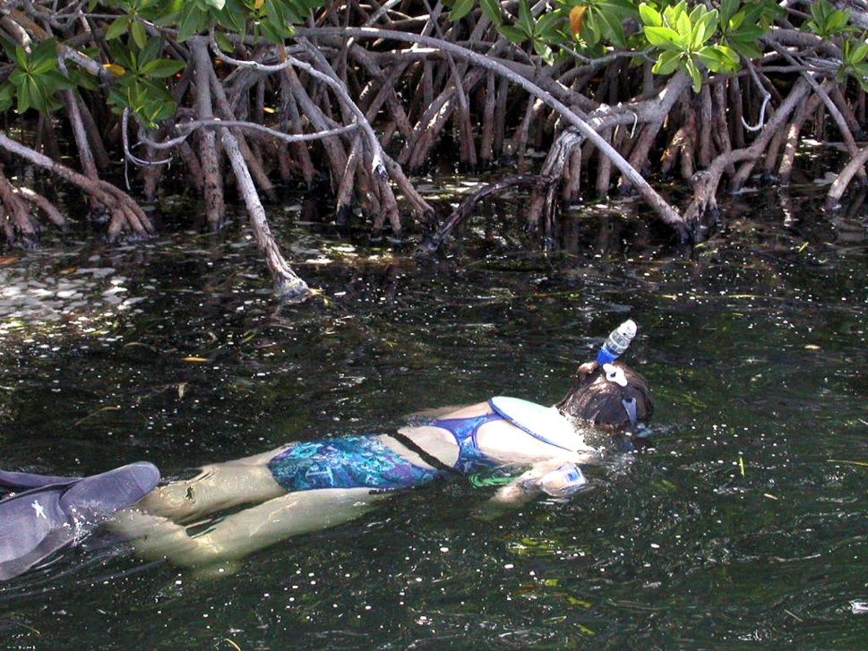
Snorkeling is a great way to explore underwater life without the complicated equipment required of scuba diving. It’s important to learn how to breathe using snorkels properly, and to receive instruction from an experienced snorkeler or equipment-rental facility. Coral, an ecosystem of shell and marine life, is a popular attraction for snorkelers and must be respected. As ocean organisms that support plants and fish, coral reefs are an essential part of the underwater ecosystem. Unfortunately, the coral reef is threatened by climate change, ocean acidification, and people who mistreat it. Touching coral can harm the delicate outer layer, which may take up to 100 years to recover.
Know where to snorkel. Just about any body of water is appropriate, but snorkeling is most recommended in warm ocean water with minimal waves. Connect with your Girl Scout council for site suggestions.
Include girls with disabilities. Communicate with girls with disabilities and/or their caregivers to assess any needs and accommodations. Learn more about the resources and information that the National Instructors Association for Divers with Disabilities provides to people with disabilities.
Snorkeling Gear
Basic Gear
- One-piece bathing suit (less cumbersome in the waves than a two-piece)
- Waterproof sunscreen (SPF of at least 15); apply generously to back and backs of legs
- Beach towel
- Dry clothing and sunglasses to wear after snorkeling
Specialized Gear
- If snorkeling in coastal areas, participants wear a U.S. Coast Guard–approved life jacket (Type III recommended) that fits according to weight and height specifications. Inspect life jackets to ensure that they are in good condition and contain no tears. Read about Coast Guard life jackets here.
- Wetsuit or dive skin recommended when swimming in cool water
- Snorkel
- Mask
- Mask defogger solution
- Fins
- At least one graspable and throwable personal flotation device (Type IV buoyant cushion or ring buoy or equivalent) is immediately available for each group on the water
Prepare for Snorkeling
- Communicate with council and parents. Inform your Girl Scout council and girls’ parents/guardians about the activity, including details about safety precautions and any appropriate clothing or supplies that may be necessary. Follow council procedures for activity approval, certificates of insurance, and council guidelines about girls’ general health examinations. Make arrangements in advance for all transportation and confirm plans before departure.
- Girls plan the activity. Keeping their grade-level abilities in mind, encourage girls to take proactive leadership roles in organizing details of the activity.
- Ensure participants are able to swim. Participants’ swimming abilities are classified and clearly identified (for instance, with colored headbands to signify beginners, advanced swimmers, etc.) at council-approved sites, or participants provide proof of swimming-test certification. In the absence of swimming-test certification, a swim test is conducted on the day of the activity. Consult with your Girl Scout council for additional guidance.
- Arrange for transportation and adult supervision. The recommended adult-to-girl ratios are two non-related adults (at least one of whom is female) to every:
- 6 Girl Scout Daisies
- 12 Girl Scout Brownies
- 16 Girl Scout Juniors
- 20 Girl Scout Cadettes
- 24 Girl Scout Seniors
- 24 Girl Scout Ambassadors
Plus one adult to each additional:
- 4 Girl Scout Daisies
- 6 Girl Scout Brownies
- 8 Girl Scout Juniors
- 10 Girl Scout Cadettes
- 12 Girl Scout Seniors
- 12 Girl Scout Ambassadors
- Verify instructor knowledge and experience. Ensure that the snorkeling instructor holds instructional certification from Scuba Schools International (SSI), Professional Association of Diving Instructors (PADI), or has equivalent certification or documented experience according to your council’s guidelines, as outlined in Volunteer Essentials.
- Compile key contacts. Give an itinerary to a contact person at home; call the contact person upon departure and return. Create a list of girls’ parents/guardian contact information, telephone numbers for emergency services and police, and council contacts—keep on hand or post in an easily accessible location.
- Size up snorkeling gear. Ensure the appropriate sizes of masks, snorkels, and fins are available, and make sure that masks fit girls’ faces securely and comfortably. An air space is needed in front of the eyes in order to see properly underwater. Also keep in mind that objects viewed underwater while wearing a mask appear about 25 percent larger and closer than objects seen through a mask out of water.
- Safeguard valuables. Don’t leave personal belongings and valuables unattended in a public place. If working with a snorkeling school, inquire about the company’s storage amenities.
- Prepare for emergencies. If a lifeguard is not on duty, an adult with rescue experience and/or certification is present; if snorkeling from a boat, at least one adult has small-craft safety certification or equivalent experience. (Both of these qualifications can be held by one person.) Ensure the presence of a waterproof first-aid kit and a first-aider with a current certificate in First Aid, including Adult and Child CPR or CPR/AED, who is prepared to handle cases of near-drowning, immersion hypothermia, and sunburn. If any part of the activity is located 60 minutes or more from emergency medical services, ensure the presence of a first-aider (level 2) with Wilderness and Remote First Aid. See Volunteer Essentials for information about first-aid standards and training.
On the Day of Snorkeling
- Get a weather and wind report. Never snorkel on a stormy or extremely windy day; strong winds and large waves decrease visibility and make swimming difficult. On the day of the snorkeling trip or lesson, check weather.com, www.scubabyte.com, or other reliable weather sources to determine if conditions are appropriate. If weather conditions prevent the snorkeling activity, be prepared with a backup plan or alternate activity.
- Use the buddy system. Girls are divided into teams of two. Each girl chooses a buddy and is responsible for staying with her buddy at all times, warning her buddy of danger, giving her buddy immediate assistance if safe to do so, and seeking help when the situation warrants it. If someone in the group is injured, one person cares for the patient while two others seek help.
- Be prepared in the event of a storm with lightning. Exit water immediately, and take shelter away from tall objects (including trees, buildings, and electrical poles). Find the lowest point in an open flat area. Squat low to the ground on the balls of the feet, and place hands on knees with head between them.
Snorkeling Links
- National Association of Underwater Instructors (NAUI): www.naui.org
- Professional Association of Diving Instructors (PADI): www.padi.com
- Snorkeling.info: www.snorkeling.info
Snorkeling Know-How for Girls
- Kick things up a notch. There are several styles of kicks in snorkeling. The flutter kick is the most common and involves moving legs up and down while positioned horizontally in the water. The dolphin kick involves motioning fins in unison on downward and upward strokes. With the frog kick, fins are kept together with toes pointed as the snorkeler brings them closer to the torso by bending the knees.
- Learn about underwater photography. Borrow or rent a waterproof camera (appropriate for the depth of water you’re diving in) and take photos of sea life and fellow divers.
Snorkeling Jargon
- Blast clearing: Method of clearing water out of a snorkel by quick and forceful exhalation
- Bore: The diameter of the opening of the barrel portion of a snorkel; snorkels are either large bore or small bore

