
Sledding, Tobogganing, and Snow Tubing:
Safety Activity Checkpoints
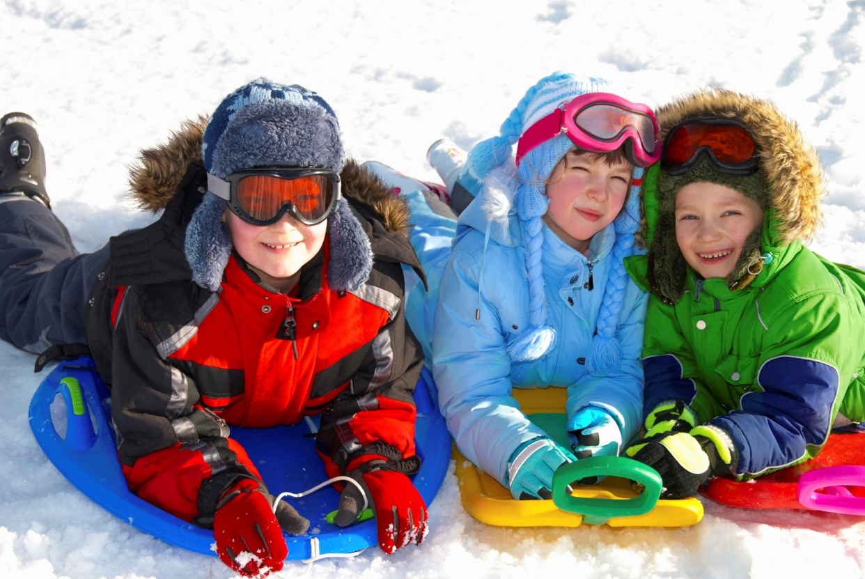
Sleds vary in design, shape, and material and can range from round plastic discs to rectangular wood structures with metal runners. A toboggan is typically a long, flat-bottomed sled made of thin boards that curve upward in a C-shape at one end. Snow tubes are inflatable, doughnut-shaped rubber or plastic inner tubes similar to those used in water tubing, but have dimpled centers.
Know where to sled, toboggan, and snow tube. Use designated sledding, tobogganing, and snow-tubing hills. Connect with your Girl Scout council for site suggestions. Also, sledriding.com provides information about U.S. sledding-hill locations. In addition, some ski resorts offer snow-tubing classes and designated areas within the resort for snow tubing.
Include girls with disabilities. Communicate with girls with disabilities and/or their caregivers to assess any needs and accommodations. Learn more about the resources and information that the National Center on Accessibility provides to people with disabilities.
Sledding, Tobogganing, and Snow Tubing Gear
Basic Gear
- Hat
- Thick, water-resistant gloves or mittens
- Heavy, wool insulating socks (avoid cotton socks)
- Winter coat
- Waterproof winter boots
- Layered clothing
- Thermal underwear or long johns
- Sunscreen (SPF of at least 15) and lip balm
Specialized Gear
- Snow pants or snow suit recommended
- Sled
- Toboggan
- Snow tube
- Bicycle helmet may be required by some snow-tubing facilities and some sledding hills
Prepare for Sledding, Tobogganing, and Snow Tubing
- Communicate with council and parents. Inform your Girl Scout council and girls’ parents/guardians about the activity, including details about safety precautions and any appropriate clothing or supplies that may be necessary. Follow council procedures for activity approval, certificates of insurance, and council guidelines about girls’ general health examinations. Make arrangements in advance for all transportation and confirm plans before departure.
- Girls plan the activity. Keeping their grade-level abilities in mind, encourage girls to take proactive leadership roles in organizing details of the activity.
- Arrange for transportation and adult supervision. The recommended adult-to-girl ratios are two non-related adults (at least one of whom is female) to every:
- 6 Girl Scout Daisies
- 12 Girl Scout Brownies
- 16 Girl Scout Juniors
- 20 Girl Scout Cadettes
- 24 Girl Scout Seniors
- 24 Girl Scout Ambassadors
Plus one adult to each additional:
- 4 Girl Scout Daisies
- 6 Girl Scout Brownies
- 8 Girl Scout Juniors
- 10 Girl Scout Cadettes
- 12 Girl Scout Seniors
- 12 Girl Scout Ambassadors
- Select a safe site. Ensure that sledding is conducted in an area free of vehicles and that the site has no obstructions such as rocks, trees, or signposts. The nature of the terrain, potential hazards (such as an avalanche or frozen lake), mileage, and approximate activity time are known to all group members in advance. When a latrine is not available, individual cat holes at least 200 feet away from water sources are used to dispose of and bury human waste; tampons, sanitary supplies, and toilet paper are packed out (visit www.lnt.org for more information).
- Prepare for emergencies. Ensure the presence of a waterproof first-aid kit and a first-aider with a current certificate in First Aid, including Adult and Child CPR or CPR/AED, who is prepared to handle cases of frostbite, cold exposure, hypothermia, sprains, fractures, and altitude sickness. Emergency transportation is available; if any part of the activity is located 60 minutes or more from emergency medical services, ensure the presence of a first-aider (level 2) with Wilderness and Remote First Aid. See Volunteer Essentials for information about first-aid standards and training.
- Compile key contacts. Give an itinerary to a contact person at home; call the contact person upon departure and return. Create a list of girls’ parents/guardian contact information, telephone numbers for emergency services and police, and council contacts—keep on hand or post in an easily accessible location. Before a sledding, tobogganing, or snow-tubing trip, a meeting place is designated where girls can contact an adult.
- Girls learn about sledding, tobogganing, and snow tubing. Girls receive basic instruction in sledding safety and conduct rules. Girls learn to perform basic steering skills, including how to slow down and stop.
On the Day of Sledding, Tobogganing, or Snow Tubing
- Get a weather report. On the morning of the activity, check weather.com or other reliable weather sources to determine if conditions are appropriate. Xcski.org provides reports about snow conditions by region. If weather conditions prevent the activity, be prepared with a backup plan or alternate activity, or postpone the activity. Write, review, and practice evacuation and emergency plans for severe weather with girls.
- Use the buddy system. Girls are divided into teams of two. Each girl chooses a buddy and is responsible for staying with her buddy at all times, warning her buddy of danger, giving her buddy immediate assistance if safe to do so, and seeking help when the situation warrants it. If someone in the group is injured, one person cares for the patient while two others seek help.
- Safeguard valuables. Secure equipment in a dry, locked storage area.
- Practice safe sledding, tobogganing, and snow tubing. Conditions are monitored, and breaks are taken to prevent hypothermia and frostbite. Girls slide downhill feet-first to reduce the potential for head injuries from collisions. Girls and adults agree on the portion of slope to be used for sledding and the portion to be used for walking uphill.
Sledding, Tobogganing, and Snow-Tubing Links
- Sled Riding: www.sledriding.com
Sledding, Tobogganing, and Snow Tubing Know-How for Girls
- Learn about competitive and Olympic sledding. Find out about the sport of sled racing on the USA Bobsled and Skeleton Federation site.
- Know the history of sledding. Traditionally sleds were used to transport goods and people in places where wheels couldn’t operate. Toboggans made of poles tied together with leather were used by Native Americans to carry food, clothing, and other items through snow.
Sledding, Tobogganing, and Snow Tubing Jargon
- Aerodynamics: The science of studying how objects move through air; an aerodynamically designed sled or toboggan is made smooth to cut through wind faster
- Luge: A competitive sport that uses a luge (pronounced LOOzh) or small sled; luge users ride with their backs on the sled and faces up
- Skeleton: A small, flat sled with no steering or braking mechanisms that is used competitively; the rider faces down

