
Skateboarding: Safety Activity Checkpoints
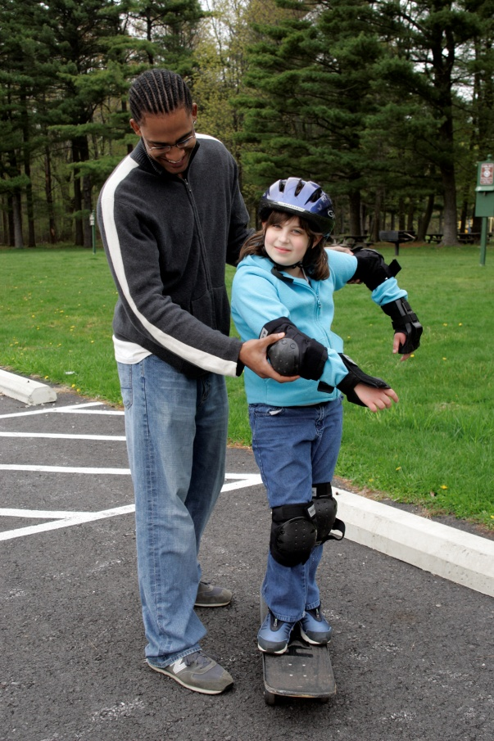
Invented in the 1930s by California surfers who were frustrated by bad waves, skateboarding has become a popular sport and pastime with competitions and professional skateboarders. Skateboarding schools and camps teach beginners how to ride, perform tricks, and skate ramps and half-pipes. In general, for groups learning to skateboard, four class sessions are recommended. Girl Scout Daisies do not participate in skateboarding.
Caution: Girls are not allowed to do aerial tricks on skateboards.
Know where to skateboard. Beginners skateboard in organized skateboarding facilities such as skate schools and enclosed areas. Experienced skateboarders skate in skate parks and other skateboarding-designated areas. Connect with your Girl Scout council for site suggestions. Also, SkateboardDirectory.com provides information about skateboarding parks and schools.
Include girls with disabilities. Communicate with girls with disabilities and/or their caregivers to assess any needs and accommodations. Learn about the resources and information that the National Center on Accessibility provides to people with disabilities.
Skateboarding Gear
Basic Gear
- Flexible, loose-fitting clothing that allows freedom of movement
- Long-sleeve shirts, which help to prevent scrapes
- Sunscreen (SPF of at least 15), if outdoors
- Sneakers
- Daypack to carry personal belongings
Specialized Gear
- Skateboard (beginners should start with a standard skateboard, approximately 32 inches in length) with sturdy wheels
- Protective helmet with properly fitting safety harness that meets the American Society for Testing and Materials (ASTM) F1492 requirements, displaying the Safety Equipment Institute (SEI) seal
- Snug-fitting elbow pads and kneepads
- Skateboarding/in-line skating wrist guards
Prepare for Skateboarding
- Communicate with council and parents. Inform your Girl Scout council and girls’ parents/guardians about the activity, including details about safety precautions and any appropriate clothing or supplies that may be necessary. Follow council procedures for activity approval, certificates of insurance, and council guidelines about girls’ general health examinations. Make arrangements in advance for all transportation and confirm plans before departure.
- Girls plan the activity. Keeping their grade-level abilities in mind, encourage girls to take proactive leadership roles in organizing details of the activity.
- Arrange transportation and adult supervision. The recommended adult-to-girl ratios are two non-related adults (at least one of whom is female) to every:
- 12 Girl Scout Brownies
- 16 Girl Scout Juniors
- 20 Girl Scout Cadettes
- 24 Girl Scout Seniors
- 24 Girl Scout Ambassadors
Plus one adult to each additional:
- 6 Girl Scout Brownies
- 8 Girl Scout Juniors
- 10 Girl Scout Cadettes
- 12 Girl Scout Seniors
- 12 Girl Scout Ambassadors
- Verify instructor knowledge and experience. Instruction is given by a person with experience teaching and/or supervising skateboarding or has equivalent certification or skill in teaching and/or supervising skateboarding and has documented experience according to your council’s guidelines, as outlined in Volunteer Essentials. Check the instructor’s references to ensure reliability and skill level.
- Compile key contacts. Give an itinerary to a contact person at home; call the contact person upon departure and return. Create a list of girls’ parents/guardian contact information, telephone numbers for emergency services and police, and council contacts—keep on hand or post in an easily accessible location.
- Select a safe skateboarding site. Obtain council guidance in selecting the skating site. Ensure that the site has a smooth skating surface free of debris. Beginners start on a flat, painted surface such as an outdoor basketball court. Avoid skate parks until girls are ready to skateboard at a higher level. When skateboarding at skate parks, the manager is called in advance to arrange for large groups or for practice sessions. The skate park is adequately staffed to monitor the size of the crowd. (Check with the skate park supervisor in advance to learn how many adults, in addition to the park staff, are needed to supervise the group.) Local ordinances or parks offices are checked to see whether skateboarding is permitted on bike paths or in city parks. Do not skateboard in back alleys, in the street, or on private property.
- Prepare for emergencies. Ensure the presence of a first-aid kit and a first-aider with a current certificate in First Aid, including Adult and Child CPR or CPR/AED, who is prepared to handle cases of injury from falls, especially abrasions. If any part of the activity is located 60 minutes or more from emergency medical services, ensure the presence of a first-aider (level 2) with Wilderness and Remote First Aid. See Volunteer Essentials for information about first-aid standards and training.
On the Day of Skateboarding
- Get a weather report. For outdoor skateboarding, on the morning of the activity, check weather.com or other reliable weather sources to determine if conditions are appropriate, and make sure, if skateboarding outside, that the ground is free of ice. If severe weather conditions prevent the activity, be prepared with a backup plan or alternate activity, or postpone the activity. Write, review, and practice evacuation and emergency plans for severe weather with girls. In the event of a storm, take shelter away from tall objects (including trees, buildings, and electrical poles). Find the lowest point in an open flat area. Squat low to the ground on the balls of the feet, and place hands on knees with head between them.
- Use the buddy system. Girls are divided into teams of two. Each girl chooses a buddy and is responsible for staying with her buddy at all times, warning her buddy of danger, giving her buddy immediate assistance if safe to do so, and seeking help when the situation warrants it. If someone in the group is injured, one person cares for the patient while two others seek help.
- Safeguard valuables. Secure equipment in a dry, locked storage area if skateboarding in an indoor skatepark.
- Girls learn basic skating skills. Girls receive basic instruction in skateboarding skills. Girls learn to perform basic skateboarding skills before attempting more advanced skills. Gentle warm-up exercises are done before any strenuous skating; cool-down exercises end the sessions.
- Follow basic skateboarding safety standards. Be aware of surroundings and stay out of the way of other skateboarders. Follow skate park or facility rules. Loose or sharp articles, such as handbags, combs, and keys, are not carried in pockets, hands, hair, or anyplace where they might injure a skater in the event of a fall, fall to the floor, or injure another skater. Girls do not skate faster than their ability to stop, and skaters do not wear headphones while skating. To help avoid injuries, instruct girls to discontinue skateboarding if they’re experiencing exhaustion or pain.
- Practice safe outdoor skateboarding. Outdoors, girls skate in areas where traffic or pedestrians will not interfere. Check local ordinances for any restrictions. Girls skate in the street or in a parking lot only if it is closed to traffic. When skating on a walkway, yield to pedestrians.
Skateboarding Links
- International Skateboarding Federation: www.internationalskateboardingfederation.com
- USA Skateboarding: http://usaskateboarding.org
Skateboarding Know-How for Girls
- Learn about tricks. Before trying them out in skate camp or school, learn about the ollie, kick flip, pop shuv-it, and other skateboarding moves at www.skateboard.com/howtoskate.
- Start a skateboard club. Don’t have a skateboarding school, park, or club in your area? Consider starting one. This Skateboard About Web site provides tips.
Skateboarding Jargon
- ABEC: A unit of measurement for rating the manufacturing tolerances of skateboard bearings; the bearings range from ABEC 1, the least precise, to ABEC 7, the most precise
- Bowl: A concave skateboarding ramp that is 360 degrees, forming a bowl shape

