
Sailing: Safety Activity Checkpoints
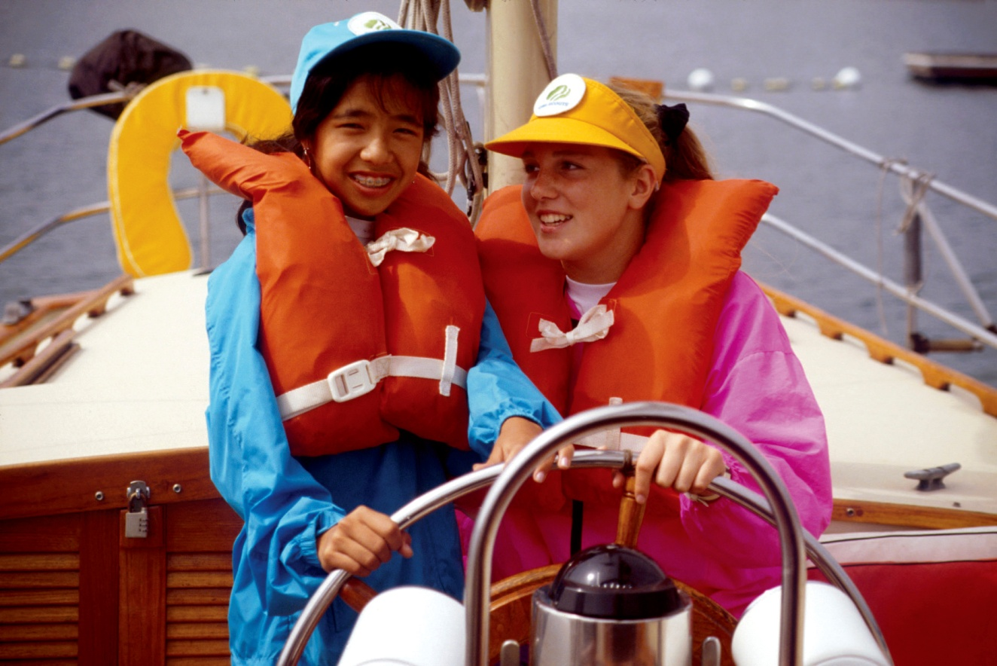
The sport of sailing has become very high-tech and competitive since its humble beginnings, but sailors and racers still must rely on the force of wind to push their boats. There are a wide variety of sailboats, including small and large sailboats, keelboats, and multihulls. Sailboating is not recommended for Girl Scout Daisies and Brownies.
Caution: Girls are not allowed to operate motorized boats without council permission; girls are never allowed to parasail.
Know where to sail. The ocean and lakes are ideal for sailing, but many sailing clubs offer instructions on reservoirs, rivers, and ponds. Connect with your Girl Scout council for site suggestions. Also, the U.S. Sailing Web site provides a list of U.S. sailing camps, clubs, and associations. Visit New to Sailing for information about international sailing associations.
Include girls with disabilities. Communicate with girls with disabilities and/or their caregivers to assess any needs and accommodations. Learn more about the resources and information that the International Association for Disabled Sailing provides to people with disabilities.
Sailing Gear
Basic Gear
- Layered clothing that’s easily changeable depending on temperatures (waterproof jacket recommended)
- Boat shoes, closed-toe and nonslip hiking/sport sandals with heel strap, or water socks or shoes (no flip-flops)
- Waterproof sunscreen (SPF of at least 15)
- Sunglasses
- Flashlight and extra batteries
Specialized Gear
- Participants wear a U.S. Coast Guard–approved life jacket (Type III recommended) that fits according to weight and height specifications. Inspect life jackets to ensure that they are in good condition and contain no tears. Read about Coast Guard life jackets here.
- Sailing gloves (help save tender hands and improve grip)
- Rigging knife
- Emergency sound device, such as a fog horn or sounding flares
- Emergency repair kit (duct tape or electrical tape, screwdriver, pliers, shackles, extra line, sewing kit, a spare drain plug, extra cotter rings/pins, and a short piece of light line/rope)
- Paddle (as second means of propulsion)
- Bailer (a bucket used to remove water from a boat)
- At least one graspable and throwable personal flotation device (Type IV buoyant cushion or ring buoy or equivalent) is immediately available for each group on the water
Prepare for Sailing
- Communicate with council and parents. Inform your Girl Scout council and girls’ parents/guardians about the activity, including details about safety precautions and any appropriate clothing or supplies that may be necessary. Follow council procedures for activity approval, certificates of insurance, and council guidelines about girls’ general health examinations. Make arrangements in advance for all transportation and confirm plans before departure.
- Girls plan the activity. Keeping their grade-level abilities in mind, encourage girls to take proactive leadership roles in organizing details of the activity.
- Ensure participants are able to swim. Participants’ swimming abilities are classified and clearly identified (for instance, with colored headbands to signify beginners, advanced swimmers, etc.) at council-approved sites, or participants provide proof of swimming-test certification. In the absence of a swimming-test certification, a swim test is conducted on the day of the activity. Consult with your Girl Scout council for additional guidance.
- Arrange for transportation and adult supervision. The recommended adult-to-girl ratios are two non-related adults (at least one of whom is female) to every:
- 16 Girl Scout Juniors
- 20 Girl Scout Cadettes
- 24 Girl Scout Seniors
- 24 Girl Scout Ambassadors
Plus one adult to each additional:
- 8 Girl Scout Juniors
- 10 Girl Scout Cadettes
- 12 Girl Scout Seniors
- 12 Girl Scout Ambassadors
- Verify instructor knowledge and experience. Ensure that the adult or sailing instructor is certified as a Sailing Instructor by U.S. Sailing, holds an American Red Cross Small Craft Safety certification, or possesses equivalent certification or documented experience according to your council’s guidelines, as outlined in Volunteer Essentials.
- Compile key contacts. Give an itinerary to a contact person at home; call the contact person upon departure and return. Create a list of girls’ parents/guardian contact information, telephone numbers for emergency services and police, and council contacts—keep on hand or post in an easily accessible location.
- Select appropriate sailboats for water and passengers. Make sure craft weight and capacity are not exceeded (some crafts clearly display maximum capacity). Consider weather and water conditions, weight of passengers, and equipment.
- File a float plan. If participating in a long-distance sailing trip, file a float plan with local authorities that includes names of people on board, destination, craft description, times of departure and return, and additional details about routes and marine communications, and so on. The Coast Guard provides an electronic, printable form.
- Prepare for emergencies. Ensure the presence of a waterproof first-aid kit and a first-aider with a current certificate in First Aid, including Adult and Child CPR or CPR/AED, who is prepared to handle cases of near-drowning, immersion hypothermia, and sunburn. If any part of the activity is located 60 minutes or more from Emergency Medical Services response time, ensure the presence of a first-aider (level 2) with Wilderness and Remote First Aid. See Volunteer Essentials for information about first-aid standards and training.
On the Day of Sailing
- Get a weather and wind report. Never sail on a stormy or excessively windy day. On the day of the sailing trip or lesson, visit weather.com (which includes marine forecasts, including water temperature and wave height) to determine if conditions are appropriate. Intellicast also reports on sailing conditions. If weather conditions prevent the sailing activity, be prepared with a backup plan or alternate activity.
- Review rescue tips. U.S. Sailing provides instructions on small-boat capsize recovery.
- Use the buddy system. Girls are divided into teams of two. Each girl chooses a buddy and is responsible for staying with her buddy at all times, warning her buddy of danger, giving her buddy immediate assistance if safe to do so, and seeking help when the situation warrants it. If someone in the group is injured, one person cares for the patient while two others seek help.
- Be prepared in the event of a storm with lightning. Exit water immediately and take shelter away from tall objects (including trees, buildings, and electrical poles). Find the lowest point in an open flat area. Squat low to the ground on the balls of the feet, and place hands on knees with head between them. During storms, if shore cannot be reached, secure all loose gear, keep a sharp lookout for other boats and obstructions, head into the wind at a 45-degree angle, and stay low.
- Ensure docking safety. Ensure that docking lines are in good condition. Follow general safety guidelines provided by boating facility for docking the craft, and ensure the boat is securely connected to the dock before participants exit.
Sailing Links
- American Sail Training Association: www.tallships.sailtraining.org
- International Sailing Federation: www.sailing.org
- U.S. Sailing: www.ussailing.org
- U.S. Coast Guard’s Boating Safety Division: www.uscgboating.org
Sailing Know-How for Girls
- Get ready to race. Read racing rules set by U.S. Sailing and International Sailing Federation.
- Know the ropes. Sailing uses a number of special line-handling and knot-tying techniques.
Sailing Jargon
- Helm: The mechanism (or wheel) for steering the boat
- Mast: The large pole to which the sail is attached
- Regatta: A boat race that traditionally is held at a distance of 2,000 meters (1.25 miles)
- Spinnaker: A large, lightweight sail

