
STEM (Science, Technology, Engineering, and Math):
Safety Activity Checkpoints
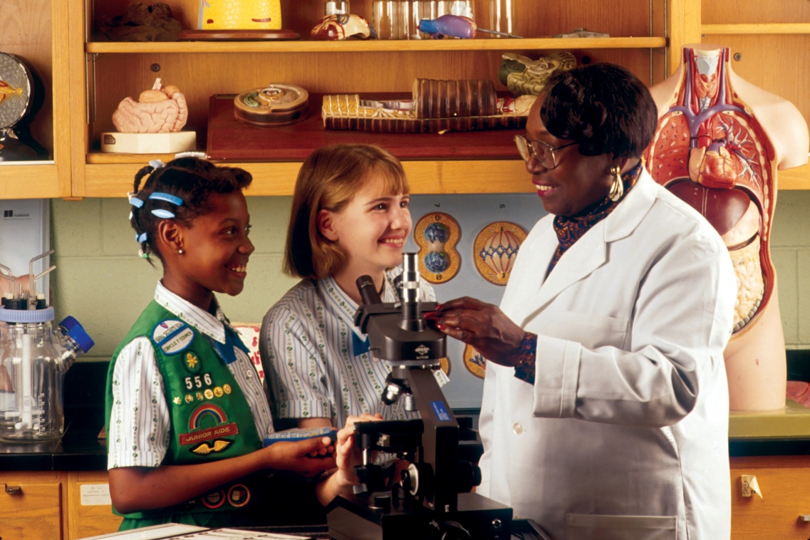
Women have made incredible contributions to the STEM community and have, as a result, advanced culture and improved modern ways of life. Unfortunately, women are underrepresented in these fields, especially technology and engineering. A number of organizations work to encourage girls to enter the sciences and to connect girls with mentorship and education in the sciences (see the “STEM Links” section for resources). To encourage girls’ interest in STEM, it’s important to engage them in hands-on activities that provide ties to real-world applications. Activities should allow girls to explore the vast array of career opportunities available to them. Before working with girls, make sure you fully understand the STEM activity and make note of any additional safety precautions provided in the activity directions.
Include girls with disabilities. Communicate with girls with disabilities and/or their caregivers to assess any needs and accommodations. Learn more about the resources and information that Foundation for Science and Disability provides to people with disabilities.
Prepare for the STEM Activity
- Communicate with council and parents. Inform your Girl Scout council and girls’ parents/guardians about the activity, including details about safety precautions and any appropriate clothing or supplies that may be necessary. Follow council procedures for activity approval, certificates of insurance, and council guidelines about girls’ general health examinations. Make arrangements in advance for all transportation and confirm plans before departure.
- Girls plan the activity. Keeping their grade-level abilities in mind, encourage girls to take proactive leadership roles in organizing details of the activity.
- Arrange for transportation and adult supervision. The recommended adult-to-girl ratios are two non-related adults (at least one of whom is female) to every:
- 12 Girl Scout Daisies
- 20 Girl Scout Brownies
- 25 Girl Scout Juniors
- 30 Girl Scout Cadettes
- 30 Girl Scout Seniors
- 30 Girl Scout Ambassadors
Plus one adult to each additional:
- 6 Girl Scout Daisies
- 8 Girl Scout Brownies
- 10 Girl Scout Juniors
- 12 Girl Scout Cadettes
- 15 Girl Scout Seniors
- 15 Girl Scout Ambassadors
- Prepare for informative learning experiences. Research STEM activity and encourage girls to take active roles in preparing educational and safety aspects. If using chemicals, prior to the activity, adults and instructors should be familiar with safety procedures and possible side effects of contact with the chemical as listed on the chemicals’ corresponding Material Safety Data Sheet.
- Select a safe location. Inspect the site to be sure it is free of potential hazards, and make sure emergency medical care is accessible. There are well-ventilated areas for the use of vaporous materials such as chemicals. Flammable materials are kept in fireproof containers and in an area away from ignition sources. Food or beverages are not consumed in an activity area. Hands are washed before eating.
- Ensure safety of equipment and materials. The work area is ample and appropriate for the science activity. When working with any chemical, plant, or animal, the following are observed:
- Hands do not touch the mouth or face during the activity.
- Facilities for washing hands and eyes are available at the site.
- Hands are washed thoroughly after the activity.
- Equipment is thoroughly cleaned.
- Used materials are disposed of properly.
- Chemical substances are used or mixed only when the adult in charge specifically knows the outcome.
- When chemicals are used, goggles stamped ANSI Z87 on the frame and lens must be worn. Even the simplest experiment can be an eye hazard.
- Ensure use of gloves when necessary. Non-latex gloves made of nitrile or neoprene are worn when working with chemicals and unknown plants and substances. Vinyl gloves generally do not provide appropriate protection. The American Chemical Society provides additional information about chemical safety.
- Compile key contacts. Give an itinerary to a contact person at home; call the contact person upon departure and return. Create a list of girls’ parents/guardian contact information, telephone numbers for emergency services and police, and council contacts—keep on hand or post in an easily accessible location.
- Dress appropriately for the activity. Make sure girls and adults avoid wearing dangling earrings, bracelets, and necklaces that may become entangled in equipment.
- Be prepared in the case of an emergency. Ensure the presence of a waterproof first-aid kit and a first-aider with a current certificate in First Aid, including Adult and Child CPR or CPR/AED, who is prepared to handle burns. Emergency procedures are clearly posted for swallowing a chemical, getting a chemical in the eyes, skin contact with a chemical, and so on. See Volunteer Essentials for information about first-aid standards and training.
On the Day of the STEM Activity
- Get a weather report. If the activity is outdoors, on the morning of the science activity, check weather.com or other reliable weather sources to determine if conditions are appropriate, and make sure that the ground is free of ice. If severe weather conditions prevent the activity, be prepared with a backup plan or alternate activity, or postpone the activity. Write, review, and practice evacuation and emergency plans for severe weather with girls. In the event of a storm, take shelter away from tall objects (including trees, buildings, and electrical poles). Find the lowest point in an open flat area. Squat low to the ground on the balls of the feet, and place hands on knees with head between them.
- Use the buddy system. Girls are divided into teams of two. Each girl chooses a buddy and is responsible for staying with her buddy at all times, warning her buddy of danger, giving her buddy immediate assistance if safe to do so, and seeking help when the situation warrants it. If someone in the group is injured, one person cares for the patient while two others seek help.
- Communicate with girls about STEM safety. Before beginning a STEM activity, talk with girls about safety and point out potential dangers and appropriate safety precautions to take.
- Take care with animals. Whenever animals or objects they use—such as food bowls, water dishes, toys—are handled, hands must be thoroughly washed with soap under running water. Iguanas, turtles, and other reptiles, as well as pet ducklings and chicks, can harbor salmonella bacteria, which can be passed on to humans. Contact with these animals should be avoided. Activities with animals are carried out with sensitivity and concern for the needs of the animals. Aquariums and terrariums are kept in areas where proper care, temperature regulation, and maintenance are always possible. Girls are aware of the proper care, feeding, and maintenance of animals and take responsibility for meeting these needs.
STEM Links
- FIRST (For Inspiration and Recognition of Science and Technology): www.usfirst.org
- NASA: www.nasa.gov
- National Girls Collaborative Project: www.pugetsoundcenter.org/ngcp
- Society of Women Engineers: http://aspire.swe.org
- Women in Science: www.womeninscience.org
STEM Know-How for Girls
- Learn about careers in the sciences. Aerospace engineer, meteorologist, cryptographer—these are just some of the jobs in science, technology, engineering, and technology. Learn more about more career options at Engineer Your Life and BrainCake.
- Pick cool STEM projects. What do you want to learn about in science, technology, engineering, and math? Visit Girl Scout partner site pbskids.org to watch shows such as Curious George, FETCH!, Design Squad, Cyberchase, and SciGirls.

