
Rowboating: Safety Activity Checkpoints
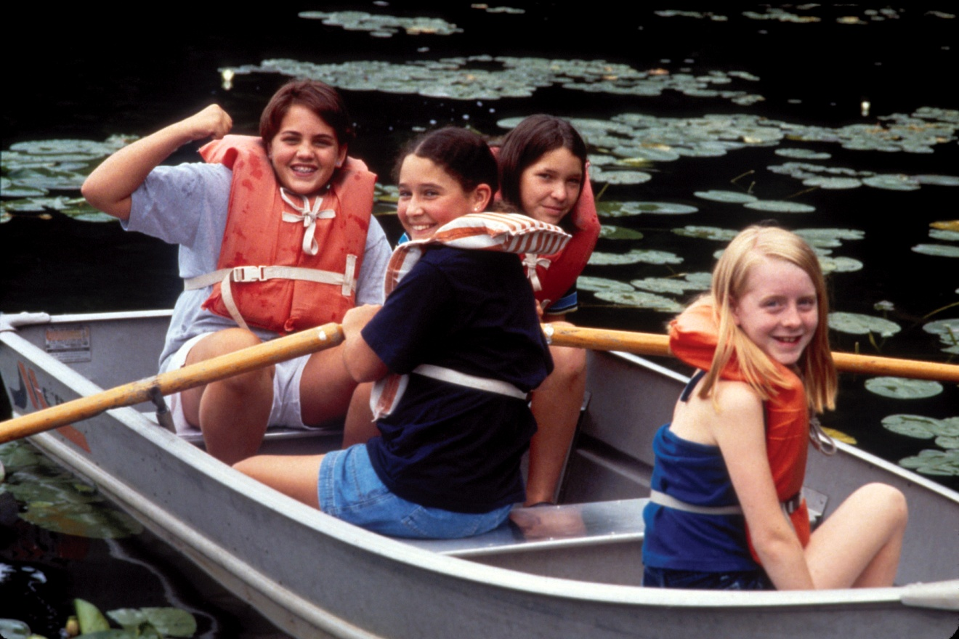
One of the most historic means of transportation, rowboating has evolved to become a leisurely activity and competitive sport. Ocean rowing, competitive rowing, and Venetian are just a handful of rowing styles; in racing rowboats, an eight-oared shell can hit speeds of up to 16 miles per hour.
An excellent form of relaxation and exercise as a group or individual activity, beginners should be careful of overexertion. If girls aren’t accustomed to using oars, they may experience strained arm muscles.
Know where to rowboat. Lakes, rivers, and ponds are most common for rowing, but the ocean can be suitable so long as waves are manageable. Connect with your Girl Scout council for site suggestions.
Include girls with disabilities. Communicate with girls with disabilities and/or their caregivers to assess any needs and accommodations. Learn more about the resources and information that Global Explorers and Wilderness Inquiry provide to people with disabilities.
Rowboating Gear
Basic Gear
- Layered clothing that’s easily changeable depending on temperatures (waterproof jacket recommended)
- Boat shoes, closed-toe and nonslip hiking/sport sandals with heel strap, or water socks or shoes (no flip-flops)
- Waterproof sunscreen (SPF of at least 15)
- Sunglasses or sunhat
- Emergency sound-producing device, such as a horn or whistle
- Flashlight
- Insect repellant
Specialized Gear
- Participants wear a U.S. Coast Guard–approved life jacket (Type III recommended) that fits according to weight and height specifications. Inspect life jackets to ensure that they are in good condition and contain no tears. Read about Coast Guard life jackets here.
- Emergency repair kit containing quick-repair items such as duct tape, rope, aluminum or fiberglass repair shields
- Oars
- Bow and stern lines to secure each end of the boat to the pier or dock
- Anchor that is appropriate for the water bottom (if necessary)
- Bailer (a bucket used to remove water from a boat)
- At least one graspable and throwable personal flotation device (Type IV buoyant cushion or ring buoy or equivalent) is immediately available for each group on the water.
Prepare for Rowboating
- Communicate with council and parents. Inform your Girl Scout council and girls’ parents/guardians about the activity, including details about safety precautions and any appropriate clothing or supplies that may be necessary. Follow council procedures for activity approval, certificates of insurance, and council guidelines about girls’ general health examinations. Make arrangements in advance for all transportation and confirm plans before departure.
- Girls plan the activity. Keeping their grade-level abilities in mind, encourage girls to take proactive leadership roles in organizing details of the activity.
- Ensure participants are able to swim. Participants’ swimming abilities are classified and clearly identified (for instance, with colored headbands to signify beginners, advanced swimmers, etc.) at council-approved sites, or participants provide proof of swimming-test certification. In the absence of swimming-test certification, a swim test is conducted on the day of the activity. Consult with your Girl Scout council for additional guidance.
- Arrange for transportation and adult supervision. The recommended adult-to-girl ratios are two non-related adults (at least one of whom is female) to every:
- 6 Girl Scout Daisies
- 12 Girl Scout Brownies
- 16 Girl Scout Juniors
- 20 Girl Scout Cadettes
- 24 Girl Scout Seniors
- 24 Girl Scout Ambassadors
Plus one adult to each additional:
- 4 Girl Scout Daisies
- 6 Girl Scout Brownies
- 8 Girl Scout Juniors
- 10 Girl Scout Cadettes
- 12 Girl Scout Seniors
- 12 Girl Scout Ambassadors
- Verify instructor knowledge and experience. Ensure that the adult or rowboating instructor holds an American Red Cross Small Craft Safety certification, or possesses equivalent certification or documented experience according to your council’s guidelines, as outlined in Volunteer Essentials.
- Compile key contacts. Give an itinerary to a contact person at home; call the contact person upon departure and return. Create a list of girls’ parents/guardian contact information, telephone numbers for emergency services and police, and council contacts—keep on hand or post in an easily accessible location.
- Select appropriate boats for water and passengers. Make sure craft weight and capacity are not exceeded (some crafts clearly display maximum capacity). Consider weather and water conditions, weight of passengers, and equipment.
- File a float plan. If participating in a long-distance rowboating trip, file a float plan with local authorities that includes names of people on board, destination, craft description, times of departure and return, and additional details about routes and marine communications. The Coast Guard provides an electronic, printable form.
- Prepare for emergencies. If a lifeguard is not on duty, an adult with rescue and resuscitation experience and/or certification is present; at least one adult present has small craft safety certification or equivalent experience. (Both of these qualifications can be held by one person.) Ensure the presence of a waterproof first-aid kit and a first-aider with a current certificate in First Aid, including Adult and Child CPR or CPR/AED, who is prepared to handle cases of near-drowning, immersion hypothermia, and sunburn. If any part of the activity is located 60 minutes or more from Emergency Medical Services response time, ensure the presence of a first-aider (level 2) with Wilderness and Remote First Aid. See Volunteer Essentials for information about first-aid standards and training.
On the Day of Rowboating
- Get a weather and wind report. Never rowboat on a stormy or extremely windy day. On the day of the rowboating trip or lesson, visit weather.com or other reliable sources to determine if conditions are appropriate. If weather conditions prevent the rowboat trip, be prepared with a backup plan or alternate activity.
- Use the buddy system. Girls are divided into teams of two. Each girl chooses a buddy and is responsible for staying with her buddy at all times, warning her buddy of danger, giving her buddy immediate assistance if safe to do so, and seeking help when the situation warrants it. If someone in the group is injured, one person cares for the patient while two others seek help.
- Be prepared in the event of a storm with lightning. Exit water immediately and take shelter away from tall objects (including trees, buildings, and electrical poles). Find the lowest point in an open flat area. Squat low to the ground on the balls of the feet, and place hands on knees with head between them. During storms, if shore cannot be reached, secure all loose gear, keep a sharp lookout for other boats and obstructions, head into the wind at a 45-degree angle, and stay low.
Rowboating Links
- Boatsafe.com (docking, undocking, anchoring basics, rescue methods, and so on): www.boatsafe.com
- U.S. Coast Guard’s Boating Safety Division: www.uscgboating.org
- U.S. Power Squadrons: www.usps.org
- U.S. Rowing Association: www.usrowing.org
Rowboating Know-How for Girls
- Know the currents. On rivers, row upstream to avoid any uncomfortable rapids or over falls.
- Keep weight evenly distributed. Never stand in a boat; the shift in weight can cause the boat to overturn. Never sit on the side of a rowboat; sit on the boat floor or seat. If places need to be changed while rowing, be sure the boat is stable enough. Try to keep weight low and centered in the boat as much as possible.
- Host a rowing event. In sculls, each rower uses two oars—one in each hand. In sweeps, each rower uses only one oar, extending out one side of the boat.
Rowboating Jargon
- Bow: The front of the boat
- Catching a crab: When a rower fails to push the oar back to its starting position properly after a stroke, the water catches the edge of the oar and yanks it down; the effect feels like a large crab has grabbed the oar
- Outrigger: A bracket extending outward from the side of a racing boat, to support an oarlock
- Stern: The back of the boat

