
Parades and Other Large Group Gatherings:
Safety Activity Checkpoints
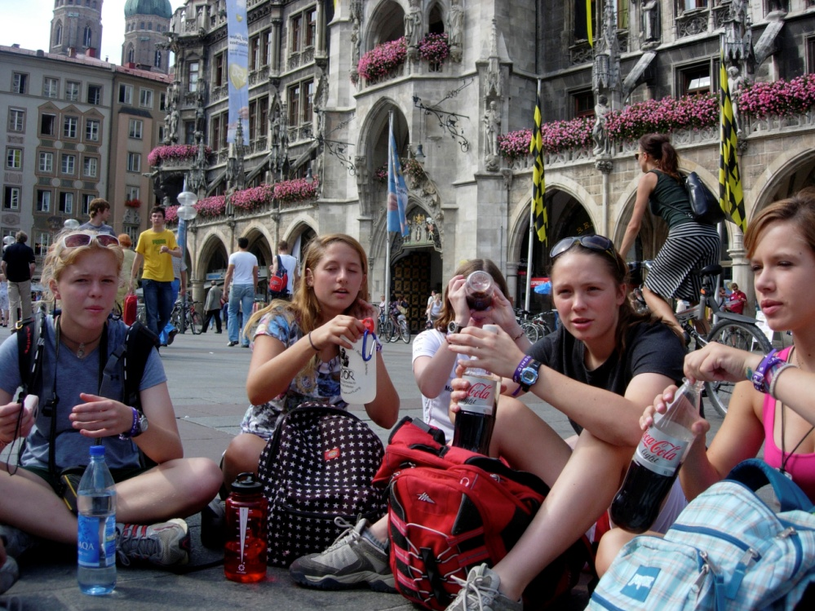
Whether you’re participating in a parade or planning a Girl Scout event, series, or other large group gathering, it’s important to represent Girl Scouts in the best possible way and encourage girls to plan the festivities.
Include girls with disabilities. Communicate with girls with disabilities and/or their caregivers to assess any needs and accommodations.
Gear for Parades and Other Large Group Gatherings
Basic Gear
- Girl Scout uniform, pin, or some other means of group identification
- Comfortable walking shoes
- Sunscreen (SPF of at least 15) and sunglasses on sunny or hazy days
Prepare for the Parade and Other Large Group Gathering
- Communicate with council and parents. Inform your Girl Scout council and girls’ parents/guardians about the activity, including details about safety precautions and any appropriate clothing or supplies that may be necessary. Follow council procedures for activity approval, certificates of insurance, and council guidelines about girls’ general health examinations. Make arrangements in advance for all transportation and confirm plans before departure.
- Girls plan the activity. Keeping their grade-level abilities in mind, encourage girls to take proactive leadership roles in organizing details of the activity.
- Arrange for transportation and adult supervision. The recommended adult-to-girl ratios are two non-related adults (at least one of whom is female) to every:
- 6 Girl Scout Daisies
- 12 Girl Scout Brownies
- 16 Girl Scout Juniors
- 20 Girl Scout Cadettes
- 24 Girl Scout Seniors
- 24 Girl Scout Ambassadors
Plus one adult to each additional:
- 4 Girl Scout Daisies
- 6 Girl Scout Brownies
- 8 Girl Scout Juniors
- 10 Girl Scout Cadettes
- 12 Girl Scout Seniors
- 12 Girl Scout Ambassadors
- Compile key contacts. Give an itinerary to a contact person at home; call the contact person upon departure and return. Create a list of girls’ parents/guardian contact information, telephone numbers for emergency services and police, and council contacts—keep on hand or post in an easily accessible location.
- Consider the appropriateness of the activity or event. When planning parades or large group gatherings, think about the needs, interests, and readiness of the girls; the sponsor; the needs of the community to be served; scheduling concerns; GSUSA and council guidelines on fund-raising, endorsements, collaborating with other organizations, and maintaining nonprofit status.
- Respect parade and large-group gathering standards. Local regulations and permit procedures are observed for public gatherings, facility use, food handling, certificates of insurance, and sales or excise tax. Guidelines for personal protection are observed. Local authorities are contacted for safety and security suggestions and assistance applicable to the parade or event. For safety reasons, name tags or other personal identification are not worn in public places. GSUSA and council guidelines on publicity, photo releases, and interviews are observed.
- Select a safe location. The location for any community event, large group gathering, or parade is inspected in advance, with consideration for the following, as they apply: Accessibility to the group and to the public; suitability to event size, age groups, and kinds of activities; parking availability; availability of restrooms; security arrangements; lighting for evening and indoor events; vulnerability to inclement weather; proximity to medical facilities; availability of police protection; fire safety. Also ensure that occupancy limits are not exceeded for indoor gatherings and events. Emergency exits are sufficient, well marked, and operational, and an emergency evacuation plan is in place. A food-preparation area used for large groups of people meets state and local standards. Sufficient portable water and restrooms are available to participants. Provisions are made for garbage removal and site cleanup.
- Make appropriate plans for parade floats. Floats drawn by trucks and automobiles are covered by automobile insurance in the name of the vehicle owners. Float construction is safe, using no toxic or highly flammable materials, and secured to the body of the float and the vehicle. Floats are equipped with portable ABC fire extinguishers. Riders on floats have secure seating, or a secure handhold or safety harness if standing. Floats are not overcrowded. Participants do not walk close to moving floats. An adult accompanies girls on any moving float. Any coupling of a trailer to a vehicle is appropriate to the load and has a safety chain. Nothing is distributed to onlookers from a moving vehicle or a float.
- Prepare for emergencies. Ensure the presence of a first-aid kit and a first-aider with a current certificate in First Aid, including Adult and Child CPR or CPR/AED. An emergency vehicle is available at large group gatherings. Location of the nearest telephone is known at all times, and the adult carries emergency-contact phone numbers. An evacuation plan is part of written and oral communication with participants for any large indoor or outdoor gathering. See Volunteer Essentials for information about first-aid standards and training.
On the Day of the Parade or Other Large Group Gathering
- Get a weather report. On the morning of the activity, check weather.com or other reliable weather sources to determine if conditions are appropriate, and make sure that the ground is free of ice. If severe weather conditions prevent the activity, be prepared with a backup plan or alternate activity, or postpone the activity. Write, review, and practice evacuation and emergency plans for severe weather with girls. In the event of a storm, take shelter away from tall objects (including trees, buildings, and electrical poles). Find the lowest point in an open flat area. Squat low to the ground on the balls of the feet, and place hands on knees with head between them.
- Use the buddy system. Girls are divided into teams of two. Each girl chooses a buddy and is responsible for staying with her buddy at all times, warning her buddy of danger, giving her buddy immediate assistance if safe to do so, and seeking help when the situation warrants it. If someone in the group is injured, one person cares for the patient while two others seek help.
- Take safety precautions. Instruction is given on safe pedestrian practices, when applicable. Adults know girls’ location at all times. Advance arrangements are made for picking up the girls after the event and parents and girls understand the arrangements. Adults and girls pick a place to meet in case of separation from the supervising adult or the group.
Parades and Other Large Group Gatherings Link
- National Safety Council: www.nsc.org

