
Outdoor Cooking: Safety Activity Checkpoints
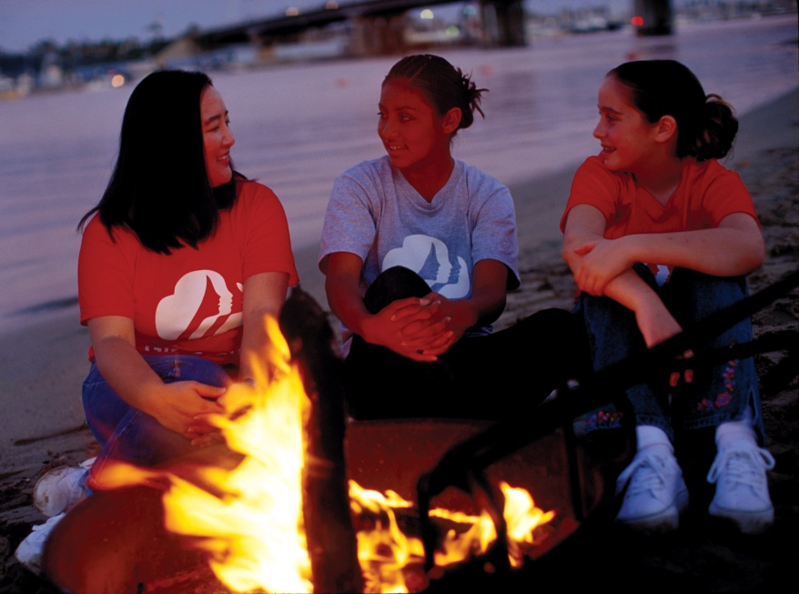
Historically, wood fires were the primary source of heat for camp cooking, but the practice of cooking with large fires is no longer recommended, because of the detrimental effects on camping areas. Instead, use an established fire pit to ignite a small fire, or use alternative cooking methods such as a portable cook stove (electric or fuel-based). When cooking outdoors, it’s important to pack the appropriate amount of food for the group, so as to avoid discarding unused food. To properly plan food supplies, consider the activities you’ll be participating in, keeping in mind that girls will burn more calories and hence need to eat more when participating in rigorous activities. Also, more calories are needed during cold weather. Extensive outdoor cooking is not recommended for Girl Scout Daisies, but a less extensive activity, such as roasting marshmallows, is appropriate.
Know where to cook outdoors. Preferably at campsites with designated fire-pit areas. Connect with your Girl Scout council for site suggestions.
Include girls with disabilities. Communicate with girls with disabilities and/or their caregivers to assess any needs and accommodations. Learn more about the resources and information that Global Explorers and Wilderness Inquiry provide to people with disabilities.
Outdoor Cooking Gear
Basic Gear
- Pots and pans
- Portable water for drinking, cooking, and cleaning
- Biodegradable dishwashing soap
- Pot scrubber
- Hand sanitizer or soap and paper towels
- Mess kit with nonbreakable plates, bowls, mugs, and cutlery in dunk bag
- Knives
- Containers to store leftover food
- Can opener
- No plastic garments, such as ponchos, are worn around open flame
- Rubber band, barrette, or bandana to tie back hair
Specialized Gear
- Firefighting equipment, including fire extinguisher, water, loose soil or sand, and a shovel and rake
- Portable cook stove and fuel
- Long-handled cooking utensils such as ladles
- Pot holders and/or insulated gloves
- Insulated cooler and ice for food storage
- Water purification method (tablets or filter), if needed
Prepare for Outdoor Cooking
- Communicate with council and parents. Inform your Girl Scout council and girls’ parents/guardians about the activity, including details about safety precautions and any appropriate clothing or supplies that may be necessary. Follow council procedures for activity approval, certificates of insurance, and council guidelines about girls’ general health examinations. Make arrangements in advance for all transportation and confirm plans before departure.
- Girls plan the activity. Keeping their grade-level abilities in mind, encourage girls to take proactive leadership roles in organizing details of the activity.
- Arrange for transportation and adult supervision. The adult supervising the outdoor cooking has taken council learning opportunities. The recommended adult-to-girl ratios are two non-related adults (at least one of whom is female) to every:
- 6 Girl Scout Daisies (non-extensive cooking activities only)
- 12 Girl Scout Brownies
- 16 Girl Scout Juniors
- 20 Girl Scout Cadettes
- 24 Girl Scout Seniors
- 24 Girl Scout Ambassadors
Plus one adult to each additional:
- 4 Girl Scout Daisies (non-extensive cooking activities only)
- 6 Girl Scout Brownies
- 8 Girl Scout Juniors
- 10 Girl Scout Cadettes
- 12 Girl Scout Seniors
- 12 Girl Scout Ambassadors
- Compile key contacts. Give an itinerary to a contact person at home; call the contact person upon departure and return. Create a list of girls’ parents/guardian contact information, telephone numbers for emergency services and police, and council contacts—keep on hand or post in an easily accessible location.
- Consult with council about permits where necessary, and prepare for fire safety. Connect with your Girl Scout council to inquire about permits with the local fire district, land-management agency, or conservation office. Fires are not permitted when there is excessive dryness or wind. The adult volunteer also checks the fire index with local authorities. Local air-pollution regulations are followed.
- Girls share resources. Support girls in creating a checklist of group and personal equipment and distribute to group members. Girls learn to use a variety of cooking methods, including use of wood fire, propane, butane, and gas stoves, charcoal, canned heat, and solar energy. Repackage all food to minimize waste and the amount of garbage that needs to be removed from the campsite.
- Be prepared for primitive campsites. If cooking in primitive areas with little to no modern conveniences, observe these standards:
- Choose and set up campsite well before dark.
- Use a previously established campsite if available.
- Make sure the campsite is level and located at least 200 feet from all water sources and below tree line.
- Avoid fragile mountain meadows and areas of wet soil.
- Avoid camping under dead tree limbs.
- Use existing fire rings if a fire is necessary.
- If a latrine is not available, use individual cat holes—holes for human waste that are at least 200 feet away from the trail and known water sources—to dispose of human waste (visit www.lnt.org for more information).
- Do dishwashing and personal bathing at least 200 feet away from water sources.
- Store food well away from tents and out of reach of animals. Where necessary, hang food at least 10 feet high from a rope stretched between two trees. If the site is in bear country, check with local authorities on precautions to take.
- See that garbage, tampons, sanitary supplies, and toilet paper are carried out.
- Take safety precautions. Fire-safety rules, emergency procedures, and first aid for burns are reviewed with the group and understood. Procedures are established and known in advance for notifying the fire department or land-management agency officials in case of a fire. Fire drills are practiced at each site.
- Prepare for emergencies. Ensure the presence of a waterproof first-aid kit and a first-aider with a current certificate in First Aid, including Adult and Child CPR or CPR/AED, who is prepared to handle burns and other injuries related to the location, including extremes of temperature, such as heat exhaustion, heat stroke, frostbite, cold exposure, hypothermia, as well as sprains, fractures, and sunburn. If any part of the activity is located 60 minutes or more from emergency medical services, ensure the presence of a first-aider (level 2) with Wilderness and Remote First Aid. If feasible, a vehicle is available to transport an injured or sick person. See Volunteer Essentials for information about first-aid standards and training.
On the Day of Outdoor Cooking
- Get a weather report. On the morning of the outdoor cooking activity, check weather.com or other reliable weather sources to determine if conditions are appropriate. If severe weather conditions prevent the cooking activity, be prepared with a backup plan or alternate activity. Write, review, and practice evacuation and emergency plans for severe weather with girls.
- Use the buddy system. Girls are divided into teams of two. Each girl chooses a buddy and is responsible for staying with her buddy at all times, warning her buddy of danger, giving her buddy immediate assistance if safe to do so, and seeking help when the situation warrants it. If someone in the group is injured, one person cares for the patient while two others seek help.
- Respect the environment and keep site clean. Use the principles of minimal-impact camping. Store garbage in insect- and animal-proof containers with plastic inner linings, and cover it securely when there is a campsite garbage-pickup service. When there is no garbage-pickup service, remove garbage from campsite in plastic bags and discard, as appropriate. Recycle whenever possible. Do not bury food; carry out grease and fuel canisters. Do not remove natural materials, such as leaves or branches.
Tips for Cooking with Cook Stoves and Open Fires
- Prepare for safe usage of portable cook stoves. Portable cook stoves differ in size and in fuel use. Follow the manufacturer’s instructions carefully, and closely supervise the girls when using any stove. Take an adequate amount of fuel, and store the extra fuel supply away from the cooking flame. Never use portable cook stoves inside a tent. Keep all stove parts clean. Check that lines and burners are not clogged. Do not refuel the cook stove or change canisters near an open flame. Take care not to spill fuel; if fuel does spill, relocate the stove before lighting it. Place portable cook stoves in safe, level, and stable positions, shielded from the wind and away from foot traffic. Do not pile rocks or other items around the cook stove for stability. Do not overheat the fuel tank. Use pots of appropriate size, so that the stove is not top-heavy. Do not dispose of pressurized cans in a fire, leave them in direct sunlight, or keep them in enclosed areas where the temperature is high. See the manufacturer’s instructions on the label. Store and dispose of fuel canisters in the recommended manner. Be sure to check with local authorities to make sure cook stoves are permitted during times of extreme fire danger.
- Cook safely with solar stoves. If using solar cookware, remember that pots and food inside a solar oven are hot even if the stove does not feel hot. Use insulated gloves when removing pots and opening the lid.
- Practice safe cooking with open fire. If cooking over open flames, build fires in designated areas, and avoid establishing new fire sites. An established fire site is clear of overhanging branches, steep slopes, rotted stumps or logs, dry grass and leaves, and cleared of any burnable material, such as litter, duff, or pine needles. Where wood gathering is permitted, use only dead, fallen wood, and keep the cooking fires small. Store wood away from the fire area. Watch for flying sparks and put them out immediately. Before leaving the site, check that the fire is completely out by sprinkling the fire with water or smothering it with earth or sand, stirring, and then sprinkling or smothering again; finally, hold hands on coals, ashes, partially burned wood, or charcoal for one minute to ensure it is cool to the touch. Make a plan for disposing of cold ashes and partially burned wood. You may scatter ashes and burned wood throughout the woods away from the campsite. Do not put ashes and burned wood in a plastic pail; do not leave a pail with ashes or burned wood against the side of a building or on a wood deck. Obtain wood from local sources to avoid bringing pests and diseases from one location to another.
- Practice safe cooking with charcoal fires. If using charcoal, fires are started with fuels explicitly labeled as “charcoal starters”—never use gasoline as a fire starter. Never add charcoal lighter fluid to a fire once it has started.
Tips for Food Preparation and Storage
- Prepare nutritious meals. Meals are prepared with consideration of food allergies, religious beliefs, and dietary restrictions (such as vegetarianism and veganism) of group members. Whenever possible, buy food and supplies that avoid excess packaging, and buy in bulk. Review health considerations, including the importance of keeping utensils and food preparation surfaces sanitized, cleaning hands, cooking meats thoroughly, refrigerating perishables, and using clean water when preparing food. Do not use chipped or cracked cups and plates.
- Cook with caution. Girls learn about the safe use of kitchen tools and equipment, including knives. Maintain discipline in the cooking area to prevent accidents with hot food and sharp utensils. Do not overfill cooking pots, and do not use pressurized cans, soda-can stoves, or plastic basins, bottles, and cooking utensils near an open flame.
- Avoid spreading germs. Each person has an individual drinking cup. Cooks roll up long sleeves and tie back long hair. Wash hands before food preparation and eating. No person with a skin infection, a cold, or a communicable disease participates in food preparation.
- Keep perishables cool. Store perishables such as creamed dishes, dairy products, meats, and salads at or below 40 degrees Fahrenheit in a refrigerator or insulated cooler with ice. If this will not be possible, use powdered, dehydrated, freeze-dried, or canned foods. On extended trips, do not use foods requiring refrigeration. Use safe drinking water (see the “Water Purification Tips”) to reconstitute powdered, dehydrated, or freeze-dried food. Once reconstituted, eat perishable items within one hour or refrigerate them.
Water Purification Tips
- Access a safe drinking water supply for cooking, drinking, and personal use. Safe drinking water is defined as tap water tested and approved by the local health department. All other sources are considered potentially contaminated and must be purified before use. Giardia lamblia (a parasite) is suspected in all surface water supplies.
- Use one of the three water-purification methods. First, strain water through a clean cloth into a clean container to remove sediment, and then choose one of the following methods:
- Boil water rapidly for a full minute and let cool.
- Disinfect water with water-purification tablets, following the manufacturer’s instructions. Check the product’s shelf life to make sure it has not expired.
- Pour water through a water purifier or specially designed water-filtration device that removes Giardia. These filters will also remove many other contaminants. Follow the manufacturer’s instructions carefully.
- Important note: These methods will not remove chemical pollutants. In addition, only boiling the water or pouring it through a specially designed filter will remove Giardia lamblia.
Dishwashing Tips
- Wash dishes in a prescribed area according to this procedure:
- Remove food particles from utensils and dishes.
- Wash dishes in warm, soapy water.
- Rinse dishes in hot, clear water.
- Sanitize dishes by dipping in clear, boiling water or immersing for at least two minutes in a sanitizing solution approved by the local health department. Use long-handled utensil, tongs, or tool to remove sanitized dishes.
- Air-dry and store dishes in a clean, covered area.
- Dispose of dishwashing and rinse water according to the campsite regulations. In backcountry areas, scatter wastewater on the ground at least 200 feet beyond any water source or trail.
Outdoor Cooking Links
- OutdoorCook.com: www.outdoorcook.com
- Leave No Trace: www.lnt.org
Outdoor Cooking Know-How for Girls
- Learn how to start a fire without matches. What are the ways that you can get a fire going without using matches or a lighter? Read camping how-to books or online sources to learn how.
- Plan outdoor recipes. Vote for your favorite meals and plan how to cook them outdoors. For additional outdoor recipe ideas, read Discover the Outdoors, netwoods.com, and outdoorcook.com.
Outdoor Cooking Jargon
- Dunk kit: A mesh bag used to hold dirty dishes; the bag is dunked into hot water or chlorine solution and then hung to dry with clean, sterilized dishes inside
- Dutch oven: A cooking kettle used for baking in an open fire (do not use soap on cast iron)

