
Other Land Sports: Safety Activity Checkpoints
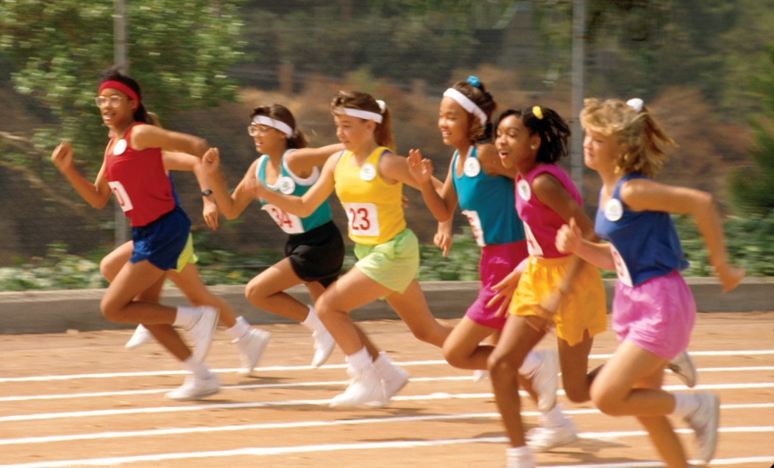
Other land sports include team sports such as soccer, softball, and basketball, as well as individual activities such as dance, gymnastics, and track and field. In planning activities, ensure that girls aren’t pushed beyond their capabilities. As is the case for all Girl Scout activities, a girl’s participation depends on her readiness, level of maturity, physical conditioning, and level of training.
Caution: Girls are not allowed to use firearms unless 12 years and older and with council permission; girls are never allowed to hunt. Without council permission, girls are also not allowed to fly as passengers in noncommercial aircraft, such as small private planes, helicopters, sailplanes, untethered hot air balloons, and blimps; girls are never allowed in potentially uncontrolled free falls, such as bungee jumping, hang gliding, parachuting, parasailing, and trampolining. Girls are also never allowed to ride all-terrain vehicles or motor bikes.
Include girls with disabilities. Communicate with girls with disabilities and/or their caregivers to assess any needs and accommodations. Learn more about the resources and information that the National Center on Accessibility and Challenged Athletes Foundation provide to people with disabilities.
Gear for Other Land Sports
Basic Gear
- Appropriate clothing, supplies, tools, and other equipment, depending on location and specific activity
- Ample drinking water
- Daypack to carry personal belongings, as appropriate
Specialized Gear
- Girls who wear eyeglasses have shatterproof lenses or wear eyeglass guards. A band should be worn to hold eyeglasses securely.
Prepare for Other Land Sports
- Communicate with council and parents. Inform your Girl Scout council and girls’ parents/guardians about the activity, including details about safety precautions and any appropriate clothing or supplies that may be necessary. Follow council procedures for activity approval, certificates of insurance, and council guidelines about girls’ general health examinations. Make arrangements in advance for all transportation and confirm plans before departure.
- Girls plan the activity. Keeping their grade-level abilities in mind, encourage girls to take proactive leadership roles in organizing details of the activity.
- Arrange for transportation and adult supervision. The recommended adult-to-girl ratios are two non-related adults (at least one of whom is female) to every:
- 6 Girl Scout Daisies
- 12 Girl Scout Brownies
- 16 Girl Scout Juniors
- 20 Girl Scout Cadettes
- 24 Girl Scout Seniors
- 24 Girl Scout Ambassadors
Plus one adult to each additional:
- 4 Girl Scout Daisies
- 6 Girl Scout Brownies
- 8 Girl Scout Juniors
- 10 Girl Scout Cadettes
- 12 Girl Scout Seniors
- 12 Girl Scout Ambassadors
- Verify instructor knowledge and experience. In cases where instruction is necessary, ensure that instructors have adequate experience and knowledge of the activity and have documented experience according to your council’s guidelines, as outlined in Volunteer Essentials. Where necessary, trained officials or referees administer rules of the sport, and girls are instructed in the rules of the sport, safety guidelines, expected behaviors, and issues of fair play. Trained spotters and/or instructors’ assistants are used for individual sports such as gymnastics.
- Select a safe site. Playing surfaces for the activity are smooth and clear of obstructions, broken glass, and so on. Playing areas have clearly marked boundaries and adequate space for girls to move around freely. Where necessary, there is adequate protection for spectators.
- Compile key contacts. Give an itinerary to a contact person at home; call the contact person upon departure and return. Create a list of girls’ parents/guardian contact information, telephone numbers for emergency services and police, and council contacts to keep on hand or post in an easily accessible location.
- Girls prepare for and practice the activity. Girls do conditioning exercises and practice basic skills. Girls do a gentle warm-up, cool-down, and stretching exercises to reduce sprains, strains, and other injuries. In competition, girls are matched in age, weight, height, skill, and physical maturity. In team sports, positions and sides are rotated to prevent domination of the game and to allow for full, fun participation. Practice sessions and games are properly supervised and of reasonable length. Practice or competition occurs only when an instructor and/or supervisor is present at the site of play.
- Prepare for emergencies. Ensure the presence of a first-aid kit and a first-aider with a current certificate in First Aid, including Adult and Child CPR or CPR/AED, who is prepared to handle cases of abrasions, sprains, and fractures. Emergency transportation is available; if any part of the activity is located 60 minutes or more from emergency medical services, ensure the presence of a first-aider (level 2) with Wilderness and Remote First Aid. See Volunteer Essentials for information about first-aid standards and training.
On the Day of Other Land Sports
- Get a weather report. If participating in an outdoor activity, check weather.com or other reliable weather source to determine if conditions are appropriate. Be prepared to alter the activity plan or have an alternate activity prepared if weather conditions change. Write, review, and practice evacuation and emergency plans for severe weather with girls. If outdoors, in the event of a storm, take shelter away from tall objects (including trees, buildings, and electrical poles). Find the lowest point in an open flat area. Squat low to the ground on the balls of the feet, and place hands on knees with head between them. Outdoor activities are suspended during an electrical storm or in very hot, humid weather.
- Use the buddy system. Girls are divided into teams of two. Each girl chooses a buddy and is responsible for staying with her buddy at all times, warning her buddy of danger, giving her buddy immediate assistance if safe to do so, and seeking help when the situation warrants it. If someone in the group is injured, one person cares for the patient while two others seek help.
- Safeguard valuables. Secure equipment in a dry, locked storage area or have girls wear a daypack to carry personal belongings.
- Ensure that equipment is well-maintained. There are sufficient floor mats for gymnastics, tumbling, and similar activities. Inspect rented or borrowed equipment carefully before using it.
- Dress appropriately for the activity and take breaks. Sharp objects, jewelry, and watches are removed and pockets emptied. Long hair is pulled back from the face and fastened to prevent tangling. Sufficient rest periods are given to avoid overexertion and to replenish fluids.
- Take safety precautions. Fatigued or injured girls are removed from competition and cared for promptly. A seriously injured girl is moved only by trained rescue personnel. An injured girl is not returned to practice or competition without the written approval of a physician.
Other Land Sports Links
- American Alliance for Health, Physical Education, Recreation, and Dance: www.aahperd.org
- National Association for Girls and Women in Sport: www.aahperd.org/nagws

