
Orienteering: Safety Activity Checkpoints
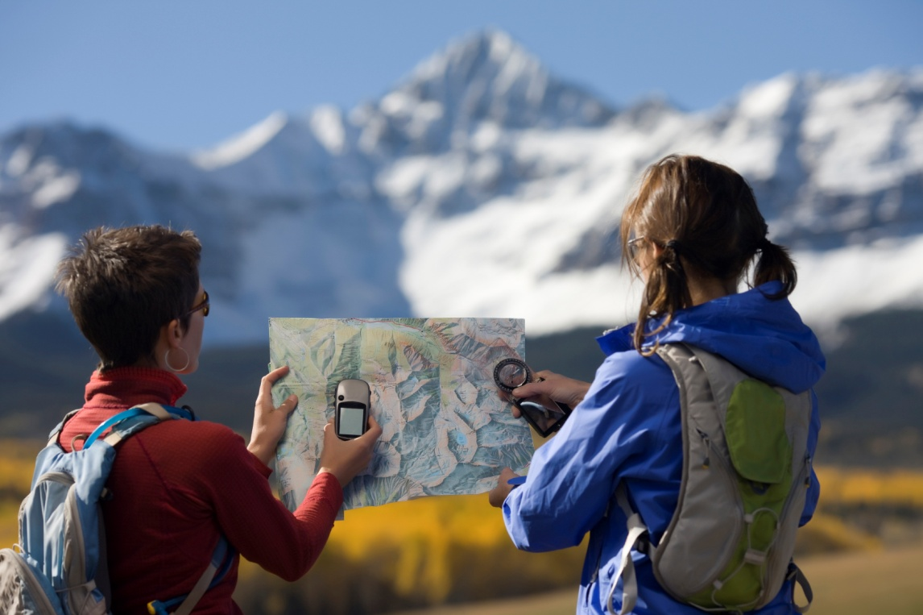
Orienteering is an activity that involves using a map, compass, and navigational skills to find your way around or across an unfamiliar area, and may also incorporate camping, backpacking, hiking, cross-country skiing, or horseback-riding skills. Orienteering often takes place in the wilderness, although events can take place in just about any terrain such as a beach, urban area, or park. Orienteers often use control markers to flag various land features found on the map, serving as checkpoints along a course.
Orienteering is not recommended for Girl Scout Daisies and Brownies, but they may enjoy pre-orienteering activities such as “introduction to maps” and map-drawing.
Caution: Girls are not allowed to use firearms unless 12 years and older and with council permission; girls are never allowed to hunt or go on high-altitude climbs. Girls are also never allowed to ride all-terrain vehicles or motor bikes.
Know where to go orienteering. Connect with your Girl Scout council for site suggestions. Also, locate orienteering clubs in the U.S. and Canada at us.orienteering.org.
Include girls with disabilities. Communicate with girls with disabilities and/or their caregivers to assess any needs and accommodations. Learn more about the resources and information that organizations such as Global Explorers provide.
Orienteering Gear
Basic Gear
- Long pants
- Hiking boots or sneakers
- Sunscreen with SPF of at least 15 on sunny days
- Insect repellent
- Sunglasses and/or hat
- Daypack to carry personal belongings
Specialized Orienteering Gear
- Orienteering map
- Compass
- Emergency signaling whistle
- Watch
Prepare for Orienteering
- Coordinate age-appropriate activity. Girl Scout Juniors in small groups are accompanied on a course by an adult with basic instruction in orienteering. Girl Scouts Cadettes, Seniors, and Ambassadors who have received training may orienteer in groups of at least two. Competitive Orienteering Courses often require participants to operate independently; solo competition is not recommended for inexperienced girls or Girl Scout Juniors. However, Girl Scout Cadettes, Seniors, and Ambassadors whose skills match or exceed the demands of the course may participate in such competitions. As with all orienteering sites, there should be a clear area of safety (a safety lane), a specific finish time and location, and a search-and-rescue procedure designed by the competition’s host and the Girl Scout adult volunteer.
- Communicate with council and parents. Inform your Girl Scout council and girls’ parents/guardians about the activity, including details about safety precautions and any appropriate clothing or supplies that may be necessary. Follow council procedures for activity approval, certificates of insurance, and council guidelines about girls’ general health examinations. Make arrangements in advance for all transportation and confirm plans before departure.
- Girls plan the activity. Keeping their grade-level abilities in mind, encourage girls to take proactive leadership roles in organizing details of the activity.
- Arrange for transportation and adult supervision. The recommended adult-to-girl ratios are two non-related adults (at least one of whom is female) to every:
- 6 Girl Scout Daisies (pre-orienteering activities only)
- 12 Girl Scout Brownies (pre-orienteering activities only)
- 16 Girl Scout Juniors
- 20 Girl Scout Cadettes
- 24 Girl Scout Seniors
- 24 Girl Scout Ambassadors
Plus one adult to each additional:
- 4 Girl Scout Daisies (pre-orienteering activities only)
- 8 Girl Scout Juniors
- 10 Girl Scout Cadettes
- 12 Girl Scout Seniors
- 12 Girl Scout Ambassadors
- Verify instructor knowledge and experience. Participants receive instruction from a person experienced in orienteering before navigating an orienteering course. First-timers participate on a beginner-level course. Girls with previous topographic map-reading experience may be eligible to attempt an advanced beginners’ course.
- Compile key contacts. Give an itinerary to a contact person at home; call the contact person upon departure and return. Create a list of girls’ parents/guardian contact information, telephone numbers for emergency services and police, and council contacts—keep on hand or post in an easily accessible location. Before the activity starts, make a list of all participants’ cell-phone numbers, and give every orienteer a copy of the list.
- Select a safe orienteering site. Whenever possible, girls take part in a meet organized by an orienteering club. When other areas are used, check for the following: the site selected is a park, camp, or other area with a good trail network; proper landowner permission is secured to use the site; during hunting season, the orienteering site is in a “no hunting” area with sufficient separation from hunting activity to ensure no accidental contact between hunters and orienteers; out-of-bounds and dangerous areas are marked on the map; hazardous obstacles are marked on the ground—they are surrounded by surveyor’s tape or a similar marking; the orienteering map is sufficiently accurate so that the participants are not navigationally misled.
- Prepare for emergencies. Ensure the presence of a waterproof first-aid kit and a first-aider with a current certificate in First Aid, including Adult and Child CPR or CPR/AED; if any part of the activity is located 60 minutes or more from emergency medical services, ensure the presence of a first-aider (level 2) with Wilderness and Remote First Aid. See Volunteer Essentials for information about first-aid standards and training.
On the Day of Orienteering
- Get a weather report. On the morning of the activity, check weather.com or other reliable weather sources to determine if weather conditions are appropriate, and make sure that the ground is free of ice. If severe weather conditions prevent the activity, be prepared with a backup plan, alternative activity, or postpone the activity. Write, review, and practice evacuation and emergency plans for severe weather with girls. In the event of a storm with lightning, take shelter away from tall objects (including trees, buildings, and electrical poles). Find the lowest point in an open flat area. Squat low to the ground on the balls of the feet, and place hands on knees with heads between them.
- Use the buddy system. Divide girls into teams of two. Each person is responsible for staying with her buddy at all times, warning her buddy of danger, giving her buddy immediate assistance if safe to do so, and seeking help when the situation warrants it. If someone in the group is injured, one person cares for the patient while two others seek help.
- Follow basic orienteering safety standards. Each participant is given a specific time limit to complete the course and must check in at the finish area whether or not she completed the course. Beginning and finishing course times of each participant are carefully noted to ensure that all participants have returned. Girls take proper precautions in areas where poisonous plants or snakes or ticks are prevalent.
Orienteering Link
- U.S. Orienteering Federation: www.us.orienteering.org
Orienteering Know-how for Girls
- Map your course. Get to know map symbols and how elements such as elevation and relief are communicated on maps at 4orienteering.com.
- Learn about orienteering techniques. Before participating in orienteering, get to know strategies such as pacing, thumbing, and handrails at 4orienteering.com.
Orienteering Jargon
- Control: A point on an orienteering course that participants have to visit, and is marked on a map with a circle; controls are typically flagged with a marker or flag
- Elephant track: A path created by trampling of orienteers using the same route

