
Kayaking: Safety Activity Checkpoints
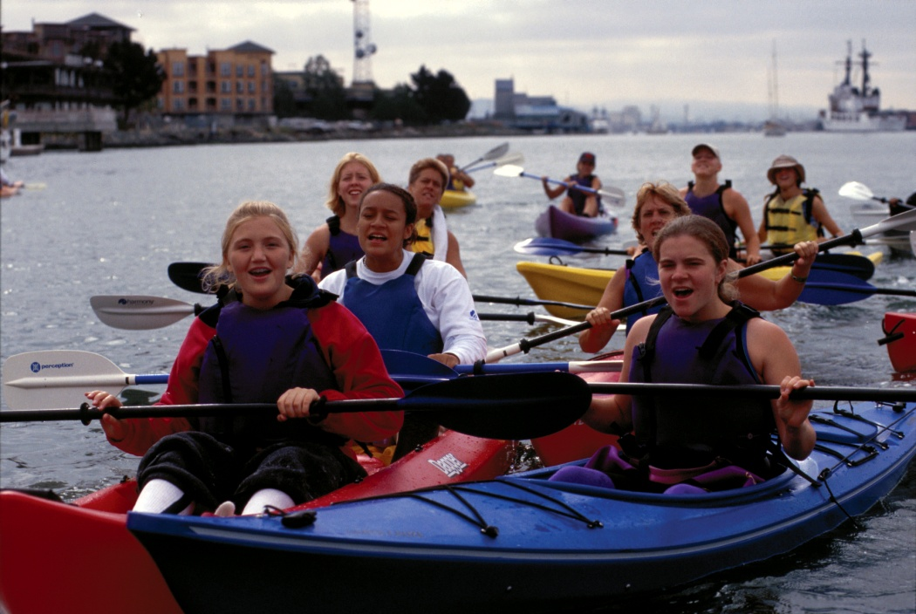
Kayaks come in a variety of styles and sizes, and like canoes are almond-shaped and powered by paddling. Kayaks tend to be smaller than canoes, sometimes covered by a deck and spray skirt, and seat one or two kayakers, who sit with legs extended in front of them. Kayakers almost always use a two-bladed paddle. Beginners should be careful of overexertion. If girls aren’t accustomed to using oars, they may experience strained arm muscles. Kayaking is not recommended for Girl Scout Daisies; Class III and Class IV whitewater is not recommended for Brownies; Class IV whitewater is not recommended for Juniors.
Caution: You must seek council permission for activities with uncontrollable and highly changeable environment conditions, such as unclassified rivers and some watercraft trips; girls are never allowed on Class V and above whitewater.
Know where to go kayaking. Just about any body of water (lake, stream, river, ocean) is suitable for kayaking, so long as the proper equipment, instructions, and safety precautions are used. Kayaking is done only on water that has been approved by your Girl Scout council or that has been run and rated, and on whitewater only up to Class IV difficulty, as defined by the American Version of the International Scale of River Difficulty. The American Whitewater Association provides information about American and some international river locations, classes, and levels. Connect with your Girl Scout council for site suggestions.
Include girls with disabilities. Communicate with girls with disabilities and/or their caregivers to assess any needs and accommodations. Learn more about the paddleability resources and information that the International Canoe Federation and British Canoe Union provide to people with disabilities.
Kayaking Gear
Basic Gear
- Layered clothing that’s easily changeable depending on temperatures (waterproof jacket and pants recommended)
- Change of dry clothing (no cotton; store in waterproof bag secured to kayak)
- Boat shoes, closed-toe hiking/sport sandals with heel strap, water socks or shoes, or other nonslip footwear (no flip-flops)
- Waterproof sunscreen (SPF of at least 15)
- Sunglasses
- Flashlight (and extra batteries)
- Emergency repair kit: duct tape or electrical tape, screwdriver, pliers
- Emergency survival packet: raincoat, waterproof matches, food, lightweight/space blanket, hat, raincoat, pocket knife
- Compass and chart of the area (for each adult)
Specialized Gear
- Participants wear a U.S. Coast Guard–approved life jacket (Type III recommended) that fits according to weight and height specifications. Inspect life jackets to ensure that they are in good condition and contain no tears. Read about Coast Guard life jackets here.
- Wetsuit or drysuit recommended when water is colder than 70 degrees Fahrenheit (should be worn when the combined air and water temperature is less than 100 degrees Fahrenheit or when the combination of cool air, wind chill, and evaporative cooling may lead to hypothermia)
- Safety helmet (with flexible, strong, plastic shell with a chin strap and openings for drainage) when kayaking in waters that are Class II and higher
- Throw bag
- At least one graspable and throwable personal flotation device (Type IV buoyant cushion or ring buoy or equivalent) is immediately available for each group on the water
- Paddles (select the appropriate size and style for the activity and person using them); have extras on hand
- Bailer (a bucket used to remove water from a boat) or sponge
- Each kayak is sized for the person using it and has an adjustable bracing system for the feet and bow and stern grab loops. Each kayak is outfitted with proper flotation. If used, air bags are checked before trips to ensure that the seals are intact.
- Spray skirt with release loop (provides a water-resistant seal around the waist; optional)
- For river rescue, each instructor attaches a locking-blade knife, two carabiners (rectangular metal rings with spring-hinged openings), and two Prusik loops to life jacket or secures them to the kayak in an easily accessible place. (A prusik loop is a mountaineering knot with loops, used with a carbiner for quick tie-offs and z-drag rescues, to recover a kayak pinned against a rock or other obstacle.)
- A 50-foot length of tow line (lightweight nylon, polypropylene, or 50- to 100-pound monofilament fishing line) is carried for every three to four kayaks.
- Each adult carries a spare paddle, a first-aid kit, a repair kit, and standard safety equipment, including signaling equipment and a paddle float—a solid block of foam or inflatable nylon attached to a paddle that may be used as an outrigger for self-rescue.
Prepare for Kayaking
- Communicate with council and parents. Inform your Girl Scout council and girls’ parents/guardians about the activity, including details about safety precautions and any appropriate clothing or supplies that may be necessary. Follow council procedures for activity approval, certificates of insurance, and council guidelines about girls’ general health examinations. Make arrangements in advance for all transportation and confirm plans before departure.
- Girls plan the activity. Keeping their grade-level abilities in mind, encourage girls to take proactive leadership roles in organizing details of the activity.
- Ensure participants are able to swim. Participants’ swimming abilities are classified and clearly identified (for instance, with colored headbands to signify beginners, advanced swimmers, etc.) at council-approved sites, or participants provide proof of swimming-test certification. In the absence of swimming-test certification, a swim test is conducted on the day of the activity. Consult with your Girl Scout council for additional guidance.
- Arrange for transportation and adult supervision. The recommended adult-to-girl ratios are two non-related adults (at least one of whom is female) to every:
- 12 Girl Scout Brownies
- 16 Girl Scout Juniors
- 20 Girl Scout Cadettes
- 24 Girl Scout Seniors
- 24 Girl Scout Ambassadors
Plus one adult to each additional:
- 6 Girl Scout Brownies
- 8 Girl Scout Juniors
- 10 Girl Scout Cadettes
- 12 Girl Scout Seniors
- 12 Girl Scout Ambassadors
- Verify instructor knowledge and experience. Ensure that the skill level of the adults is higher than the difficulty of the intended activity. For each of the following types of kayaking, one adult must hold either: 1) American Red Cross Small Craft Safety Instructor certification (Kayaking and Moving Water modules), or 2) the following certification appropriate for the activity, or equivalent certification, or documented experience according to your council’s guidelines, as outlined in Volunteer Essentials:
- River and whitewater kayaking: Moving Water Kayaking Instructor certification from the American Canoe Association; the ratio of instructor to participant is 1 to 5.
- Sea/surf kayaking: Coastal Kayaking Instructor from the American Canoe Association; the ratio of instructor to participant is 1 to 5. For sea kayaking, the adult is familiar with water and weather conditions and in tidal areas is aware of tidal fluctuations, currents, and wind patterns that may accompany tide changes.
- Select a safe kayak site. Trips are not taken to unknown coastal areas, and locations of all boat channels are known and avoided. Also make sure of the following:
- Busy channels are not crossed.
- Surf zones and areas with standing waves are avoided.
- On long crossings, kayaks are close enough together so that a group decision can be made if wind and water conditions change.
- Transport kayaks safely. Kayaks are transported on car-top racks or trailers designed to haul kayaks. Kayaks are secured with two lines across the top and a line at the bow and the stern.
- Compile key contacts. Give an itinerary to a contact person at home; call the contact person upon departure and return. Create a list of girls’ parents/guardian contact information, telephone numbers for emergency services and police, and council contacts—keep on hand or post in an easily accessible location.
- Research water conditions and select kayaks appropriate to skill level. Consider weather and water conditions, weight of passengers, and equipment. Also make sure of the following:
- Craft weight and capacity are not exceeded (some crafts clearly display maximum capacity).
- Kayaks 15 feet or shorter hold no more than two persons.
- Each kayak is sized for the person using it.
- You are knowledgeable of the difficulty of the water run and the International Scale of River Difficulty.
- You are aware of possible changes in river level and weather and their effects on the run’s level of difficulty.
- Respect the environment. Make sure kayaking on whitewater or semiprotected waters meets the Safety Code of American Whitewater.
- File a float plan. If participating in a long-distance kayak trip, file a float plan with local authorities that includes names of people on board, destination, craft description, times of departure and return, and additional details about routes and marine communications. The Coast Guard provides an electronic, printable form.
- Prepare for emergencies. If a lifeguard is not on duty, an adult with rescue and resuscitation experience and/or certification is present; at least one adult has small-craft safety certification or equivalent experience (both of these qualifications can be held by one person). Ensure the presence of a waterproof first-aid kit and a first-aider with a current certificate in First Aid, including Adult and Child CPR or CPR/AED, who is prepared to handle cases of near-drowning, immersion hypothermia, and sunburn. If participating in whitewater kayaking or an overnight trip, or if any part of the activity is located 60 minutes or more from emergency medical services, ensure the presence of a first-aider (level 2) with Wilderness and Remote First Aid. See Volunteer Essentials for information about first-aid standards and training.
- Know the Universal River Signals. The adult and/or kayak instructor understands the American Whitewater codes. Also, a set of whistle and visual signals is established that allows messages to pass between kayaks.
- Kayaking participants know cold-water survival techniques and treatment for hypothermia. Each person practices appropriate self-rescue and reentry techniques. (Basic information is available on the U.S. Search and Rescue Task Force site.)
On the Day of Kayaking
- Get a weather report. Never kayak on a stormy day. On the day of the activity, visit weather.com, Intellicast, or other reliable sources to assess weather conditions, water temperature, and river/wave conditions. If weather conditions prevent the trip, be prepared with a backup plan or alternative activity.
- Review rescue tips. Know how to right a tipped kayak and other river-rescue techniques.
- Use the buddy system. Girls are divided into teams of two. Each girl chooses a buddy and is responsible for staying with her buddy at all times, warning her buddy of danger, giving her buddy immediate assistance if safe to do so, and seeking help when the situation warrants it. If someone in the group is injured, one person cares for the patient while two others seek help.
- Be prepared in the event of a storm with lightning. Exit water immediately and take shelter away from tall objects (including trees, buildings, and electrical poles). Find the lowest point in an open flat area. Squat low to the ground on the balls of the feet, and place hands on knees with head between them. During storms, if shore cannot be reached, secure all loose gear, keep a sharp lookout for other boats and obstructions, and stay low.
Kayaking Links
- American Canoe Association: www.americancanoe.org
- American Whitewater: www.americanwhitewater.org
- International Canoe Federation: www.canoeicf.com
- National Organization for River Sports: www.nationalrivers.org
- U.S. Coast Guard’s Boating Safety Division: www.uscgboating.org
- Whitewater Rescue Institute: www.whitewaterrescue.com
Kayaking Know-How for Girls
- Learn about kayaking variations. Polo, slalom, whitewater, surf, touring/expedition, light touring, and general recreation are the six primary classifications.
Kayaking Jargon
- Aerated water: Moving water that collects oxygen as it flows over a rock or drops quickly; aerated water is white and fluffy and is found in holes and stoppers
- Cockpit-style kayak: The configuration of kayak in which the kayaker sits with legs and hips inside the kayak hull with a “spray skirt” around the waist; the other configuration is a “sit-on-top,” in which the kayaker sits on top of the kayak

