
Ice Skating: Safety Activity Checkpoints
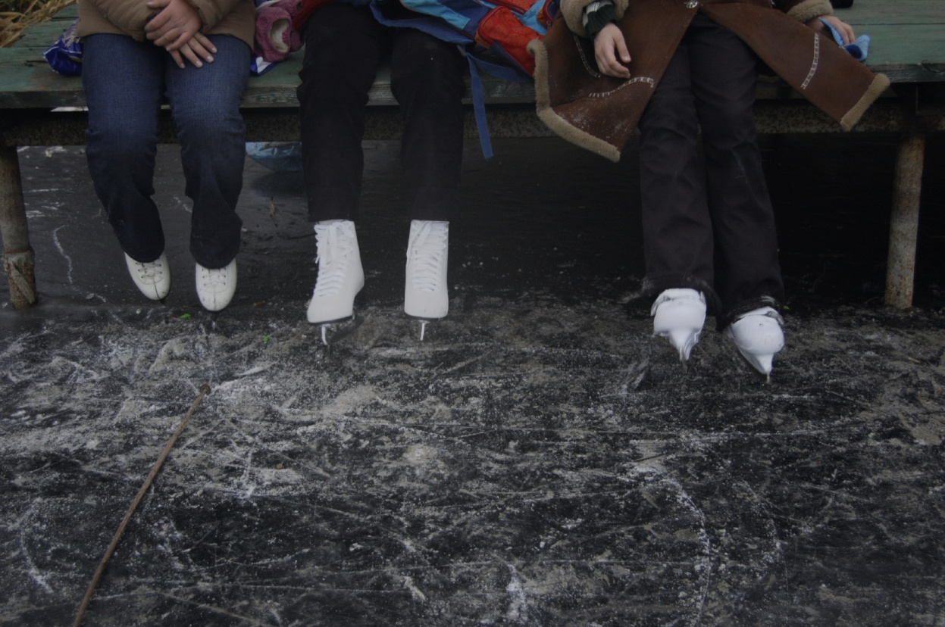
Ice skating is an exhilarating form of exercise and entertainment in the wintertime—and a safe activity if precautions are taken. It’s important to use skates that are properly fitted, securely laced, and properly tied. Figure skates are different from hockey skates and speed skates in that they have a higher top, which provides ankle support during jumps. Falling on the ice is the riskiest situation for skaters, but there are ways to avoid injury. For beginners, falling is part of the learning process. Learn tips to avoid injuries at skatingfitness.com.
Know where to skate. Your best bet is an indoor or outdoor ice-skating rink. Connect with your Girl Scout council for site suggestions. Also, for regional ice-skating rinks, visit SkatingFitness.com. Girls may skate on a pond or lake (which will be far bumpier than a rink and may lead to more falling) with supervision, but may never skate on a stream or river. Consult with park personnel and local police to determine if the ice is safe for skating. Girls may skate at night if the area is well lit.
Include girls with disabilities. Communicate with girls with disabilities and/or their caregivers to assess any needs and accommodations. Learn more about the resources and information that Skating Athletes Bold at Heart provides to people with disabilities.
Ice Skating Gear
Basic Gear
- For outdoor skating, several layers of warm clothing that allow freedom of movement
- Thermal underwear
- Warm coat
- Stocking hat and scarf
- Gloves or mittens
- Change of socks
- Lip balm if skating outdoors
- Tissues
Specialized Gear
- Ice skates
- Protective skate gear for beginners (helmet, wrist, elbow, knee pads)
Prepare for Ice Skating
- Communicate with council and parents. Inform Girl Scout council and parents/guardians about the activity, including details about safety precautions and any appropriate clothing or supplies that may be necessary. Follow council procedures for activity approval, certificates of insurance, and council guidelines about girls’ general health examinations. Make arrangements in advance for all transportation and confirm plans before departure.
- Girls plan the activity. Keeping their grade-level abilities in mind, encourage girls to take proactive leadership roles in organizing details of the activity.
- Organize transportation and arrange for adult supervision. Adults keep a close watch on skaters from outside the main skating area. The recommended adult-to-girl ratios are two non-related adults (at least one of whom is female) to every:
- 6 Girl Scout Daisies
- 12 Girl Scout Brownies
- 16 Girl Scout Juniors
- 20 Girl Scout Cadettes
- 24 Girl Scout Seniors
- 24 Girl Scout Ambassadors
Plus one adult to each additional:
- 4 Girl Scout Daisies
- 6 Girl Scout Brownies
- 8 Girl Scout Juniors
- 10 Girl Scout Cadettes
- 12 Girl Scout Seniors
- 12 Girl Scout Ambassadors
- Verify instructor knowledge and experience. An experienced ice-skating instructor instructs girls in basic ice-skating skills, safety, conduct rules, and has documented experience according to your council’s guidelines, as outlined in Volunteer Essentials. Practice sessions are scheduled for beginners.
- Select a safe ice-skating site. Obtain council guidance in selecting the ice-skating site; established ice-skating rinks are safest. Ensure that the rink has a smooth skating surface free of debris. Skating surfaces are checked in advance for thickness, and to ensure there are no patches of grass, rocks, and cracks. The rink supervisor is called in advance to arrange for large groups or for practice sessions. (Check with the rink supervisor in advance to learn how many adults, in addition to the rink staff, are needed to supervise the group.)
- Compile key contacts. Give an itinerary to a contact person at home; call the contact person upon departure and return. Create a list of girls’ parents/guardian contact information, telephone numbers for emergency services and police, and council contacts—keep on hand or post in an easily accessible location.
- Prepare for emergencies. Ensure the presence of a waterproof first-aid kit and a first-aider (level 1) with a current certificate in First Aid, including Adult and Child CPR or CPR/AED, who is prepared to handle cases of injury from falls as well as abrasions, near drowning, and immersion hypothermia. Emergency transportation is available; if any part of the activity is located 60 minutes or more from emergency medical services, ensure the presence of a first-aider (level 2) with Wilderness and Remote First Aid. Basic ice rescue techniques are understood and practiced. Appropriate rescue equipment is on hand (for example, ring buoy, rope, throw bag, pole, ladder, boat, where necessary; indoor rinks do not require such equipment). See Volunteer Essentials for information about first-aid standards and training.
On the Day of Ice Skating
- Get a weather report. If skating outdoors, on the morning of the activity, check weather.com or other reliable weather sources to determine if conditions are appropriate. If severe weather conditions prevent the activity, be prepared with a backup plan or alternate activity, or postpone the activity. Write, review, and practice evacuation and emergency plans for severe weather with girls. In the event of a storm, take shelter away from tall objects (including trees, buildings, and electrical poles). Find the lowest point in an open flat area. Squat low to the ground on the balls of the feet, and place hands on knees with head between them.
- Use the buddy system. Girls are divided into teams of two. Each girl chooses a buddy and is responsible for staying with her buddy at all times, warning her buddy of danger, giving her buddy immediate assistance if safe to do so, and seeking help when the situation warrants it. If someone in the group is injured, one person cares for the patient while two others seek help.
- Safeguard valuables. Secure equipment in a dry, locked storage area.
- Warm up for ice skating. Girls learn to perform basic skating skills, including how to fall and get up, before attempting more advanced skills. Gentle warm-up exercises are done before any strenuous ice skating; cool-down exercises end the sessions.
- Follow basic ice-skating safety standards. Follow rink rules, such as:
- Everyone skates in the same direction.
- Girls do not stop in the main skating area.
- Skaters yield the right-of-way to those already in the rink.
- Skaters do not cut across the paths of other skaters.
- Skaters do not push, shove, or race on the ice.
- A falling skater does not grab hold of another skater.
- A fallen skater rises quickly, unless injured.
- Loose or sharp articles, such as handbags, combs, and keys are not carried in pockets, hands, hair, or anyplace where they might cause injury to the skater in the event of a fall, or injure another skater by falling to the floor.
Ice Skating Links
- Ice Skating Institute: www.skateisi.com
- Professional Skaters Association: www.skatepsa.com
- U.S. Figure Skating: www.usfigureskating.org
Ice Skating Know-How for Girls
- Learn ice-skating techniques. Learn about dozens of ice-skating turns, spins, and jumps at iceskate.net (www.iceskate.net/term_turn.php). Learn how to fall and stop at www.skatingfitness.com.
Ice Skating Jargon
- Toe pick: The metal “teeth” on the fronts of figure skates that help skaters perform jumps and spins
- Tracings: Marks left on the ice by a skater’s blades

