
Ice Fishing: Safety Activity Checkpoints
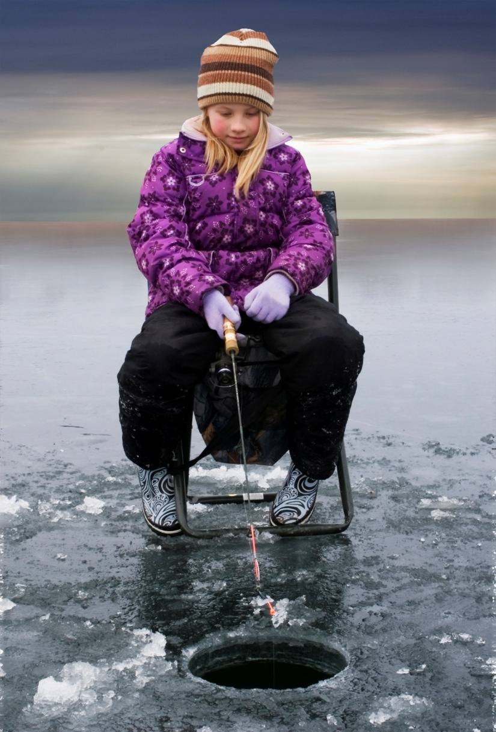
Ice fishing, the practice of fishing through a hole cut in the ice of a body of water, is a relaxing wintertime activity—particularly in northern U.S. states. Ice anglers often sit on stools inside small ice shanties, which provide shelter and warmth in cold temperatures. Shanties are typically made of wood or plastic and are rented from sport-fishing outlets or made at home.
Know where to ice fish. Lakes and ponds tend to be best. Connect with your Girl Scout council for site suggestions. Also, the Take Me Fishing Web site provides an online tool to select fishing locations by U.S. location and water body. Consult state ice angler associations for information about ice fishing events and resources.
Include girls with disabilities. Communicate with girls with disabilities and/or their caregivers to assess any needs and accommodations. Learn more about the resources and information that Global Explorers, National Center on Accessibility, and the National Center of Physical Activities and Disabilities provide to people with disabilities.
Ice Fishing Gear
Basic Gear
- Snowsuit, warm coat, hat, and mittens
- Lightweight rubber gloves or hunting/fishing gloves
- Waterproof boots that protect against cold temperatures
- Flashlight and lantern
- Folding or portable chairs
- Cooler for storing fish (if intended for consumption)
Specialized Gear
- Fishing rod (1- to 3-foot rods are most common)
- Fishing tackle appropriate for the size and skill level of the participants and the type of fish to be caught (and tackle box)
- Tools for removing hooks and cutting lines
- Shanty
- Ice auger (ice saw or chisel)
- Ice sled for pulling equipment
- Jigging rod/pole or tip-up to catch fish
- Ice bucket and scoop
- At least one graspable and throwable personal flotation device (Type IV buoyant cushion or ring buoy or equivalent) is immediately available for each group on the water
Prepare for Ice Fishing
- Communicate with council and parents. Inform your Girl Scout council and girls’ parents/guardians about the activity, including details about safety precautions and any appropriate clothing or supplies that may be necessary. Follow council procedures for activity approval, certificates of insurance, and council guidelines about girls’ general health examinations. Make arrangements in advance for all transportation and confirm plans before departure.
- Girls plan the activity. Keeping their grade-level abilities in mind, encourage girls to take proactive leadership roles in organizing details of the activity.
- Arrange for transportation and adult supervision. The recommended adult-to-girl ratios are two non-related adults (at least one of whom is female) to every:
- 6 Girl Scout Daisies
- 12 Girl Scout Brownies
- 16 Girl Scout Juniors
- 20 Girl Scout Cadettes
- 24 Girl Scout Seniors
- 24 Girl Scout Ambassadors
Plus one adult to each additional:
- 4 Girl Scout Daisies
- 6 Girl Scout Brownies
- 8 Girl Scout Juniors
- 10 Girl Scout Cadettes
- 12 Girl Scout Seniors
- 12 Girl Scout Ambassadors
- Verify instructor knowledge and experience. Ensure that the adult or ice-fishing instructor holds American Red Cross Basic Water Rescue certification or possesses equivalent certification; the ratio of instructor to participant is 1 to 10. Additional adult watchers are necessary for groups that are spread out or out of direct sight.
- Compile key contacts. Give an itinerary to a contact person at home; call the contact person upon departure and return. Create a list of girls’ parents/guardian contact information, telephone numbers for emergency services and police, and council contacts—keep on hand or post in an easily accessible location.
- Observe fishing and environmental regulations. When selecting an ice-fishing location, follow local, state, and federal fishing regulations, and obtain fishing licenses, where required. Use the correct type of bait and fishing gear permitted in that area, and learn about limits on the number, size, and kind of fish that you can keep.
- Verify safety of ice-fishing location. Ensure that ice is solid and thick enough to support the ice fishers’ weight. Opinions vary about the appropriate thickness of ice; some ice anglers fish in ice that is a minimum of 4 inches, while others fish in ice that is 5 to 6 inches.
- Prepare for emergencies. Ensure the presence of a waterproof first-aid kit and a first-aider with a current certificate in First Aid, including Adult and Child CPR or CPR/AED, who is prepared to handle cases of near-drowning, immersion hypothermia, and sunburn. If any part of the activity is located 60 minutes or more from emergency medical services, ensure the presence of a first-aider (level 2) with Wilderness and Remote First Aid. Basic ice rescue techniques are understood and practiced. Appropriate rescue equipment is on hand (for example, ring buoy, rope, throw bag, pole, ladder, boat, where necessary). See Volunteer Essentials for information about first-aid standards and training.
On the Day of Ice Fishing
- Get a weather report. Never fish on a stormy or extremely cold day. On the day of the ice fishing activity, visit weather.com or other reliable sources to determine if conditions are appropriate. If weather conditions prevent the ice-fishing trip, be prepared with a backup plan or alternate activity.
- Use the buddy system. Girls are divided into teams of two. Each girl chooses a buddy and is responsible for staying with her buddy at all times, warning her buddy of danger, giving her buddy immediate assistance if safe to do so, and seeking help when the situation warrants it. If someone in the group is injured, one person cares for the patient while two others seek help.
- Be prepared in the event of a storm with lightning. Exit the ice-fishing location immediately and take shelter away from tall objects (including trees, buildings, and electrical poles). Find the lowest point in an open flat area. Squat low to the ground on the balls of the feet, and place hands on knees with head between them.
- Respect fish and wildlife. Whenever possible, use barbless hooks, and return live fish to the water. Remove fishing gear, bait, and dead fish at the end of the fishing activity.
Ice Fishing Links
- American Sportfishing Association: www.asafishing.org
- Association of Fish and Wildlife Agencies: www.fishwildlife.org
- International Game Fish Association: www.igfa.org
- Leave No Trace: www.lnt.org
- Take Me Fishing: www.takemefishing.org
- IceLeaders.com: www.iceleaders.com
Ice Fishing Know-How for Girls
- Learn the basics of ice fishing. Know before you go! Watch an instructional Wisconsin Department of Natural Resources video.
- Learn how to set up an ice-fishing tip-up. A tip-up is a device that holds a fishing line attached to a flag that tips up when a fish bites the attached bait. Watch an instructional video on YouTube.
Ice Fishing Jargon
- Skimmer: Tool that looks like a long-handled soup ladle and is used for scooping out slush and ice chips from a fishing hole
- Gaff hook: Large, heavy, special-purpose hook to help hoist a slippery fish through a hole in the ice

