

HONOR PIN
NOMINATION and OUTLINE FOR A LETTER OF ENDORSEMENT

Procedure
Submit nomination and three (3) letters of endorsement to the Recognition Committee no later than four (4) weeks before the presentation date. To be recognized at The Annual Meeting submit by April 1st.

Endorsement for: Date:
(Name of person being nominated)
This recommendation submitted by:
Name: Phone: Service Unit:
Address:
Street City State Zip

Email: ________________________________________

Nominee’s volunteer positions (two or more):

- I am recommending the Honor Pin for Because:
(Insert Name)

2. List at least two geographical areas on which the nominee has made an impact:

3. Please list the names and contact information for at least 3 individuals submitting letters of endorsement.
Name: Contact information:
Name: Contact information:
Name: Contact information:
It is important that you verify the accuracy of the above information with the SOURCE of that information since it may be used as part of the presentation of the award.

Honor Pin

Criteria for Selection

1. The candidate is an active adult member registered with Girl Scouts of the U.S.A., either as a volunteer or employed staff member.

2. The service performed by the candidate is outstanding, above and beyond the expectations for the position held, and is delivered to at least two or more geographic divisions or service units* within the council jurisdiction, and contributes to the council's goals and objectives.

Nomination and Approval Procedures

1. An individual or group familiar with the service performed by the candidate completes the application form and submits it to the council's Recognition Committee.

2. Three individuals or groups familiar with the service performed by the candidate submit letters of endorsement to the council's Recognition Committee.

3. The Recognition Committee reviews the letters of endorsement and submits a written recommendation to approve or deny the nomination, with the rationale for this recommendation, to the council board of directors.

4. The council board of directors approves or rejects the application and so notifies the recognition committee who notifies sponsoring group or individual.

Examples of possible candidates for the Honor pin might include, but are not limited to:

■ An individual who manages consistently successful program events for the council or for an area within the council

■ An individual who directs a membership outreach task group with positive results, either in terms of membership or in targeted groups served.

■ An individual who manages excellent training events for parts or all of the council, as demonstrated by the results of evaluations.

■ An individual who introduces Girl Scouting to the wider community through significant community action or community organization team strategy.

Form of Recognition
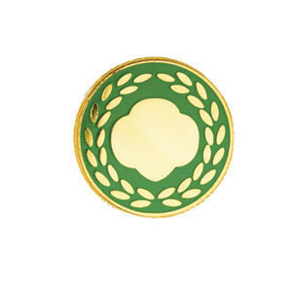

The Honor pin is a green enamel pin with a gold-tone trefoil design circled by a laurel wreath. It should be presented at an appropriate meeting or ceremony with publicity throughout the council.

*It is assumed that the primary method of delivery of service is through the geographic service unit. However, if the resources and/or needs of the area or audience to be served require flexible delivery and support, the selected method could replace requirement.

