
Hiking: Safety Activity Checkpoints
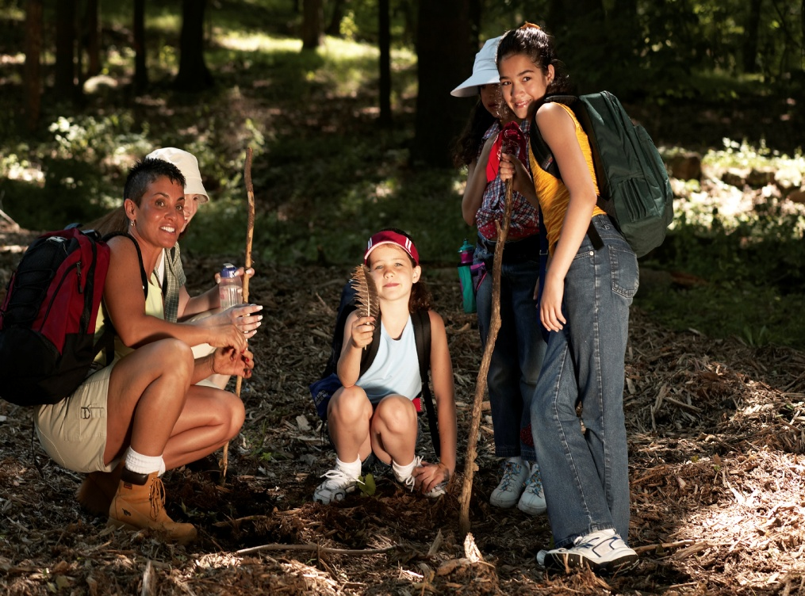
Unlike short walks, hiking involves lengthy, cross-country walking trips and often requires sturdy boots to provide traction on rocks and unruly earth floors. With respect to the Leave No Trace philosophy, it’s important for hikers to leave trails as (or better than) they found them. Although the action of one hiker may not strongly affect the environment, the effects of large groups of hikers can degrade trails.
Caution: Girls are not allowed to use firearms unless 12 years and older and with council permission; girls are never allowed to hunt or go on high-altitude climbs. Girls are also never allowed to ride all-terrain vehicles or motor bikes.
Know where to hike. Connect with your Girl Scout council for site suggestions. Also, to locate hiking areas near U.S. metropolitan areas, visit localhikes.com.
Include girls with disabilities. Communicate with girls with disabilities and/or their caregivers to assess any needs and accommodations. Contact national parks to inquire about their accommodations for people with disabilities, and learn more about the resources and information that Global Explorers and Wilderness Inquiries provide to people with disabilities.
Hiking Gear
Basic Gear
- Lightweight, layered clothing and outerwear appropriate for weather conditions
- Rain jacket or poncho
- Waterproof sunscreen (SPF of at least 15) and lip balm
- Hat or bandana
- Sunglasses
- Water bottle or hydration pack (each girl carries at least one quart)
- Nonperishable, high-energy foods such as fruits and nuts
- Insect repellent
- Flashlight
- Whistle
Specialized Gear
- Day pack
- Hiking/trail boots or footwear
- Map and compass or map and global positioning system (GPS)
- Pocket knife
Prepare for Hiking
- Communicate with council and parents. Inform your Girl Scout council and girls’ parents/guardians about the activity, including details about safety precautions and any appropriate clothing or supplies that may be necessary. Follow council procedures for activity approval, certificates of insurance, and council guidelines about girls’ general health examinations. Make arrangements in advance for all transportation and confirm plans before departure.
- Girls plan the activity. Keeping their grade-level abilities in mind, encourage girls to take proactive leadership roles in organizing details of the activity. Encourage girls to plan routes, activities, rules for group living, and guidelines for dealing with problems that may arise with other groups of hikers.
- Arrange for transportation and adult supervision. Ensure that the hiking adult or instructor has experience in teaching hiking techniques and trip planning. Ensure that one adult is in front of the group of hikers, and the other is in the rear of each group, and that both are familiar with the area. The recommended adult-to-girl ratios are two non-related adults (at least one of whom is female) to every:
- 6 Girl Scout Daisies
- 12 Girl Scout Brownies
- 16 Girl Scout Juniors
- 20 Girl Scout Cadettes
- 24 Girl Scout Seniors
- 24 Girl Scout Ambassadors
Plus one adult to each additional:
- 4 Girl Scout Daisies
- 6 Girl Scout Brownies
- 8 Girl Scout Juniors
- 10 Girl Scout Cadettes
- 12 Girl Scout Seniors
- 12 Girl Scout Ambassadors
- Compile key contacts. Give an itinerary to a contact person at home; call the contact person upon departure and return. Create a list of girls’ parents/guardian contact information, telephone numbers for emergency services and police, and council contacts—keep on hand or post in an easily accessible location. Also know the location of the nearest landline telephone in case cellular phones do not receive reception.
- Girls share resources. Encourage girls to distribute a list of hiking gear and supplies, and to determine which resources can be shared.
- Choose an appropriate hiking route. Terrain, mileage, and hiking time are known to the hikers in advance. Hikes are restricted to a reasonable length as determined by age, level of experience, nature of the terrain, physical condition of the hikers, disabilities, weather conditions, and time of day. The hiking pace always accommodates the slowest hiker.
- Assess safety of hiking routes. The route is known to at least one of the adults or a report is obtained in advance to assess potential hazards such as poisonous plants, dangerous animals, unsafe drinking water, cliffs, and drop-offs. Ensure that a land-management or similar agency is contacted during the trip-planning stage to determine available routes and campsites, recommended group size, water quantity and quality, and permits needed.
- Ensure that hikers have a comprehensive understanding of the trip. Group members are trained to be observant of the route, surroundings, and fatigue of individuals. Instruction is given on the safety rules for hiking, such as staying together in a group, recognizing poisonous plants and biting or stinging insects and ticks, respecting wild animals, and behaving effectively in emergencies. Ensure that girls know how to read maps, use a compass, navigate a route, and estimate distance.
- Take safety precautions. Search-and-rescue procedures for missing persons are written out in advance, reviewed, and practiced by girls and adults. Methods of communication with sources of emergency care, such as hospitals, and park and fire officials, are known and arranged in advance.
- Prepare for emergencies. Ensure the presence of a waterproof first-aid kit and a first-aider with a current certificate in First Aid, including Adult and Child CPR or CPR/AED, who is prepared to handle cases from extremes of temperature, such as heat exhaustion, heat stroke, frostbite, cold exposure, hypothermia, as well as sprains, fractures, insect stings, tick bites, snake bites, sunburn, and altitude sickness; a first-aider (level 2) with Wilderness and Remote First Aid is present for hikes of 10 miles or more and away from emergency assistance. If feasible, a vehicle is available to transport an injured or sick person. See Volunteer Essentials for information about first-aid standards and training.
On the Day of Hiking
- Get a weather report. On the morning of the camping trip, check weather.com or other reliable weather sources to determine if conditions are appropriate. If severe weather conditions prevent the hiking activity, be prepared with a backup plan or alternate activity. Write, review, and practice evacuation and emergency plans for severe weather with girls.
- Use the buddy system. Girls are divided into teams of two. Each girl chooses a buddy and is responsible for staying with her buddy at all times, warning her buddy of danger, giving her buddy immediate assistance if safe to do so, and seeking help when the situation warrants it. If someone in the group is injured, one person cares for the patient while two others seek help.
- Respect the environment and keep trails clean. Use the principles of minimal-impact camping. Store garbage in insect- and animal-proof containers with plastic inner linings, and cover it securely when there is a campsite garbage-pickup service. When there is no garbage-pickup service, remove garbage from campsite in plastic bags and discard, as appropriate. Recycle whenever possible. Do not bury food; carry out grease and fuel canisters. Do not remove natural materials such as leaves or branches. In addition, avoid eating wild foods, walking on or uprooting plants, interfering with or feeding wild animals, and littering.
- Practice safe hiking. Instructions are given on the safety rules for hiking, which include forbidding hiking off-trail and after dusk. Girls stay on the pathway to avoid trampling trailside plants and causing erosion. In addition, take adequate rest periods, with time to replenish fluids and eat high-energy food (such as fruits and nuts).
Hiking Links
- American Hiking Society: www.americanhiking.org
- Appalachian Mountain Club: www.outdoors.org
- Appalachian Trail Conference: www.atconf.org
- Leave No Trace: www.lnt.org
Hiking Know-How for Girls
- Practice with maps and a compass. Before heading out on a lengthy hike, learn how to read a map and use a compass. Look at a map to understand where you started, and where you plan to finish. What do you anticipate you’ll see during your hike?
- Learn about regional nature. What flowers, trees, insects are unique to the area you’re hiking in?
Hiking Jargon
- Blaze: A mark, often on a tree, that indicates a trail’s route; most often, the blaze is painted with a bright color
- Hot spot: A place on the foot that is sore as a result of a shoe’s rubbing and irritation, and where a blister will form; use moleskin to make a doughnut shape around the hot spot to prevent blisters

