
Hayrides: Safety Activity Checkpoints
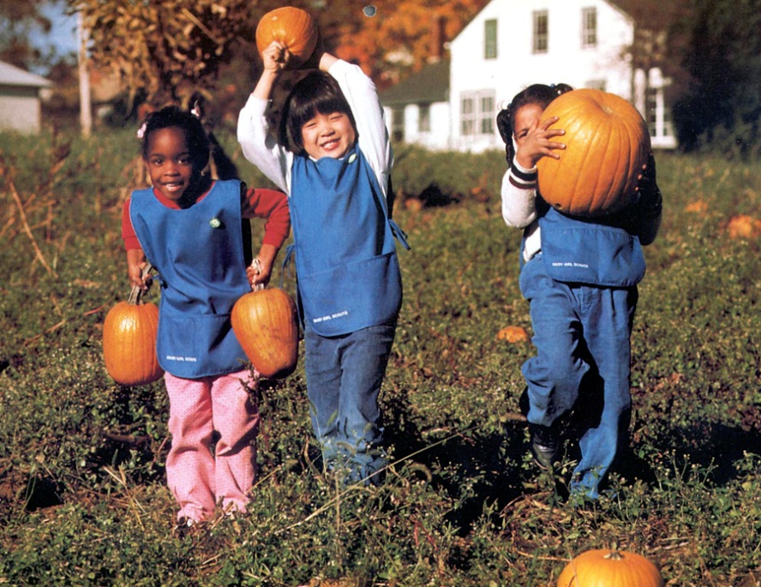
A traditional activity that’s often part of autumn festivities and apple- or pumpkin-picking trips, hayrides are fun for girls of all ages. Before participating in a hayride, ensure that hayride equipment (tractor/truck, bales of hay) are secure, that vehicle weight limitations and seating capacities are not exceeded, and that paths and trails are free of obstructions. Also ensure that girls are responsible riders who stay seated during the hayride.
Know where to go on hayrides. The hayride takes place on private property at a maximum speed of 10 miles per hour. Public roads and highways are not used. Connect with your Girl Scout council for site suggestions.
Include girls with disabilities. Communicate with girls with disabilities and/or their caregivers to assess any needs and accommodations.
Hayride Gear
- Layered clothing appropriate for the weather
- Comfortable walking shoes
Prepare for the Hayride
- Communicate with council and parents. Inform your Girl Scout council and girls’ parents/guardians about the activity, including details about safety precautions and any appropriate clothing or supplies that may be necessary. Follow council procedures for activity approval, certificates of insurance, and council guidelines about girls’ general health examinations. Make arrangements in advance for all transportation and confirm plans before departure.
- Girls plan the activity. Keeping their grade-level abilities in mind, encourage girls to take proactive leadership roles in organizing details of the activity.
- Arrange for transportation and adult supervision. The recommended adult-to-girl ratios are two non-related adults (at least one of whom is female) to every:
- 6 Girl Scout Daisies
- 12 Girl Scout Brownies
- 16 Girl Scout Juniors
- 20 Girl Scout Cadettes
- 24 Girl Scout Seniors
- 24 Girl Scout Ambassadors
Plus one adult to each additional:
- 4 Girl Scout Daisies
- 6 Girl Scout Brownies
- 8 Girl Scout Juniors
- 10 Girl Scout Cadettes
- 12 Girl Scout Seniors
- 12 Girl Scout Ambassadors
- Compile key contacts. Give an itinerary to a contact person at home; call the contact person upon departure and return. Create a list of girls’ parents/guardian contact information, telephone numbers for emergency services and police, and council contacts—keep on hand or post in an easily accessible location.
- Select a safe hayride location. Inspect the site to be sure it is free of potential hazards, and make sure emergency medical care is accessible. Ensure that the hayride route is clear of debris and hazards that may cause a jolt or jarring ride for participants.
- Dress appropriately for the activity. Make sure girls and adults avoid wearing dangling earrings, bracelets, and necklaces that may become entangled in equipment.
- Prepare for emergencies. Ensure the presence of a first-aid kit and a first-aider with a current certificate in First Aid, including Adult and Child CPR or CPR/AED. See Volunteer Essentials for information about first-aid standards and training.
On the Day of the Hayride
- Get a weather report. On the morning of the hayride trip, check weather.com or other reliable weather sources to determine if conditions are appropriate, and make sure that the ground is free of ice. If severe weather conditions prevent the activity, be prepared with a backup plan or alternate activity, or postpone the activity. Write, review, and practice evacuation and emergency plans for severe weather with girls. In the event of a storm, take shelter away from tall objects (including trees, buildings, and electrical poles). Find the lowest point in an open flat area. Squat low to the ground on the balls of the feet, and place hands on knees with head between them.
- Use the buddy system. Girls are divided into teams of two. Each girl chooses a buddy and is responsible for staying with her buddy at all times, warning her buddy of danger, giving her buddy immediate assistance if safe to do so, and seeking help when the situation warrants it. If someone in the group is injured, one person cares for the patient while two others seek help.
- Girls learn about and practice safe hayrides. Girls do not ride in the hauling vehicle. The driver of the hauling vehicle is licensed to drive a vehicle in the jurisdiction and is at least 21 years of age. The hauled vehicle meets all state and local safety requirements and displays proper identification showing these conditions have been met. The hauled vehicle has protective sides and rear fencing or gates, as well as rear lights in working order. The hay or straw is properly stacked to prevent slipping. Sufficient seating space is allowed for each person. Girls and adults remain seated during the ride.
Hayride Links
- National Safety Council: www.nsc.org
- Haunted House Association: www.hauntedhouseassociation.org/safety/hayride_safety_and_common_sense.php

