
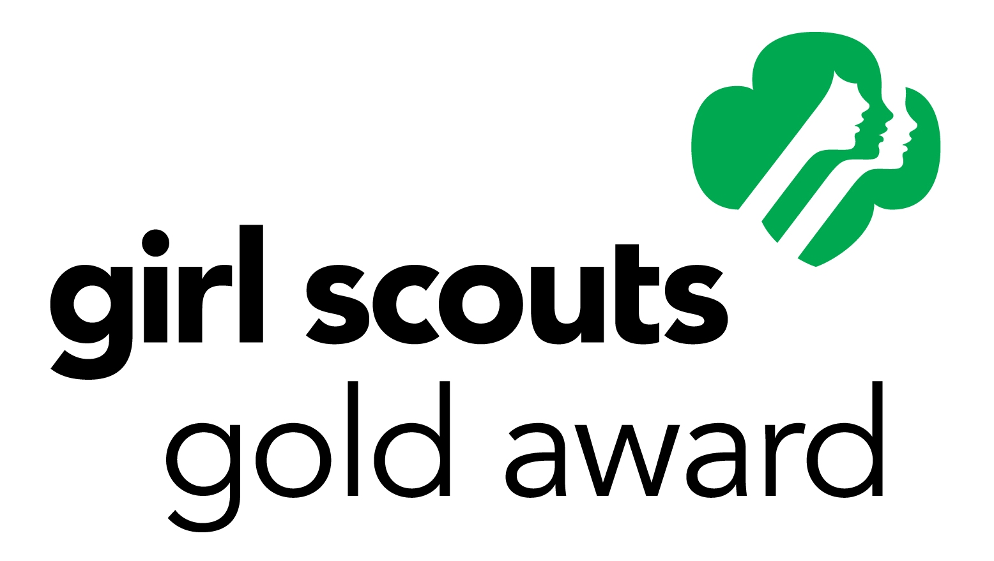
Girl Scout Gold Award Final Report
Girl Scouts of Rhode Island 125 Charles St, Providence, RI 02904
Attention: Hlee Kue

Submit the original completed form to your council. Make copies for yourself and your Girl Scout Gold Award project advisor. Type or print in black ink. The Gold Award Final Report form and the Time Log must be received by GSRI by 9/30 of the year you graduate high school. We recommend that you submit your final report no later than 8/1 of that year. This will allow you to make revisions or answer any questions the committee may have.
Contact Information
Name:
Address:
City: State: Zip code:
E-mail: Phone: ( )
Age: Current Grade: Year of Graduation:
School: School Principal:
Town Administrator/Mayor etc.:
Troop/Group Volunteer: Troop/Group Number:
Troop/Group Volunteer’s Phone: ( ) E-mail
Girl Scout Gold Award Project Advisor: (must have expertise with project topic)
Project Advisor’s Phone: ( ) E-mail:
Your Team: List the names of individuals and organizations who worked with you on your Take Action Project.

Team members | Affiliation | Role

Girl Scout Gold Award Final Report, continued

Take Action Project: Project Title:
Start Date: Completion Date: Hours:
- Describe your project, the impact you made, and who benefited.

- What was the issue your project addressed? How did you address it?

C. How will your project be sustained beyond your involvement? (i.e. by someone other than yourself) Please provide verification, i.e. a letter from the group or person who will carry on the project.

D. Explain the national and/or global link to your project.

E. Describe any obstacles you encountered and what you did to overcome them.

Girl Scout Gold Award Final Report, continued

F. Describe what steps you took to inspire others through sharing your project. (Web site, blog, presentations, etc).

G. Describe what you learned from this project including leadership skills you developed.
What did you learn about yourself as a result of this project?

H. What aspects of your project would you change or do differently if you could start over?

Your Signature: Date:

Project Advisor’s Signature: Date:
Time Log for Girl Scout Higher Award Project

Name Project
Date
Activity(BE SPECIFIC) You may use more than the space allotted to explain each activity.
Time Spent Total Hours:* Please make copies of this page if you need to expand.

