
Geocaching: Safety Activity Checkpoints
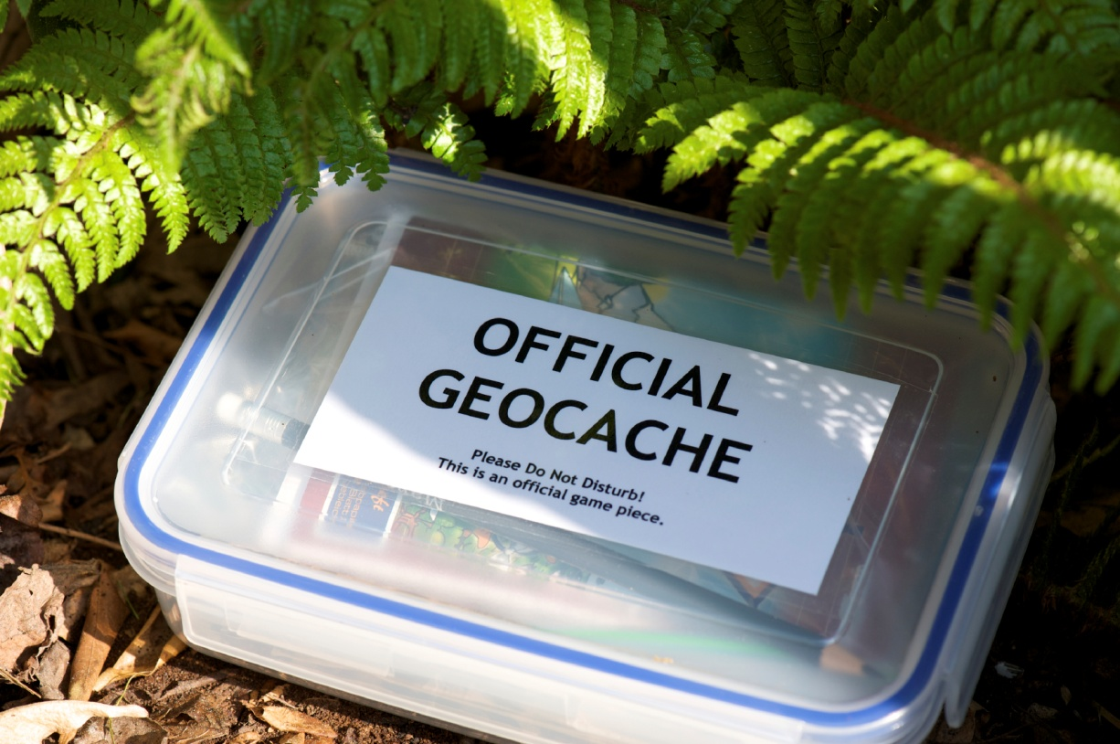
Geocaching is a recreational outdoor activity that centers on the use of a Global Positioning System (GPS) and maps. Geocachers seek out caches (waterproof containers containing logbooks) that have been hidden just about anywhere in the world, whether in urban areas, in the wilderness, in tree roots, and so on. As treasure hunters in an international game of hide-and-seek, participants use geocaching.com to select cache locations and communicate with other geocachers.
Geocaching often involves lengthy city walks or day hikes in the woods. Depending on the location of a cache, participants are prepared for more strenuous activities; if incorporating backpacking, canoeing, and/or rock climbing into a geocaching activity, reference the appropriate Safety Activity Checkpoints to ensure the presence of qualified instructor(s). Because of the challenging nature of GPS operation and the ciphering of numbers and data, geocaching is not recommended for Girl Scout Daisies unless they’re working with older girls and adults as part of another outdoor activity. Geocaching is appropriate for Girl Scout Brownies so long as the time duration is not excessive and girls are looking for basic cache hides.
Know where to participate in geocaching. Connect with your Girl Scout council for site suggestions. Also, when on private or government property, follow all posted rules, guidelines, and etiquette. Geocaching.com outlines locations that are prohibited for placing a cache.
Include girls with disabilities. Communicate with girls with disabilities and/or their caregivers to assess any needs and accommodations. Learn more about the resources and information that the National Center on Accessibility and Handicaching provide to people with disabilities.
Geocaching Gear
Basic Gear
- Sunscreen (SPF of at least 15) and lip balm
- Sunglasses
- Portable drinking water
- Cell phone
- Clothing appropriate for the activity and weather
- Notebook and pen or pencil
- Swag (or “stuff we all get”), which is the items that geocachers place into caches—usually small plastic toys, key chains, sunglasses—for other geocachers to take once they’ve located a cache
Specialized Gear
- GPS device (although not required, Geomate.jr is recommended for younger girls)
- Topographical and/or standard map of geocaching area
- Daypack to carry personal belongings
- Hiking boots for wilderness areas, or comfortable and sturdy walking shoes for urban environments
- Whistle
Prepare for Geocaching
- Communicate with council and parents. Inform your Girl Scout council and girls’ parents/guardians about the activity, including details about safety precautions and any appropriate clothing or supplies that may be necessary. Follow council procedures for activity approval, certificates of insurance, and council guidelines about girls’ general health examinations. Make arrangements in advance for all transportation and confirm plans before departure.
- Girls plan the activity. Keeping their grade-level abilities in mind, encourage girls to take proactive leadership roles in organizing details of the activity.
- Arrange for transportation and adult supervision. For a large group of girls participating in geocaching, it is recommended that girls organize themselves into small groups. The recommended adult-to-girl ratios are two non-related adults (at least one of whom is female) to every:
- 6 Girl Scout Daisies (only when working with older girls and adults as part of another outdoor activity)
- 12 Girl Scout Brownies
- 16 Girl Scout Juniors
- 20 Girl Scout Cadettes
- 24 Girl Scout Seniors
- 24 Girl Scout Ambassadors
Plus one adult to each additional:
- 4 Girl Scout Daisies (only when working with older girls and adults as part of another outdoor activity)
- 6 Girl Scout Brownies
- 8 Girl Scout Juniors
- 10 Girl Scout Cadettes
- 12 Girl Scout Seniors
- 12 Girl Scout Ambassadors
- Verify instructor knowledge and experience. The geocaching instructor has experience and skill in teaching/supervising geocaching, topographical-map reading, and proper usage of GPS devices and has documented experience according to your council’s guidelines, as outlined in Volunteer Essentials. For geocaching activities that involve caving, rock climbing, and similar activities, refer to the appropriate Safety Activity Checkpoints for details about instructor credentials and/or skill sets. The instructor reviews the rules and operating procedures with girls before geocaching.
- Compile key contacts. Give an itinerary to a contact person at home; call the contact person upon departure and return. Create a list of girls’ parents/guardian contact information, telephone numbers for emergency services and police, and council contacts—keep on hand or post in an easily accessible location.
- Select a safe geocaching location. Learn about the terrain of a geocaching site by learning about the Difficulty/Terrain rating (D/T) on the cache page of geocaching.com. The ratings, which range from 1/1 to 5/5, measure the level of difficulty for finding a cache at a designated location. A terrain rating of 1 typically means the cache is accessible for people with disabilities. Keep in mind that a GPS device provides a direct line measurement from the starting point to a destination; a GPS does not include the distance around path obstructions such as bodies of water.
- Dress appropriately for the activity. Make sure girls and adults avoid wearing dangling earrings, bracelets, and necklaces that may become entangled in equipment.
- Develop a geocaching curriculum. Encourage girls to plan the details of a geocaching trip, and develop a geocaching curriculum that includes lesson plans that cover elements such as the purpose of the activity, skills necessary, safety considerations, diagrams to aid with comprehension, and navigational resources.
- Prepare for emergencies. Ensure the presence of a waterproof first-aid kit and a first-aider with a current certificate in First Aid, including Adult and Child CPR or CPR/AED. See Volunteer Essentials for information about first-aid standards and training.
On the Day of Geocaching
- Get a weather report. On the morning of the geocaching activity, check weather.com or other reliable weather sources to determine if weather conditions are appropriate. If severe weather conditions prevent the activity, be prepared with a backup plan or alternative activity. Write, review, and practice evacuation and emergency plans for severe weather with girls. In the event of a storm, take shelter away from tall objects (including trees, buildings, and electrical poles). Find the lowest point in an open, flat area. Squat low to the ground on the balls of the feet, and place hands on knees with heads between them.
- Use the buddy system. Girls are divided into teams of two. Each girl chooses a buddy and is responsible for staying with her buddy at all times, warning her buddy of danger, giving her buddy immediate assistance if safe to do so, and seeking help when the situation warrants it. If someone in the group is injured, one person cares for the patient while two others seek help.
- Girls learn about geocaching. Girls develop skills about GPS use, latitude and longitude, and reading maps. Ideally, each girl is able to use her own GPS, or two girls share a GPS; when more than three participants share a GPS device, it becomes more difficult for girls to actively participate in the geocaching activity.
- Practice safe geocaching. To prevent injury when searching for caches, inspect areas with care before trekking into potentially dangerous locations or placing hands into unknown nooks and crannies such as ground holes, ponds, creeks, or urban buildings and structures. Be on lookout for sharp edges, animals, insects, and garbage.
Geocaching Links
- Geocaching—The Official Global GPS Cache Hunt Site: www.geocaching.com
- Geocaching with NaviCache: www.navicache.com
- TerraCaching—For Love of the Hunt: www.terracaching.com
Geocaching Know-How for Girls
- Cache in, trash out. Like the Leave No Trace initiative, geocachers are encouraged to leave caching sites cleaner than they found them. Geocachers are invited to participate in International Cache In Trash Out events, which are worldwide clean-up efforts.
- Find a benchmark. Using a GPS or directions provided by the National Oceanic and Atmospheric Administration's National Geodetic Survey, you can seek out NGS survey markers and other items that have been marked in the United States. Visit www.geocaching.com/mark to learn more.
Geocaching Jargon
- FTF: Acronym used in geocaching logbooks and sites that stands for “first to find” a new geocache
- TNLNSL: Geocaching acronym that stands for “took nothing, left nothing, signed log”

