
Fishing: Safety Activity Checkpoints
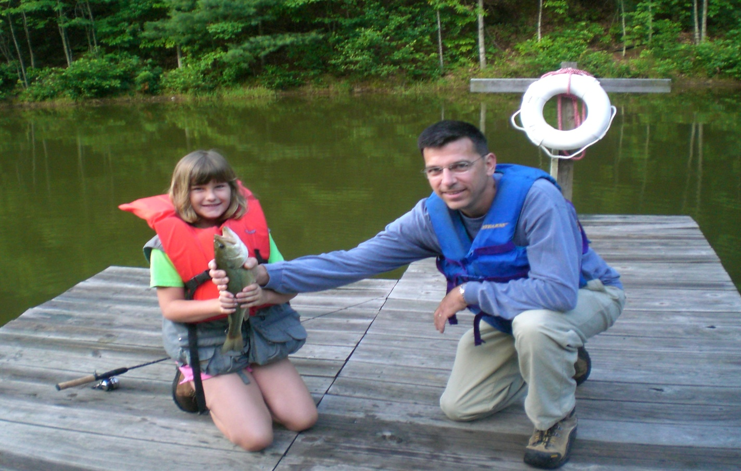
Fishing (also referred to as “angling”) is a sport, a leisurely activity, and a major food industry, depending on who you’re talking to. In the United States, freshwater fishing is more popular than saltwater fishing, and varieties include fly fishing, ice fishing (see the “Ice Fishing” Safety Activity Checkpoints), and match fishing (the most popular form of competitive fishing). The best times of day to fish rely on a variety of factors, such as amount of sunlight, temperature, and depths of water, and winds. In general, however, the best times to fish are early in the morning or in the mid-evening.
Know where to fish. Lakes, rivers, ponds, creeks, and the ocean are great places to fish. Connect with your Girl Scout council for site suggestions. Also, Takemefishing.com provides an online tool to select fishing locations in the United States.
Include girls with disabilities. Communicate with girls with disabilities and/or their caregivers to assess any needs and accommodations. Learn more about the resources and information that Global Explorers, Colorado Division of Wildlife, National Center on Accessibility and the National Center of Physical Activities and Disabilities provide to people with disabilities.
Fishing Gear
Basic Gear
- Layered, non-cotton clothing that’s easily changeable depending on temperatures (waterproof jacket recommended)
- Boat shoes, closed-toe and nonslip hiking/sport sandals with heel strap, water socks or shoes (no flip-flops)
- Waterproof sunscreen (SPF of at least 15)
- Sunglasses or sunhat
- Flashlight
- Insect repellant
- If fishing from a boat, reference the “Rowboating” or “Sailing” Safety Activity Checkpoints
Specialized Gear
- If girls are wading in water more than knee-deep or fishing from a boat, ensure that they wear a U.S. Coast Guard–approved life jacket (Type III recommended) that fits according to weight and height specifications. Inspect life jackets to ensure that they are in good condition and contain no tears. Read about Coast Guard life jackets here.
- Fishing rod appropriate to the type of fishing
- Fishing tackle (and tackle box) appropriate for the size and skill level of the participants and the type of fish to be caught
- Tools for removing hooks and cutting lines
- Fishing net
- Cooler and ice for keeping fish cool and avoiding spoilage (if intended for consumption)
- If fishing from a boat, at least one graspable and throwable personal flotation device (Type IV buoyant cushion or ring buoy or equivalent) is immediately available for each group on the water
Prepare for Fishing
- Communicate with council and parents. Inform your Girl Scout council and girls’ parents/guardians about the activity, including details about safety precautions and any appropriate clothing or supplies that may be necessary. Follow council procedures for activity approval, certificates of insurance, and council guidelines about girls’ general health examinations. Make arrangements in advance for all transportation and confirm plans before departure.
- Girls plan the activity. Keeping their grade-level abilities in mind, encourage girls to take proactive leadership roles in organizing details of the activity.
- Ensure participants are able to swim. Participants’ swimming abilities are classified and clearly identified (for instance, with colored headbands to signify beginners, advanced swimmers, etc.) at council-approved sites, or participants provide proof of swimming-test certification. In the absence of swimming-test certification, a swim test is conducted on the day of the activity. Consult with your Girl Scout council for additional guidance.
- Arrange for transportation and adult supervision. The recommended adult-to-girl ratios are two non-related adults (at least one of whom is female) to every:
- 6 Girl Scout Daisies
- 12 Girl Scout Brownies
- 16 Girl Scout Juniors
- 20 Girl Scout Cadettes
- 24 Girl Scout Seniors
- 24 Girl Scout Ambassadors
Plus one adult to each additional:
- 4 Girl Scout Daisies
- 6 Girl Scout Brownies
- 8 Girl Scout Juniors
- 10 Girl Scout Cadettes
- 12 Girl Scout Seniors
- 12 Girl Scout Ambassadors
- Verify instructor knowledge and experience. Ensure that the adult or fishing instructor holds the following certification or possesses equivalent certification or documented experience according to your council’s guidelines, as outlined in Volunteer Essentials:
- Fishing from a shoreline or dock: American Red Cross Basic Water Rescue certification; the ratio of adult watcher to participant is 1 to 10. Additional adult watchers are necessary for groups that are spread out or out of direct sight.
- Fishing while wading: American Red Cross Basic Water Rescue certification; the ratio of adult watcher to participant is 1 to 10. Additional adult watchers are necessary for groups that are spread out or out of direct sight.
- Fishing from small craft: American Red Cross Small Craft Safety certification; the ratio of adult watcher to participant is 1 to 10. Additional adult watchers are necessary for groups that are spread out or out of direct sight.
Contact your Girl Scout council about council-conducted learning opportunities.
- Compile key contacts. Give an itinerary to a contact person at home; call the contact person upon departure and return. Create a list of girls’ parents/guardian contact information, telephone numbers for emergency services and police, and council contacts—keep on hand or post in an easily accessible location.
- Observe fishing and environmental regulations. When selecting a fishing location, following local, state, and federal fishing regulations, and obtain fishing licenses, where required. Use the correct type of bait and fishing gear permitted in that area, and learn about limits on the number, size, and kind of fish that you can keep. Also select a fishing location that is separate from swimming areas.
- Select appropriate boats for water and passengers. Make sure craft weight and capacity are not exceeded (some crafts clearly display maximum capacity). Consider weather and water conditions, weight of passengers, and equipment.
- File a float plan for extensive boat trips. If going on an extended boat fishing trip, file a float plan with local authorities that includes names of people on board, destination, craft description, times of departure and return, additional details about routes and marine communications, and so on. The Coast Guard provides an electronic, printable form.
- Prepare for emergencies. Ensure the presence of a waterproof first-aid kit and a first-aider with a current certificate in First Aid, including Adult and Child CPR or CPR/AED, who is prepared to handle cases of near-drowning, immersion hypothermia, and sunburn. If any part of the activity is located 60 minutes or more from emergency medical services, ensure the presence of a first-aider (level 2) with Wilderness and Remote First Aid. See Volunteer Essentials for information about first-aid standards and training.
On the Day of Fishing
- Get a weather and wind report. Never fish on a stormy or extremely windy day. On the day of the fishing activity, visit weather.com or other reliable sources to determine if conditions are appropriate. If weather conditions prevent the fishing trip, be prepared with a backup plan or alternative activity.
- Use the buddy system. Girls are divided into teams of two. Each girl chooses a buddy and is responsible for staying with her buddy at all times, warning her buddy of danger, giving her buddy immediate assistance if safe to do so, and seeking help when the situation warrants it. If someone in the group is injured, one person cares for the patient while two others seek help.
- Be prepared in the event of a storm with lightning. Exit water immediately and take shelter away from tall objects (including trees, buildings, and electrical poles). Find the lowest point in an open flat area. Squat low to the ground on the balls of the feet, and place hands on knees with head between them. During storms, if shore cannot be reached, secure all loose gear, keep a sharp lookout for other boats and obstructions, head into the wind at a 45-degree angle, and stay low.
- Respect fish and wildlife. Whenever possible, use barbless hooks, and return live fish to the water. Remove fishing gear, bait, and dead fish at the end of the fishing activity.
Fishing Links
- American Sportfishing Association: www.asafishing.org
- Association of Fish and Wildlife Agencies: www.fishwildlife.org
- International Game Fish Association: www.igfa.org
- Leave No Trace: www.lnt.org
- Take Me Fishing: www.takemefishing.org
- U.S. Coast Guard’s Boating Safety Division: www.uscgboating.org
Fishing Know-How for Girls
- Lure them in. Learn all about the vast variety of artificial and live fish bait on this fishing site.
- Learn about rods and reels. Spincast, spinning, baitcast, and fly are the four reel types on the Take Me Fishing site.
Fishing Jargon
- Daisy chain: A “chain” of plastic, hookless lures, the main purpose of which is to attract a school of fish closer to the lures with hooks
- Jig: A weighted hook with a lead head opposite the sharp tip. Jigs are often covered with a minnow, crawfish, or worm to get a fish’s attention

