
Fencing: Safety Activity Checkpoints
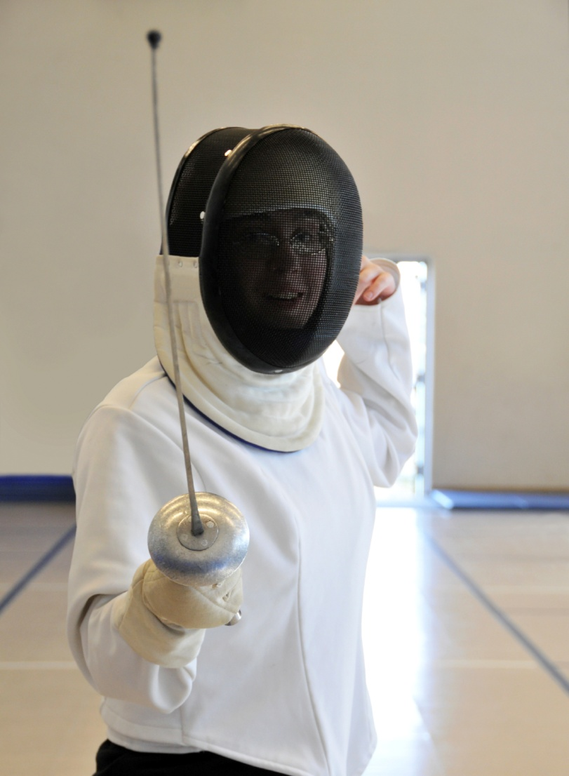
Derived from the word “defense,” fencing is a sport and martial art that involves using swords called foils (practice swords), sabers, and épées (a fencing sword with a bowl-shaped hand guard). The object of fencing is to touch the opponent with the tip of a sword without getting hit by the opponent’s sword. A fencing game (or bout) is typically three minutes—the first fencer to score five touches (or hits) wins; if neither reaches five within the designated time period, the participant with the most touches wins. If performed correctly with the proper equipment, fencing is a safe activity with a low injury rate. Most fencing clubs provide students with a full kit of equipment. Girl Scout Daisies learn about fencing games and the rules of fencing but should use only foam mock swords.
Know where to participate in fencing. Beginners learn about fencing from fencing member clubs. Connect with your Girl Scout council for site suggestions. Also, to locate fencing clubs and camps, visit the United States Fencing Association.
Include girls with disabilities. Communicate with girls with disabilities and/or their caregivers to assess any needs and accommodations. Learn more about the resources and information that organizations such as Wheelchair Fencer provide to people with disabilities.
Fencing Gear
Basic Gear
- Long socks that go up to knees (soccer socks are recommended)
- Sneakers or court shoes
Specialized Gear
- Sword (Girl Scout Daisies use foam mock swords only)
- Fencing glove
- Fencing mask
- Chest protector
- Plastron (underarm protector worn on fencing arm)
- Fencing jacket
- Fencing knickers or pants that cover knees
- Fencing mask made of wire mesh, with a thick protective bib
- Fencing sword (typically a foil, epée, or saber)
Prepare for Fencing
- Communicate with council and parents. Inform your Girl Scout council and girls’parents/guardians about the activity, including details about safety precautions and any appropriate clothing or supplies that may be necessary. Follow council procedures for activity approval, certificates of insurance, and council guidelines about girls’ general health examinations. Make arrangements in advance for all transportation and confirm plans before departure.
- Girls plan the activity. Keeping their grade-level abilities in mind, encourage girls to take proactive leadership roles in organizing details of the activity.
- Arrange for transportation and adult supervision. The recommended adult-to-girl ratios are two non-related adults (at least one of whom is female) to every:
- 6 Girl Scout Daisies (using foam mock swords only)
- 12 Girl Scout Brownies
- 16 Girl Scout Juniors
- 20 Girl Scout Cadettes
- 24 Girl Scout Seniors
- 24 Girl Scout Ambassadors
Plus one adult to each additional:
- 4 Girl Scout Daisies (using foam mock swords only)
- 6 Girl Scout Brownies
- 8 Girl Scout Juniors
- 10 Girl Scout Cadettes
- 12 Girl Scout Seniors
- 12 Girl Scout Ambassadors
- Verify instructor knowledge and experience. Ensure that the fencing instructor is certified by the U.S. Fencing Coaches Association or equivalent international fencing association.
- Select a safe fencing location. Ensure that the location of fencing instruction or event is an open space free of obstructions. The fencing floor is even and non-slippery; a wood floor or sport court is recommended.
- Compile key contacts. Give an itinerary to a contact person at home; call the contact person upon departure and return. Create a list of girls’ parents/guardian contact information, telephone numbers for emergency services and police, and council contacts—keep on hand or post in an easily accessible location.
- Dress appropriately for the activity. Make sure girls and adults avoid wearing dangling earrings, bracelets, and necklaces that may become entangled in equipment.
- Prepare for emergencies. Ensure the presence of a first-aid kit and a first-aider with a current certificate in First Aid, including Adult and Child CPR or CPR/AED. See Volunteer Essentials for information about first-aid standards and training.
On the Day of Fencing
- Use the buddy system. Girls are divided into teams of two. Each girl chooses a buddy and is responsible for staying with her buddy at all times, warning her buddy of danger, giving her buddy immediate assistance if safe to do so, and seeking help when the situation warrants it. If someone in the group is injured, one person cares for the patient while two others seek help.
- Safeguard valuables. Secure equipment in a dry, locked storage area.
Fencing Links
- U.S. Fencing Association: www.usfencing.org
- U.S. Fencing Coaches Association: www.usfca.org
- International Fencing Federation: www.fie.ch
- Fencing.net: www.fencing.net
Fencing Know-how for Girls
- Learn basics of fencing. Before fencing, learn about tactical theory, footwork, and stretching at fencing.net.
- Go for the gold. Mariel Zagunis, who won gold medals in the individual saber at the 2004 and 2008 Summer Olympics, is only the second American ever to have won a gold medal in Olympic fencing. Read about other Olympic fencing athletes.
Fencing Jargon
- En garde: French for “on guard;” the term for assuming the fencing stance
- Lunge: Rapid forward movement in fencing
- Retreat: To move backward quickly

