
Downhill Skiing and Snowboarding:
Safety Activity Checkpoints
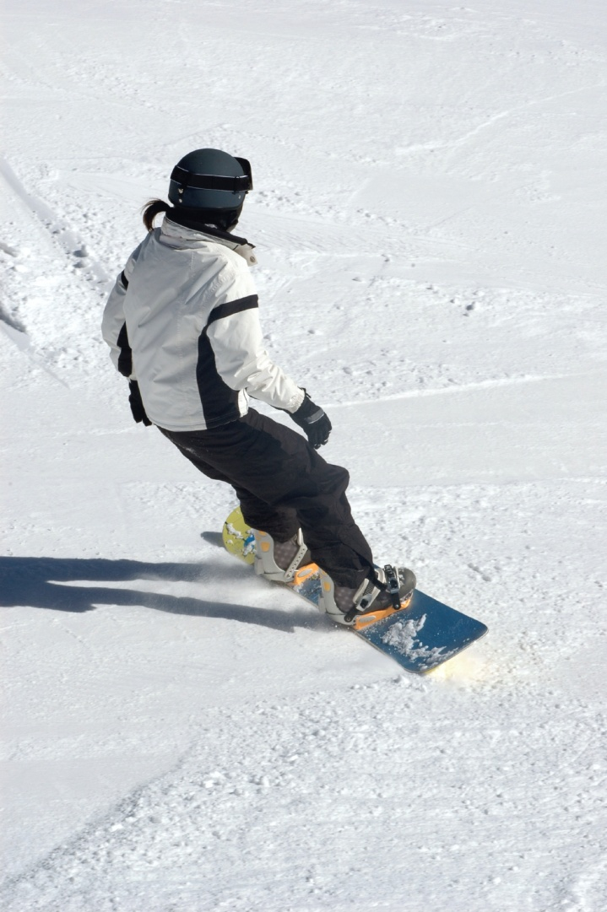
Whether girls are participating in snowboarding or traditional downhill, slalom, Super G, or other types of skiing, participants use trails and slopes matched to their abilities. Skiing.about.com describes various ski levels, which range from “never-ever” to expert. In planning a Girl Scout ski or snowboarding trip, contact the ski resort or organization to inquire about rental equipment, lift tickets, and accommodations for large groups. Downhill skiing and snowboarding is not recommended for Girl Scout Daisies.
Caution: Girls are not allowed to do aerial tricks on skis or snowboards.
Know where to downhill ski and snowboard. Connect with your Girl Scout council for site suggestions. Also, locate ski resorts by region at abc-of-snowboarding.com.
Include girls with disabilities. Communicate with girls with disabilities and/or their caregivers to assess any needs and accommodations. Learn more about the resources and information that The Whistler for the Disabled Society provides to people with disabilities.
Downhill Skiing and Snowboarding Gear
Basic Gear
- Hat
- Thick, water-resistant gloves or mittens
- Heavy insulating socks
- Sunglasses or ski goggles to protect eyes from bright snow glare
- Sunscreen with SPF of at least 15
- Lip balm
Specialized Gear
- Windproof, waterproof jacket and pants
- Protective helmet with properly fitting safety harness that meets the Snell Memorial Foundation’s RS-98 or S-98 standards or the American Society for Testing and Materials (ASTM) F2040 requirements (or both) and displays the Safety Equipment Institute (SEI) seal
- Ski or snowboarding boots
- Skis or snowboards with bindings
- Ski poles (not needed for snowboarding)
Prepare for Downhill Skiing and Snowboarding
- Communicate with council and parents. Inform your Girl Scout council and girls’ parents/guardians about the activity, including details about safety precautions and any appropriate clothing or supplies that may be necessary. Follow council procedures for activity approval, certificates of insurance, and council guidelines about girls’ general health examinations. Make arrangements in advance for all transportation and confirm plans before departure.
- Girls plan the activity. Keeping their grade-level abilities in mind, encourage girls to take proactive leadership roles in organizing details of the activity.
- Arrange for transportation and adult supervision. The recommended adult-to-girl ratios are two non-related adults (at least one of whom is female) to every:
- 12 Girl Scout Brownies
- 16 Girl Scout Juniors
- 20 Girl Scout Cadettes
- 24 Girl Scout Seniors
- 24 Girl Scout Ambassadors
Plus one adult to each additional:
- 6 Girl Scout Brownies
- 8 Girl Scout Juniors
- 10 Girl Scout Cadettes
- 12 Girl Scout Seniors
- 12 Girl Scout Ambassadors
- Verify instructor knowledge and experience. Instruction is given by a person with experience teaching and/or supervising downhill skiing/snowboarding for the age group(s) involved. Instructors are certified by the Professional Ski Instructors of America (PSIA) and the American Association of Snowboard Instructors (AASI) or possess equivalent certification or documented experience according to your council’s guidelines, as outlined in Volunteer Essentials.
- Compile key contacts. Give an itinerary to a contact person at home; call the contact person upon departure and return. Create a list of girls’ parents/guardian contact information, telephone numbers for emergency services and police, and council contacts—keep on hand or post in an easily accessible location.
- Select a safe downhill skiing and/or snowboarding site. Girls are encouraged to plan trip details and include adequate rest periods with opportunities to replenish fluids and eat high-energy foods (such as fruits and nuts). A nutritious, high-energy snack is planned, with beverages provided to prevent dehydration. Ensure that terrain and potential hazards are known to all participants.
- Prepare for emergencies. Ensure the presence of a waterproof first-aid kit and a first-aider with a current certificate in First Aid, including Adult and Child CPR or CPR/AED, who is prepared to handle cases of frostbite, cold exposure, hypothermia, sprains, fractures, and altitude sickness. Emergency transportation is available; if any part of the activity is located 60 minutes or more from Emergency Medical Services response time, ensure the presence of a first-aider (level 2) with Wilderness and Remote First Aid. See Volunteer Essentials for information about first-aid standards and training.
- Get in shape. Participants get in condition by exercising before the skiing or snowboarding trip. Safesnowboarding.com covers preparatory exercises.
On the Day of Downhill Skiing or Snowboarding
- Get a weather report. On the morning of the activity, check weather.com or other reliable weather sources to determine if conditions are appropriate. If severe weather conditions prevent the activity, be prepared with a backup plan or alternate activity, or postpone the activity. Write, review, and practice evacuation and emergency plans for severe weather with girls.
- Use the buddy system. Girls are divided into teams of two. Each girl chooses a buddy and is responsible for staying with her buddy at all times, warning her buddy of danger, giving her buddy immediate assistance if safe to do so, and seeking help when the situation warrants it. If someone in the group is injured, one person cares for the patient while two others seek help.
- Safeguard valuables. Secure equipment in a dry, locked storage area.
- Learn the basics of skiing and snowboarding. Participants learn how to ride ski lifts, including line courtesy, loading and unloading, and emergency procedures. Skiers and snowboarders ski and snowboard under control. Participants ski responsibly, and the rules of the ski area are explained and observed.
- Follow downhill skiing and snowboarding safety standards. Skiers and snowboarders follow these guidelines:
- Do not ski off-trail or in an unmarked or closed area.
- Make others aware before you turn.
- Yield the right-of-way to those already on the slope.
- Do not cross the path of skiers.
- Avoid objects and obstacles, such as trees and rocks.
- To rest or adjust equipment, stop on the sides of the slope or trail.
- Move quickly to the side of the trail or slope after falling, unless injured.
- Summon the ski patrol if a skier is injured.
Downhill Skiing and Snowboarding Links
- American Association of Snowboard Instructors: www.aasi.org01/home/copyright.asp
- National Ski Patrol: www.nsp.org
- U.S. Ski Team: www.usskiteam.com
- U.S. Snowboarding: www.ussnowboarding.com
Downhill Skiing and Snowboarding Know-How for Girls
- Know the slopes. Skiing.about.com details trail ratings, which include green circle as the easiest, blue square as intermediate, and black diamond for expert skiers and snowboarders.
- Prepare for snowboarding. Learn about the snowboard stance, using a snowboard, and how to avoid injuries at safesnowboarding.com.
Downhill Skiing and Snowboarding Jargon
- Bowling pins: Skiers and snowboarders who obstruct a ski or snowboarding hill by grouping together and blocking the track
- Moguls: Bumps in the snow created by skiers turning in the same place and pushing the snow into humps; moguls also are constructed by ski resorts to serve as a large ski obstacle course
- Snowplow: Skiing maneuver used to stop or slow down; ski tips are pointed at each other in the form of an inverted V

