
Cross-Country Skiing: Safety Activity Checkpoints
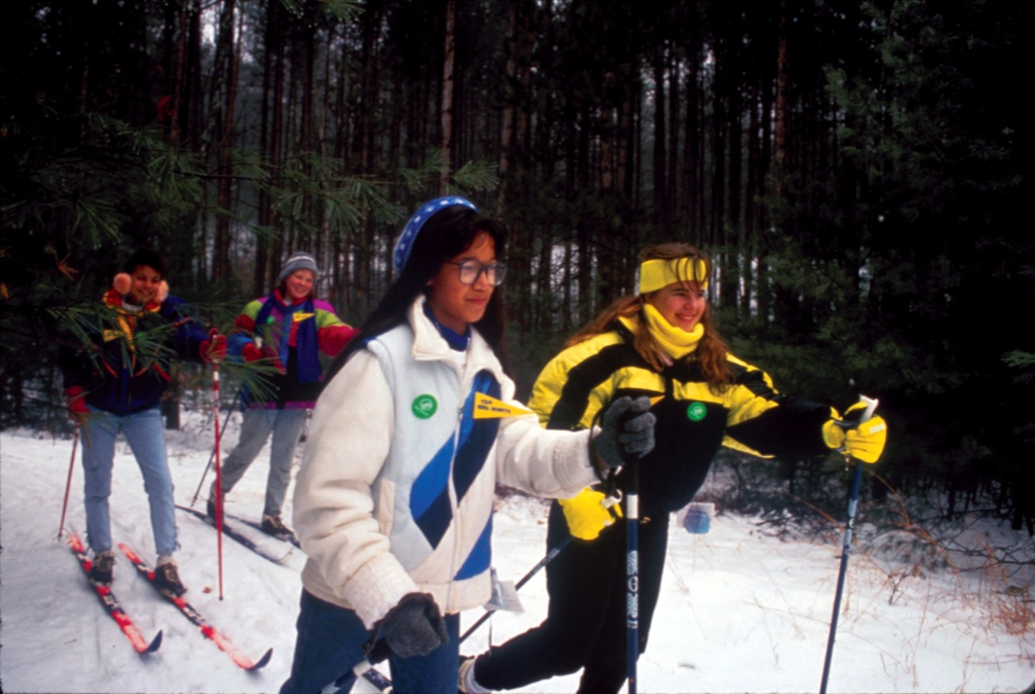
Also referred to as “back-country,” “Nordic,” and “XC skiing,” cross-country skiing is an excellent form of exercise and an opportune way to explore the outdoors in the wintertime. As with downhill skiers, cross-country skiers use two poles for guidance, and bindings to connect boots to skis. Unlike downhill skiing, in which the entire boot is attached to the ski, only the toe of the cross-country skier’s boot is attached to the ski. Contact ski shops and cross-country ski organizations to inquire about rental equipment. Cross-country skiing is not recommended for Girl Scout Daisies.
Know where to cross-country ski. Designated cross-country ski trails are recommended. Connect with your Girl Scout council for site suggestions. Also, xcski.org provides information about cross-country skiing trails.
Include girls with disabilities. Communicate with girls with disabilities and/or their caregivers to assess any needs and accommodations. Learn more about the resources and information that www.SitSki.com and Disabled Sports USA provide to people with disabilities.
Cross-Country Skiing Gear
Basic Gear
- Winter hat
- Thick, water-resistant gloves or mittens
- Heavy insulating socks
- Thermal underwear or long johns
- Sunglasses or ski goggles to protect eyes from bright snow glare
- Water bottle, high-energy food (such as fruits and nuts), sunscreen, and lip balm
- Daypack to carry personal belongings
Specialized Gear
- Windproof, waterproof jacket
- Tights and windbreakers made for skiing, bicycling, or running
- Skis
- Ski poles
- Boots
Prepare for Cross-Country Skiing
- Communicate with council and parents. Inform your Girl Scout council and girls’ parents/guardians about the activity, including details about safety precautions and any appropriate clothing or supplies that may be necessary. Follow council procedures for activity approval, certificates of insurance, and council guidelines about girls’ general health examinations. Make arrangements in advance for all transportation and confirm plans before departure.
- Girls plan the activity. Keeping their grade-level abilities in mind, encourage girls to take proactive leadership roles in organizing details of the activity.
- Arrange for transportation and adult supervision. Ensure that one adult leads and another adult brings up the rear of the group. The recommended adult-to-girl ratios are two non-related adults (at least one of whom is female) to every:
- 12 Girl Scout Brownies
- 16 Girl Scout Juniors
- 20 Girl Scout Cadettes
- 24 Girl Scout Seniors
- 24 Girl Scout Ambassadors
Plus one adult to each additional:
- 6 Girl Scout Brownies
- 8 Girl Scout Juniors
- 10 Girl Scout Cadettes
- 12 Girl Scout Seniors
- 12 Girl Scout Ambassadors
- Verify instructor knowledge and experience. Instruction is given by an adult with experience teaching and/or supervising cross-country skiing for the age group(s) involved or has documented experience according to your council’s guidelines, as outlined in Volunteer Essentials.
- Compile key contacts. Give an itinerary to a contact person at home; call the contact person upon departure and return. Create a list of girls’ parents/guardian contact information, telephone numbers for emergency services and police, and council contacts—keep on hand or post in an easily accessible location.
- Select a safe cross-country skiing site. Girls are encouraged to plan trip details and include adequate rest periods with opportunities to replenish fluids and eat high-energy foods (such as fruits and nuts). The nature of the terrain, potential hazards (such as an avalanche or frozen lake), mileage, and approximate cross-country skiing time are known to all group members. When a latrine is not available, individual cat holes at least 200 feet away from water sources are used to dispose of human waste (visit www.lnt.org for more information).
- Map the course. Before skiing, designate a meeting place where girls can contact a supervising adult. The itinerary, with planned departure and return times and names of the cross-country skiers, is left with a contact person. The route is marked on a map. The contact person is advised before the group’s departure and upon its return.
- Prepare for emergencies. Ensure the presence of a waterproof first-aid kit and a first-aider with a current certificate in First Aid, including Adult and Child CPR or CPR/AED, who is prepared to handle cases of frostbite, cold exposure, hypothermia, sprains, fractures, and altitude sickness. Emergency transportation is available; if any part of the activity is located 60 minutes or more from emergency medical services, ensure the presence of a first-aider (level 2) with Wilderness and Remote First Aid. Girls are trained in winter survival (such as snow-cave building, whiteouts, and avalanche avoidance), as needed. Search-and-rescue procedures are written out in advance; arrangements are made for medical emergencies and evacuation procedures. See Volunteer Essentials for information about first-aid standards and training.
On the Day of Cross-Country Skiing
- Get a weather report. On the morning of the activity, check weather.com or other reliable weather sources to determine if conditions are appropriate. Xcski.org provides reports about snow conditions by region. If severe weather conditions prevent the activity, be prepared with a backup plan or alternate activity, or postpone the activity. Write, review, and practice evacuation and emergency plans for severe weather with girls.
- Use the buddy system. Girls are divided into teams of two. Each girl chooses a buddy and is responsible for staying with her buddy at all times, warning her buddy of danger, giving her buddy immediate assistance if safe to do so, and seeking help when the situation warrants it. If someone in the group is injured, one person cares for the patient while two others seek help.
- Follow cross-country safety standards. Ski area rules are explained and observed:
- Girls ski under control to avoid other skiers and objects.
- Girls yield the right-of-way to those already on the trail. They step to the side to let faster skiers pass. A descending skier has the right of way.
- A faster skier indicates her desire to pass by calling “Track, please.”
- Girls do not ski close to the edge of an embankment or a cliff.
- Girls do not walk on ski trails.
Cross-Country Skiing Links
- Cross Country Ski Areas Association: www.xcski.org
- National Ski Patrol: www.nsp.org
- The World of Cross Country Skiing: www.xcskiworld.com
Cross-Country Skiing Know-How for Girls
- Get in shape. Before cross-country skiing, run and/or participate in other aerobic exercises to build endurance.
- Recover from a fall. The act of hoisting back up while wearing skis can be a cumbersome process. Learn how to get back up on your skis at the XCskiworld Web site.
Cross-Country Skiing Jargon
- Basket: Plastic “foot” on the end of a ski pole that acts as a pushing platform
- Classic technique (“diagonal stride”): A technique in which the skier uses an opposite-leg and opposite-arm motion in a straight-ahead direction

