
Girl Scout Cookie/Council-Sponsored Product Sale:
Safety Activity Checkpoints
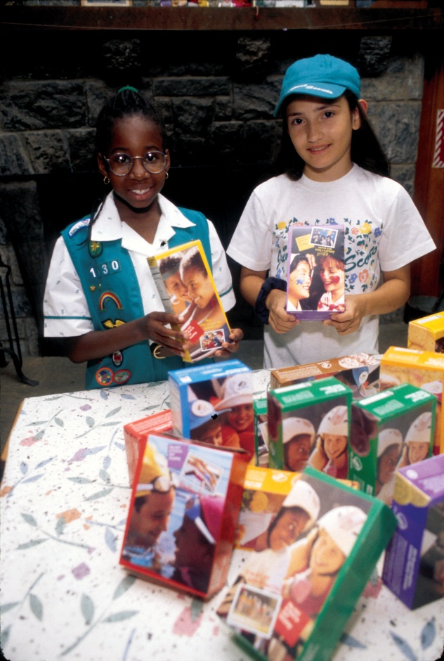
The Girl Scout Cookie Program is the largest girl-led business in the United States, generating more than $700 million for girls and communities nationwide. Through the Girl Scout Cookie Program, girls develop five essential skills: goal setting, decision making, money management, people skills, and business ethics. Girl Scout council-sponsored product sales—which include products from official Girl Scout Cookie vendors and magazine and nut vendors—give girls proven opportunities to earn money and/or credits for their Girl Scout program activities, while contributing significantly to their local councils and communities through take-action projects.
Know where to sell Girl Scout Cookies and other products. See “Sell in Designated Areas” in this checkpoint, as well as materials and information supplied by your Girl Scout council and vendors.
Include girls with disabilities. Communicate with girls with disabilities and/or their caregivers to assess any needs and accommodations.
Prepare for the Girl Scout Cookie/Council-Sponsored Product Sale
- Communicate with council and parents. Inform your Girl Scout council and girls’ parents/guardians about the activity, including details about safety precautions and any appropriate clothing or supplies that may be necessary. Follow council procedures for activity approval, certificates of insurance, and council guidelines about girls’ general health examinations. Make arrangements in advance for all transportation and confirm plans before departure. Obtain written permission from a girl’s parent or guardian before the girl participates in a council product sale, including specific permission for a girl’s use of the Internet for product marketing.
  - Girls plan the activity. In order for girls to gain essential leadership skills inherent in the Girl Scout program, it is important to involve girls in the goal setting, planning, and execution of product sales. For this reason, adults may assist, but cannot sell Girl Scout products. (The role of the Girl Scout Daisy adult is fully explained in online materials on www.girlscouts.org, on the Girl Scout Central: Cookies page.)
- Girls learn about product-sales safety. Girls learn and practice personal protection skills as outlined in GSUSA- and vendor-provided activity materials. For example, a designated adult’s telephone number and/or group e-mail overseen by an adult is given for reorders or complaints. A girl does not give out her phone number or personal e-mail address. Immediate telephone access to an adult is part of the emergency plan for Cadettes, Seniors, and Ambassadors (Daisies, Brownies, and Juniors are always accompanied by an adult). Ensure that a first-aid kit is available at a booth sale or product sale “walk-about.”
- Arrange for adult supervision. Adults provide supervision and guidance for all grade levels. Adults must accompany Girl Scout Daisies, Brownies, and Juniors when they are selling, taking orders for, or delivering products. Adults oversee Girl Scout Cadettes, Seniors, and Ambassadors; they must be aware of how, when, and where the girls are selling products; be on call when girls are participating in product sales and be able to contact girls in a timely manner; be in an automobile in the area; or be present with the girls. Supervision extends to any online activity. Consult the “Computer/Online Use” Safety Activity Checkpoints for information about safe online sales and to obtain the Girl Scout Internet Safety Pledge for All Girl Scouts. Adults are present at booth activities with girls at any grade level.
- Prepare for cookie and product sales with Girl Scout Daisies. Materials provided by GSUSA for Girl Scout Daisies focus on engaging girls in selling to friends (including neighbors and social groups) and family. This approach is based on:
- The attention span and physical abilities of the girls
- The need for one-on-one supervision when handling money (the adult should hold all money)
- The involvement of parents or trusted adults in goal-setting and ensuring that goals are appropriate for the group or individuals
- The importance of providing girls with a foundation in the basics of product-related activities
It is not appropriate for Girl Scout Daisies to be marketing online through their group site, parent or guardian Web sites, or social networking sites. Girl Scout Daisies may send e-mails only if working with an adult, and should use blind e-mails or the online marketing tools provided by GSUSA product vendors on their Web sites.
- Sell in a designated area. Girl Scouts should observe council jurisdiction (by zip codes) when marketing products in person or online, with exceptions made for close family members. Prospects that come from outside council jurisdiction should be referred to the council finder at www.girlscoutcookies.org. Girl Scouts should observe council jurisdictions when selling cookies in a parent’s or guardian’s workplace, unless other arrangements are made to accommodate all Girl Scout families connected to that workplace.
- Respect Girl Scout trademarks. Girl Scout Cookies and Girl Scouts are trademarked by Girl Scouts of the USA and cannot be used to endorse others’ products or services. Any questions regarding the use of Girl Scout Cookies or the name Girl Scouts must be addressed to the Girl Scout council or trademarks@girlscouts.org. The Girl Scout name, Girl Scout Cookies and Girl Scout marks, as well as pictures of Girl Scout Cookie boxes or cookies themselves, can be used only by Girl Scout councils and by girls in conjunction with a Girl Scout product program. These rights are not transferable to customers or businesses purchasing cookies for use with gifting or promotional activities.
On the Day of the Girl Scout Cookie/Council-Sponsored Product Sale
- Use the buddy system. Girls are divided into teams of two. Each girl chooses a buddy and is responsible for staying with her buddy at all times, warning her buddy of danger, giving her buddy immediate assistance if safe to do so, and seeking help when the situation warrants it. If someone in the group is injured, one person cares for the patient while two others seek help. Note that if an individual Girl Scout Cadette, Senior, or Ambassador is selling or delivering products or making a presentation to a group, she must be accompanied by an adult if she is not accompanied by a buddy.
- Practice safety in selling and delivering products.
- Girls wear a membership pin, uniform, or Girl Scout clothing (e.g., Girl Scout T-shirt) to clearly identify themselves as Girl Scouts.
- Girls and accompanying adults are familiar with the areas and neighborhoods where product sales take place.
- Girls participate in door-to-door sales only during daylight hours.
- When Girl Scouts operate a booth in a store, mall, or other public place, adults must be present at all times. When planning sales booths, follow council guidelines for additional information about setting up a booth and safety and security suggestions and assistance.
- Use safe pedestrian practices, especially when crossing at busy intersections. Do not enter the home of a stranger.
- Do not carry large amounts of money. Provision for safeguarding the money is made in advance.
- Practice safe booth sales. When setting up booth sales, ensure that:
- You have adequate space at the booth (table, products, and girls) to allow safe passage by pedestrians, bikes, and cars.
- Girls are a safe distance from cars. If possible, set up a safety barrier between cars and the booth—perhaps a few volunteers could park their cars in spaces near the booth location.
- The booth is not blocking a store entrance or exit.
- Keep cash safe, by keeping the cash box against a wall or behind a barrier of cookie boxes, in the safety of an adult volunteer, or by having an adult volunteer keep the money safe in a front-facing pouch tied around her waist. Girls can receive cash from buyers and make change, but should hand the money to the adult for safekeeping.
- Practice safe online marketing. Girls may use phones and e-mail messages to alert friends and relatives to product sales and accept customer commitments as mail or callbacks for the Girl Scout Cookie sale. Girl Scout cookie product partners are providing secure sites for girl use. Girls who are 13 or older may use social networking sites to market product; however, they must follow council and GSUSA guidelines. Girls writing notes for recipients of product e-mails or announcements online should sign with their first names only, their troop/group number or name, and their council name. Personal e-mails or street addresses of girls should never be used. Instead, use one of the following:
- A blind return address account where the girls’ name or personal e-mail is not revealed to the customer and is instead hosted on a secure site (such as provided by our product sales partners)
- A group account monitored by an adult
- An adult e-mail account supervised by an adult
Girl Scout Cookie/Council-Sponsored Product Sale Links
- Girl Scout Cookies official site: www.girlscoutcookies.org
Girl Scout Cookie/Council-Sponsored Product Sale Jargon
- GSUSA official product sale vendors: Companies licensed by Girl Scouts of the USA to produce official Girl Scout products for girls to sell. The companies are selected by councils and contracted for one, two, and/or three years.
- Little Brownie Bakers and ABC Bakers produce Girl Scout cookies. Their Web sites have general information as well as activities and management tools.
- Ashdon Farms and Trophy Nut are approved GSUSA nut vendors and provide online information, activities, and management tools.
- QSP and American Publishers offer magazine subscription programs approved by GSUSA. Each provides online tools and activities for download and use. Magazine selection and sales may take place online. Check with your council for more details.
- Nutritional and packaging information: Read nutritional and health information on product description sheets provided by the vendors annually or check their Web sites. Girls should be able to discuss serving size, nutritional values, and fat and allergy information. Read additional nutrition information at www.girlscoutcookies.org. Recycling information is provided on product containers.

