

NATIONAL GIRL SCOUT COOKIE WEEKEND  
Party Tips

Successful Party Hosting Tips:

1. Prepare for your cookie party!
   * Set your guest list and send out invitations.
   * Create your "to do" list at least a week in advance including all the decorations you wish to include.
   * Make your cookie party-day “cheat sheet.” Keep this on an index card in your pocket. That way you can know at a glance when it’s time to arrive, set up and when you can expect your guests to arrive.
2. Get your guests talking.
   * Pick your theme (suggested ideas below). Consider using nametags, but make them fun (think about all the great Girl Scout Cookie flavors!)
   * Give guests an assignment. One way to get people mingling is to give them assignments, like directing some to the cookie sale (if you’re hosting one), have others go to different activities with the girls, some to pose for photos with your fun decorations, etc.
3. Spread it out.
   * Consider creating a cookie party “passport” to ensure your party guests make it all the way around the room to see everything you have set up, whether it’s the cookie sale, activities with the girls or whatever else you have planned. Let the girls stamp each passport when guests have “checked in” at the respective stations.
   * Think about setting "milestones" for your party. You might start out with an informal icebreaker to get everyone to meet each other and the troop(s), and culminate in voting/awards for most cookies bought for the day or most sociable guest who talks to everyone in the troop, for example.

Cookie Party Ideas/Themes for Inspiration

Team Cookie (Sports-Inspired)

**[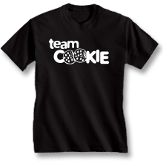](http://www.google.com/url?sa=i&rct=j&q=&esrc=s&frm=1&source=images&cd=&cad=rja&docid=FqL2oSdbJbLj6M&tbnid=CI2Dd7gCN2EFmM:&ved=0CAUQjRw&url=http://www.progressivegraphics.net/RaceDesigns.php&ei=juNqUpPuBMbokQeonIHYAQ&bvm=bv.55123115,d.eW0&psig=AFQjCNGMpVo9BdC_AFrWC5eHK0HAgSHZ6g&ust=1382823142465211)** **[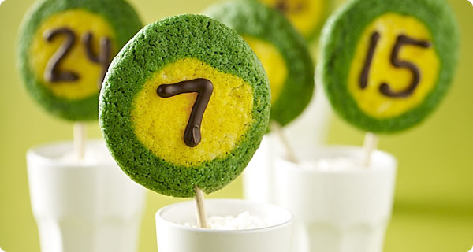](http://www.google.com/url?sa=i&rct=j&q=&esrc=s&frm=1&source=images&cd=&cad=rja&docid=i9Vc5OAGw0v1fM&tbnid=TVqy73gyZd7jWM:&ved=0CAUQjRw&url=http://www.krusteaz.com/cookies-and-molten-deep-dish-recipes-93/team-spirit-cookies-743&ei=q-NqUsSxK5T6kQeklYE4&bvm=bv.55123115,d.eW0&psig=AFQjCNGMpVo9BdC_AFrWC5eHK0HAgSHZ6g&ust=1382823142465211)**

[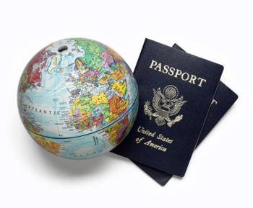](http://www.google.com/url?sa=i&rct=j&q=&esrc=s&frm=1&source=images&cd=&cad=rja&docid=tqkIrFTclUR-nM&tbnid=nupyo-kcA7AH5M:&ved=0CAUQjRw&url=http://studenthealth.uiowa.edu/services/international-travel&ei=puRqUuvwH8yHkQeVnIGQAQ&bvm=bv.55123115,d.eW0&psig=AFQjCNF_t55LyIIefiCOv8p1G3VuFYkIKg&ust=1382823393198199)[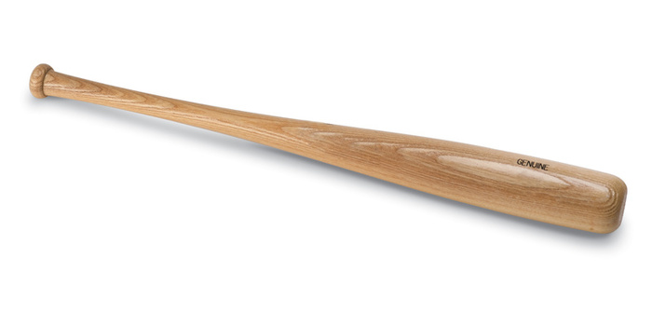](http://www.google.com/url?sa=i&rct=j&q=&esrc=s&frm=1&source=images&cd=&cad=rja&docid=IApb_OeJTq_T0M&tbnid=l2JIj7A46j2E6M:&ved=0CAUQjRw&url=http://baseballheritagemuseum.org/facts-baseball-bat/&ei=-uNqUqLmMZT6kQeklYE4&bvm=bv.55123115,d.eW0&psig=AFQjCNExKZZxo40p-MSJeoYPaURee00voQ&ust=1382823280510301)

Cookie Adventure (Adventure-Inspired)

**[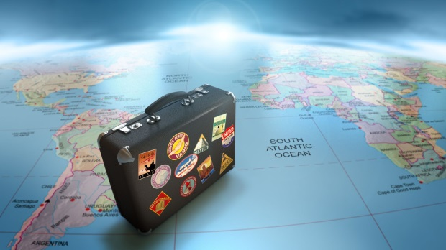](http://www.google.com/url?sa=i&rct=j&q=&esrc=s&frm=1&source=images&cd=&cad=rja&docid=JmE19VyzYncsUM&tbnid=GQSg6g33GZusgM:&ved=0CAUQjRw&url=http://iboomer.com/category/travel/&ei=deRqUs-2Kc7qkAfSp4Bo&bvm=bv.55123115,d.eW0&psig=AFQjCNF_t55LyIIefiCOv8p1G3VuFYkIKg&ust=1382823393198199)**

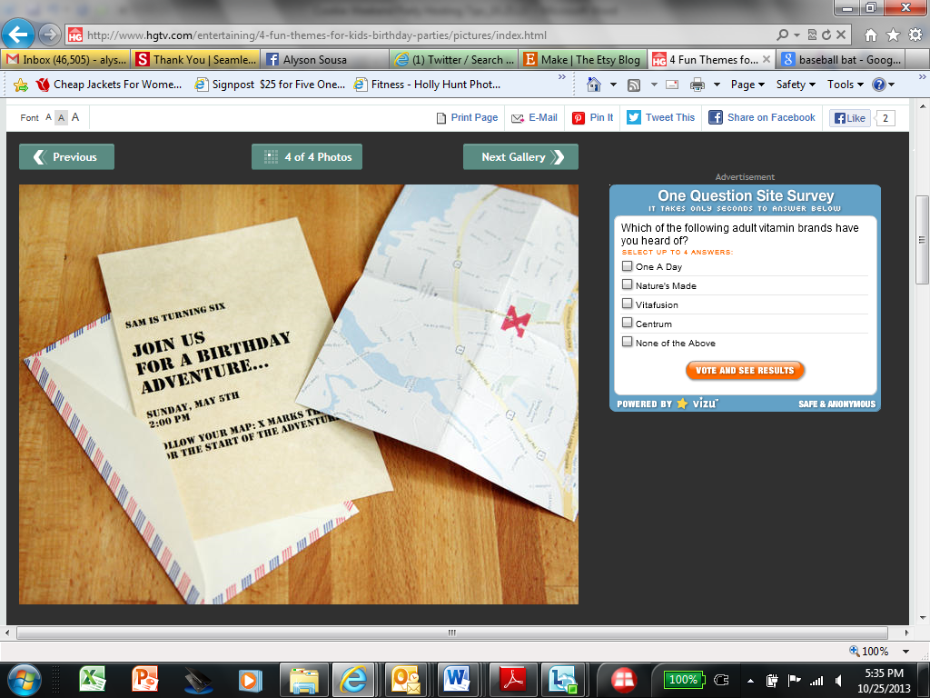

Cookie Circus (Entertainment Inspired)

**[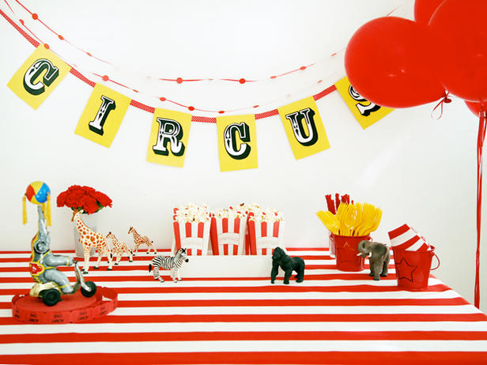](http://www.hgtv.com/entertaining/4-fun-themes-for-kids-birthday-parties/pictures/page-3.html) [](http://www.google.com/url?sa=i&rct=j&q=&esrc=s&frm=1&source=images&cd=&cad=rja&docid=7PaANYKSfCaTdM&tbnid=AGaeCI2MlxqF-M:&ved=0CAUQjRw&url=http://depositphotos.com/10096300/stock-illustration-Vector-illustration-of-circus-tent.html&ei=GeVqUpOJE4q2kAffyoFo&bvm=bv.55123115,d.eW0&psig=AFQjCNE2tppp5GyHFZp7B8al7FZ6qGNNgQ&ust=1382823546352013)**

“Cookies & Tea” – (Tea Party Inspired)

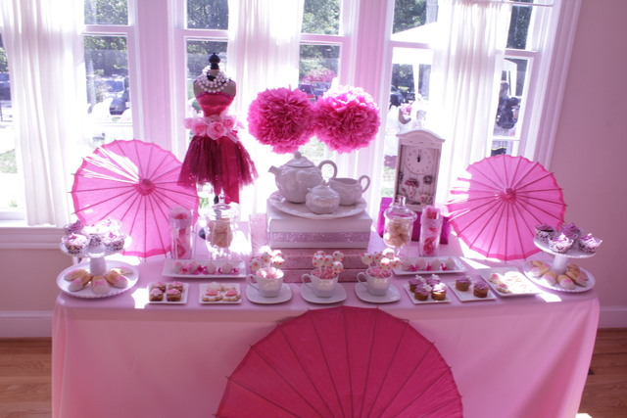

Cookie Fiesta (Fiesta/Latin Inspired)

