
Caving: Safety Activity Checkpoints
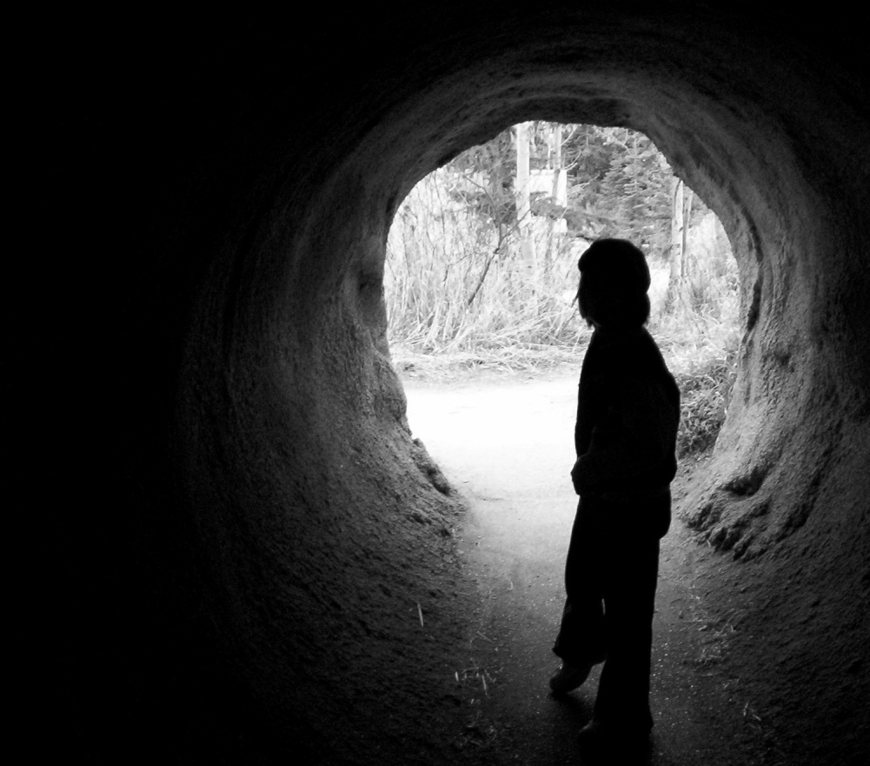
Caving—also called “spelunking” (speh-LUNK-ing) is an exciting, hands-on way to learn about speleology (spee-lee-AH-luh-gee), the study of caves, in addition to paleontology (pay-lee-en-TAH-luh-gee), the study of life from past geologic periods by examining plant and animal fossils. As a sport, caving is similar to rock climbing, and often involves using ropes to crawl and climb through cavern nooks and crannies. These checkpoints do not apply to groups taking trips to tourist or commercial caves, which often include safety features such as paths, electric lights, and stairways. Girl Scout Daisies and Brownies do not participate in caving.
Know where to go caving. Connect with your Girl Scout council for site suggestions. Also, the National Speleological Society provides an online search tool for U.S. caving clubs, and the National Park Service provides information about National Park caves.
Include girls with disabilities. Communicate with girls with disabilities and/or their caregivers to assess any needs and accommodations. Learn more about the resources and information that the National Center on Accessibility and the National Center of Physical Activities and Disabilities provide to people with disabilities.
Caving Gear
Basic Gear
- Sturdy boots with ankle protection (hiking boots for dry areas; rubber boots or wellies for wet caves)
- Warm, rubber gloves (to keep hands warm and protect against cuts and abrasions)
- Nonperishable, high-energy foods such as fruits and nuts
- Water
Specialized Gear
- Knee and elbow pads
- Water-resistant “wet socks” (for wet caves)
- Belt and harness
- Compass
- Safety helmet; ensure that safety helmets fit properly, with a strong chin strap; for horizontal caves, bump helmets may be used; for vertical caves, use safety helmets carrying the Union of International Alpine Association (UIAA) seal, which is located on the inside of the helmet
- Three sources of light; the main light is electric and mounted on the safety helmet, while the other two light sources may be flashlights
- Spare bulbs and batteries
- Trash bag (use as a poncho or for covering dirty equipment after the caving activity; cavers keep an empty trash bag in their safety helmets)
Prepare for Caving
- Communicate with council and parents. Inform your Girl Scout council and girls’ parents/guardians about the activity, including details about safety precautions and any appropriate clothing or supplies that may be necessary. Follow council procedures for activity approval, certificates of insurance, and council guidelines about girls’ general health examinations. Make arrangements in advance for all transportation and confirm plans before departure.
- Girls plan the activity. Keeping their grade-level abilities in mind, encourage girls to take proactive leadership roles in organizing details of the activity.
- Arrange for transportation and adult supervision. Ensure that at least one adult is an experienced caver. The recommended adult-to-girl ratios are two non-related adults (at least one of whom is female) to every:
- 16 Girl Scout Juniors
- 20 Girl Scout Cadettes
- 24 Girl Scout Seniors
- 24 Girl Scout Ambassadors
Plus one adult to each additional:
- 8 Girl Scout Juniors
- 10 Girl Scout Cadettes
- 12 Girl Scout Seniors
- 12 Girl Scout Ambassadors
- Verify instructor knowledge and experience. A guide with documented experience in cave exploration accompanies the group into the cave. A guide can also help decide which caves are suitable. Pre-trip instruction is given by an adult with documented experience according to your council’s guidelines, as outlined in Volunteer Essentials.
- Select a safe site. Obtain guidance from a local chapter of the National Speleological Society to select a cave to explore. Never explore a cave without a guide and without written permission from the site owner/operator.
- Compile key contacts. Give an itinerary to a contact person at home; call the contact person upon departure and return. Create a list of girls’ parents/guardian contact information, telephone numbers for emergency services and police, and council contacts—keep on hand or post in an easily accessible location.
- Girls learn about caving. Girls learn about basic caving guidelines before planning a caving trip, and they must understand safety procedures and know how to handle equipment.
- Dress appropriately for the activity. Make sure girls and adults avoid wearing dangling earrings, bracelets, and necklaces that may become entangled in equipment.
- Prepare for emergencies. Ensure the presence of a waterproof first-aid kit and a first-aider with a current certificate in First Aid, including Adult and Child CPR or CPR/AED, who is prepared to handle cases of soft tissue and bone injury, and hypothermia. If any part of the activity is located 60 minutes or more from Emergency Medical Services response time, ensure the presence of a first-aider (level 2) with Wilderness and Remote First Aid. See Volunteer Essentials for information about first-aid standards and training.
On the Day of Caving
- Get a weather report. On the morning of the caving activity, check weather.com or other reliable weather sources to determine if conditions are appropriate. If severe weather conditions prevent the caving activity, be prepared with a backup plan or alternate activity. Write, review, and practice evacuation and emergency plans for severe weather with girls. In the event of a storm, take shelter away from tall objects (including trees, buildings, and electrical poles). Find the lowest point in an open flat area. Squat low to the ground on the balls of the feet, and place hands on knees with head between them. Also, in wet weather, avoid caves with stream passages, as some caves can flood.
- Use the buddy system. Girls are divided into teams of two. Each girl chooses a buddy and is responsible for staying with her buddy at all times, warning her buddy of danger, giving her buddy immediate assistance if safe to do so, and seeking help when the situation warrants it. If someone in the group is injured, one person cares for the patient while two others seek help.
Caving Links
- American Cave Conservation Association: www.cavern.org
- National Caves Association: http://cavern.com
- National Speleological Society: www.caves.org
Caving Know-How for Girls
- Leave No Trace in caving. Learn about threats to cave and karst systems, which are underground drainage systems, from the National Park Service.
- Get into archaeology. Read up about the archaeological explorations in caving at caverinfo.com.
Caving Jargon
- Calcite: One of the most common minerals that is a major component of limestone, marble, and chalk
- Scallops: Spoon-shaped hollows dissolved in cave walls, ceilings, and floors by flowing water

