
Canoeing: Safety Activity Checkpoints
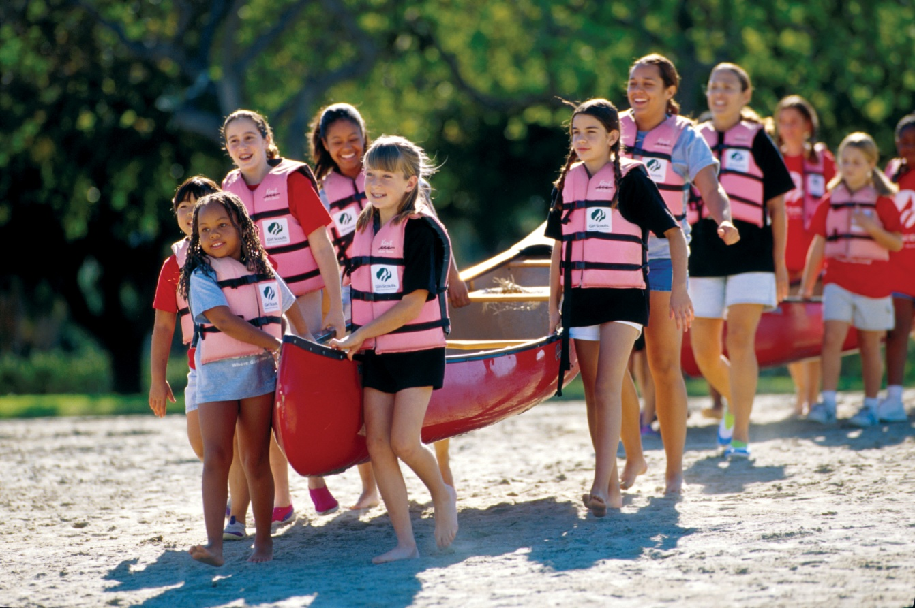
Canoeing is a great team-building activity and an enjoyable and relaxing way to experience the outdoors. Compared to kayaks, canoes tend to be larger and uncovered, and usually accommodate several people kneeling or sitting on a seat. Canoeists use either a single- or double-bladed paddle, and kayakers almost always use a two-bladed paddle. Canoeing is not recommended for Girl Scout Daisies; Class III and Class IV whitewater is not recommended for Brownies; Class IV whitewater is not recommended for Juniors.
Caution: You must seek council permission for activities with uncontrollable and highly changeable environment conditions, such as unclassified rivers and some watercraft trips; girls are never allowed on Class V and above whitewater.
Know where to go canoeing. Just about any body of water (lake, stream, river, ocean) is suitable for canoeing, so long as the proper equipment, instructions, and safety precautions are used. Canoeing is done only on water that has been approved by your Girl Scout council or that has been run and rated, and on whitewater only up to Class IV difficulty, as defined by the American Version of the International Scale of River Difficulty. The American Whitewater Association provides information about American and some international river locations, classes, and levels. Connect with your Girl Scout council for site suggestions.
Include girls with disabilities. Communicate with girls with disabilities and/or their caregivers to assess any needs and accommodations. Learn more about the paddleability resources and information that the International Canoe Federation and British Canoe Union provide to people with disabilities.
Canoeing Gear
Basic Gear
- Layered clothing that’s easily changeable depending on temperatures (wool, nylon, or polypropylene pile)
- Waterproof jacket and pants
- Hat and change of dry clothing (no cotton; store in waterproof bag)
- Boat shoes, closed-toe and nonslip hiking/sport sandals with heel strap, or water socks or shoes (no flip-flops)
- Waterproof sunscreen (SPF of at least 15)
- Sunglasses
- Flashlight (and extra batteries)
- Emergency repair kit: duct tape or electrical tape, screwdriver, pliers
- Emergency survival packet: raincoat, waterproof matches, emergency food supplies, lightweight/space blanket, and pocket knife
- Compass and chart of the area (for each adult)
Specialized Gear
- Participants wear a U.S. Coast Guard–approved life jacket (Type III recommended) that fits according to weight and height specifications. Inspect life jackets to ensure that they are in good condition and contain no tears. Read about Coast Guard life jackets here.
- Wetsuit or drysuit recommended when water is colder than 70 degrees Fahrenheit (should be worn when the combined air and water temperature is less than 100 degrees Fahrenheit or when the combination of cool air, wind chill, and evaporative cooling may lead to hypothermia)
- Safety helmet (with flexible, strong, plastic shell with a chin strap and openings for drainage) when canoeing in waters that are Class II and higher
- Throw bag
- Paddles (select appropriate size and style for the canoeists and the activity); have extras on hand; on longer trips or trips involving whitewater, one extra paddle per canoe is carried; on trips of 48 hours or less on flatwater, each group carries two to three extra paddles
- Bailer (a bucket used to remove water from a boat) or sponge
- Emergency sound device, such as a fog horn or sounding flares
- At least one graspable and throwable portable-flotation device (Type IV buoyant cushion or ring buoy or equivalent) is immediately available for each group on the water
- Painter (see “Canoeing Jargon” for definition) is secured to each end of the canoe
Prepare for Canoeing
- Communicate with council and parents. Inform your Girl Scout council and girls’ parents/guardians about the activity, including details about safety precautions and any appropriate clothing or supplies that may be necessary. Follow council procedures for activity approval, certificates of insurance, and council guidelines about girls’ general health examinations. Make arrangements in advance for all transportation and confirm plans before departure.
- Girls plan the activity. Keeping their grade-level abilities in mind, encourage girls to take proactive leadership roles in organizing details of the activity.
- Ensure participants are able to swim. Participants’ swimming abilities are classified and clearly identified (for instance, with colored headbands to signify beginners, advanced swimmers, etc.) at council-approved sites, or participants provide proof of swimming-test certification. In the absence of swimming-test certification, a swim test is conducted on the day of the activity. Consult with your Girl Scout council for additional guidance.
- Arrange for transportation and adult supervision. Ensure that the skill level of the adults is higher than the difficulty of the intended activity and that they have firsthand knowledge of the hazards and rapids on the river to be run. The recommended adult-to-girl ratios are two non-related adults (at least one of whom is female) to every:
- 12 Girl Scout Brownies
- 16 Girl Scout Juniors
- 20 Girl Scout Cadettes
- 24 Girl Scout Seniors
- 24 Girl Scout Ambassadors
Plus one adult to each additional:
- 6 Girl Scout Brownies
- 8 Girl Scout Juniors
- 10 Girl Scout Cadettes
- 12 Girl Scout Seniors
- 12 Girl Scout Ambassadors
- Verify instructor knowledge and experience. For each of the following types of canoeing, one instructor or qualified adult is currently certified by the American Canoe Association, the American Red Cross, or other sponsoring organization approved by your council with the following certification(s) appropriate for the activity, or equivalent certification, or has documented experience according to your council’s guidelines, as outlined in Volunteer Essentials:
- Flatwater canoeing: Flatwater, Moving, Paddling, or River Paddling Instructor Certification from the American Canoe Association, and the certification must include certification of Waterfront lifeguarding from the American Red Cross; the ratio of instructor to participant is 1 to 12.
- Whitewater canoeing: Whitewater Instructor Certification from the American Canoe Association or Small Craft Safety Instructor from the American Red Cross and the certification must include Swiftwater Safety & Rescue and Advanced Swiftwater Safety & Rescue; the ratio of instructor to participant is 1 to 8.
- Canoe trips—flatwater and whitewater canoeing: The instructor must have the appropriate certification: Moving Water Instructor or White-Water Instructor from the American Canoe Association or Small Craft Safety Instructor from the American Red Cross; the ratio of adult to participant is 1 to 8.
- Compile key contacts. Give an itinerary to a contact person at home; call the contact person upon departure and return. Create a list of girls’ parents/guardian contact information, telephone numbers for emergency services and police, and council contacts—keep on hand or post in an easily accessible location.
- Research river condition and select canoes appropriate to skill level. Consider weather and water conditions, weight of passengers, and equipment. Also make sure of the following: Craft weight and capacity are not exceeded (some crafts clearly display maximum capacity).
- Canoes that are 15 feet or shorter hold no more than two people.
- Each canoe is sized for the number of people using it.
- You are knowledgeable of the difficulty of the water run and the International Scale of River Difficulty.
- You are aware of possible changes in river level and weather and their effects on the run’s level of difficulty.
- Prepare for emergencies. If a lifeguard is not on duty, an adult with rescue and resuscitation experience and/or certification is present; at least one adult has small-craft safety certification or equivalent experience (both of these qualifications can be held by one person). Ensure the presence of a waterproof first-aid kit and a first-aider with a current certificate in First Aid, including Adult and Child CPR or CPR/AED, who is prepared to handle cases of near-drowning, immersion hypothermia, and sunburn. If any part of the activity is located 60 minutes or more from emergency medical services, ensure the presence of a first-aider (level 2) with Wilderness and Remote First Aid. See Volunteer Essentials for information about first-aid standards and training.
- Respect the environment. Make sure canoeing on whitewater or semi-protected waters meets the Safety Code of American Whitewater.
- File a float plan. If participating in a long-distance canoe trip, file a float plan with local authorities that includes names of people on board, destination, craft description, times of departure and return, and additional details about routes and marine communications. The Coast Guard provides an electronic, printable form.
- Know the Universal River Signals. The qualified adult and/or canoe instructor understands the American Whitewater codes. Also, a set of whistle and visual signals is established that allows messages to pass between canoes.
- Take river-rescue precautions. Instructor/qualified adult attaches a locking blade knife to life jacket or secures it inside the canoe in an easily accessible place.
- Transport canoes safely. Canoes are transported on car-top racks or trailers designed to haul canoes. Canoes are secured with two lines across the top and a line at the bow and the stern.
- Encourage girls to pack wisely. Additional gear (clothing, sleeping, cooking) is stored in waterproof containers or packages and secured in the canoe. Do not overload the canoe.
On the Day of Canoeing
- Get a weather report. Never canoe on a stormy day. On the day of the activity, visit weather.com, intellicast.com, or other reliable sources to assess weather conditions, water temperature, and river/wave conditions. If weather conditions prevent the trip, be prepared with a backup plan or alternative activity.
- Conduct a swimming test. A test that determines a person’s ability to handle herself when pitched into the water is conducted.
- Review rescue tips. Know how to right a tipped canoe and other river-rescue techniques.
- Use the buddy system. Girls are divided into teams of two. Each girl chooses a buddy and is responsible for staying with her buddy at all times, warning her buddy of danger, giving her buddy immediate assistance if safe to do so, and seeking help when the situation warrants it. If someone in the group is injured, one person cares for the patient while two others seek help.
- Be prepared in the event of a storm with lightning. Exit water immediately and take shelter away from tall objects (including trees, buildings, and electrical poles). Find the lowest point in an open flat area. Squat low to the ground on the balls of the feet, and place hands on knees with head between them. During storms, if shore cannot be reached, secure all loose gear, keep a sharp lookout for other boats and obstructions, and stay low.
Canoeing Links
- American Canoe Association: www.americancanoe.org
- American Whitewater: www.americanwhitewater.org
- Beginner’s Guide to Canoeing: http://canoeing.com/beginner
- International Canoe Federation: www.canoeicf.com
- National Organization for River Sports: www.nationalrivers.org
- U.S. Coast Guard’s Boating Safety Division: www.uscgboating.org
- Whitewater Rescue Institute: www.whitewaterrescue.com
Canoeing Know-How for Girls
- Master canoeing strokes. The more you know about strokes, the better the canoeist you’ll be. Learn about basic paddle strokes and the single-blade power stroke.
Canoeing Jargon
- Painter: A strong line that floats and is used for securing or towing a canoe; recommended to be at least half the length of the canoe
- Thwart: Canoe seat

