
Bicycling: Safety Activity Checkpoints
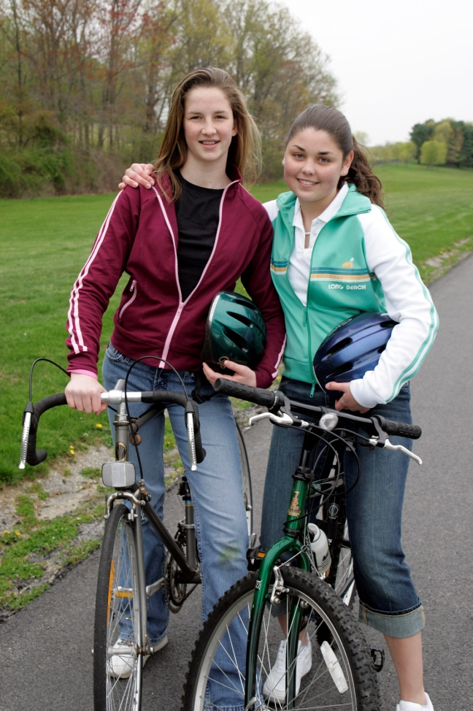
Whether you’re riding a mountain, racing, or hybrid bike, it’s important to assure that bikes are the proper size and in good condition. Make sure that the seat height is adjusted properly; when seated, girls should have a slight bend in the knee—in other words, the legs should never be fully extended. A too-low seat is a common problem and causes significant discomfort. The helmet should fit comfortably but snugly, be worn level on the head, and not move in any direction when the chin strap is securely fastened.
Bike races, mountain-biking, and long-distance cycling trips can be strenuous, and it’s essential for girls to condition themselves beforehand. Also, long-distance touring involves many hours of cycling, sometimes in difficult terrain, and requires girls to carry more gear and supplies than on short day trips. When training for lengthy bicycle trips, set realistic goals for mileage, and gradually increase the distance; for instance, one week, aim to ride 10 miles, and the next, strive for 12.
Caution: Girls are not allowed to do aerial tricks on bicycles.
Know where to bike. Learn about American road bike trails at adventurecycling.org. Connect with your Girl Scout council for site suggestions.
Include girls with disabilities. Communicate with girls with disabilities and/or their caregivers to assess any needs and accommodations. Learn more about the resources and information that the National Center on Accessibility and the National Center of Physical Activities and Disabilities provide to people with disabilities.
Bicycling Gear
Basic Gear
- Waterproof sunscreen and (SPF of at least 15) and lip balm
- Sunglasses
- Nonperishable, high-energy foods such as fruits and nuts
- Daypack to carry personal belongings
Specialized Gear
- Bicycle (padded handlebars and gel-padded seat recommended)
- Reflectors
- Headlamp and taillight if bicycling at dusk
- Horn or bell
- Bicycle clothing: Wear comfortable, close-fitting clothing (such as bicycle shorts or aerobic exercise tights when cycling in temperatures below 68 degrees) that cannot catch in bicycle gears or chain; avoid cotton and use synthetic fabrics that wick perspiration away from skin more comfortably; reflective or light-colored clothing is recommended when cycling at dusk; wear bright-colored or fluorescent clothing during day; on extended trips in cooler weather, wear layers and carry extra clothing and rain gear
- Pant clips or bands if necessary
- Protective bicycle helmet with properly fitting safety harness that meets the American Society for Testing and Materials (ASTM) F1163-88 requirements, displaying the Safety Equipment Institute (SEI) seal
- Biker pack
- Cycling gloves
- Cycling shoes, or stiff-soled athletic shoes such as court shoes
- General map and/or bike-route map
- Compass
- Cycling repair kit: Each group carries a tire pump, tire patch kit, tire irons, screwdriver, adjustable wrench, pliers, hex-head (Allen) wrenches, lubricating fluids
- Two water bottles per person
Prepare for Bicycling
- Communicate with council and parents. Inform your Girl Scout council and girls’ parents/guardians about the activity, including details about safety precautions and any appropriate clothing or supplies that may be necessary. Follow council procedures for activity approval, certificates of insurance, and council guidelines about girls’ general health examinations. Make arrangements in advance for all transportation and confirm plans before departure.
- Girls plan the activity. Keeping their grade-level abilities in mind, encourage girls to take proactive leadership roles in organizing details of the activity. The length and terrain of a trip, day or extended, are appropriate to the girls’ skill levels, their experience, and their physical condition, as well as the time of day, the weather, and the equipment available. Review the route and practice map-reading skills. Make careful plans for the type of road to be traveled. For example, secondary roads are quiet, but may have trees, curves, and hills that obstruct visibility. Ride only during daylight hours.
- Organize cycling groups and arrange for adult supervision. Except when riding on bicycle paths, participants travel in groups of five or six, allowing at least 150 feet between groups so that vehicles may pass. Participants ride one to a bicycle except when riding tandem. In tandem riding, each girl has her own seat and the number of riders doesn’t exceed the intended limits of the bicycle. For every two groups, there is an adult at the head and another at the rear. The recommended adult-to-girl ratios are two non-related adults (at least one of whom is female) to every:
- 6 Girl Scout Daisies
- 12 Girl Scout Brownies
- 16 Girl Scout Juniors
- 20 Girl Scout Cadettes
- 24 Girl Scout Seniors
- 24 Girl Scout Ambassadors
Plus one adult to each additional:
- 4 Girl Scout Daisies
- 6 Girl Scout Brownies
- 8 Girl Scout Juniors
- 10 Girl Scout Cadettes
- 12 Girl Scout Seniors
- 12 Girl Scout Ambassadors
- Compile key contacts. Give an itinerary to a contact person at home; call the contact person upon departure and return. Create a list of girls’ parents/guardian contact information, telephone numbers for emergency services and police, and council contacts—keep on hand or post in an easily accessible location.
- Select safe cycling site or route. Observe all state and local regulations, and notify jurisdictional authorities about the group’s trip, when necessary. Use designated bicycle trails whenever possible, select bicycle trails with even surfaces, and avoid routes involving heavily trafficked streets and highways. Know in advance the location of emergency and medical services along the route.
- Cyclists learn road safety. Girls learn to recognize and avoid common roadway hazards, including drainage grates and manhole covers, sand, gravel, glass, wet leaves, and litter on road shoulders, and other road-surface hazards; to communicate and cooperate with other road users; and to ride defensively. Motor-vehicle traffic presents the greatest danger to cyclists; hazards such as oil, wet leaves, parked cars, and rocks cause the majority of cycling accidents. Girls practice bicycling with a load comparable in weight to the load on the trip and learn to brake before they have to, especially on curves and down hills. Girls are instructed in and practice bicycle-riding skills in traffic, including signaling, scanning ahead and behind (especially before moving left), yielding to oncoming traffic, and making left turns. Emergency braking techniques are taught. Girls cycle single file with traffic; it is acceptable to ride briefly two abreast when passing a slower bicyclist.
- Dress appropriately for the activity. Make sure girls and adults avoid wearing dangling earrings, bracelets, and necklaces that may become entangled in equipment.
- Prepare for emergencies. Ensure the presence of a first-aid kit and a first-aider with a current certificate in First Aid, including Adult and Child CPR or CPR/AED, who is prepared to handle cases of soft tissue and bone injuries, and sunburn. If any part of the activity is located 60 minutes or more from emergency medical services, ensure the presence of a first-aider (level 2) with Wilderness and Remote First Aid. See Volunteer Essentials for information about first-aid standards and training.
On the Day of Bicycling
- Get a weather report. On the morning of the bicycling activity, check weather.com or other reliable weather sources to determine if conditions are appropriate. If severe weather conditions prevent the bicycling activity, be prepared with a backup plan or alternate activity, and/or postpone the cycling activity. Write, review, and practice evacuation and emergency plans for severe weather with girls. In the event of a storm, take shelter away from tall objects (including trees, buildings, and electrical poles). Find the lowest point in an open flat area. Squat low to the ground on the balls of the feet, and place hands on knees with head between them.
- Use the buddy system. Girls are divided into teams of two. Each girl chooses a buddy and is responsible for staying with her buddy at all times, warning her buddy of danger, giving her buddy immediate assistance if safe to do so, and seeking help when the situation warrants it. If someone in the group is injured, one person cares for the patient while two others seek help.
- Be prepared in the case of an emergency. Provide a detailed itinerary and an established call-in schedule for each day. Carry identification and a list of emergency phone numbers and contact information for bike-repair shops.
- Prepare for the long haul. Adjust bicycles frequently for comfort, and check handlebars after adjusting the seat for proper leg extension. Girls should not stop cycling abruptly; instead, after stopping, make sure they cool down gradually by walking around for a few minutes. Girls do not push past their endurance levels.
- Ride safely. Cyclists ride with the flow of traffic and obey applicable traffic regulations, signals, lane markings, and local ordinances pertaining to bicycle operation. Bicyclists do not weave in and out of traffic or between parked cars. Light gear is stored in bicycle panniers (foldable carriers) or packs on the back of the bike. Bicyclists make a full stop and look left, right, and left again, especially at the end of a driveway and before entering a street or roadway. Cyclists walk their bikes across busy intersections. Bicyclists use hand signals to indicate turning or stopping. Bicyclists keep a safe distance between themselves and the vehicle ahead. Bicycles have lights and reflectors. When bicycles are not on segregated paths, lights are on to increase visibility.
Bicycling Links
- Adventure Cycling Association: www.adventurecycling.org
- USA Cycling: www.usacycling.org
- Tread Lightly: www.treadlightly.org
Bicycling Know-How for Girls
- Stretch your muscles. Before cycling, gently stretch your hamstrings, quads (against a wall), and calves. Learn how at www.grouptrails.com/Stretches.htm.
- Learn emergency maneuvers. Read about and practice the quick stop, rock dodge, and instant turn on the League of American Bicyclists site, which also provides tips for beginners.
Bicycling Jargon
- Bully: To ride uphill without slowing down
- Brain bucket: Bicycle helmet
- Century: A 100-mile bike ride

