
Backpacking: Safety Activity Checkpoints
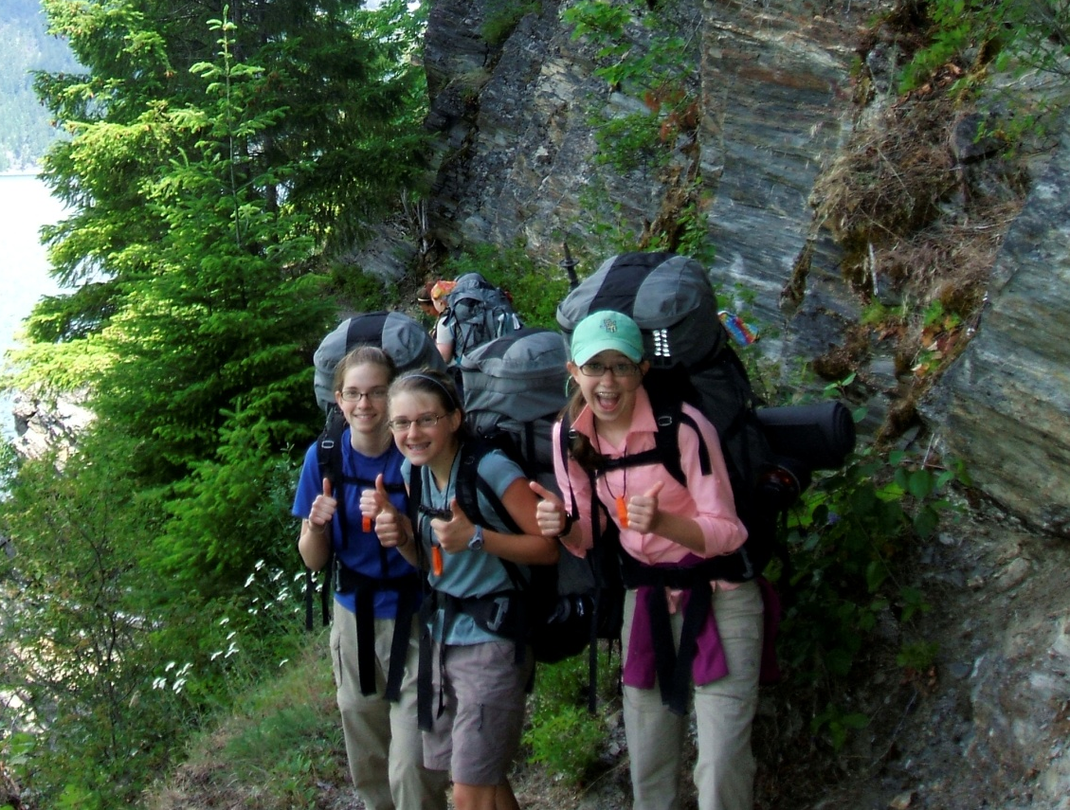
By some definitions, backpacking entails a low-budget method of travel in just about any part of the globe, particularly in urban areas. By other definitions, backpacking is specific to front-country or back-country environments in parks or wilderness areas. No matter the destination, a backpacker’s primary mission is to explore on foot, while carrying all her gear in a backpack and being a good steward of the land. These checkpoints focus on preparing for backpacking in remote areas, but the recommendations can be used in urban areas, too. For information about backpacking schools and services, visit thebackpacker.com. Backpacking is not recommended for Girl Scout Daisies and Brownies.
Caution: Girls are not allowed to use firearms unless 12 years and older and with council permission; girls are never allowed to hunt or go on high-altitude climbs. Girls are also never allowed to ride all-terrain vehicles or motor bikes.
Know where to backpack. Connect with your Girl Scout council for site suggestions, such as Girl Scout camps. Also, for information about hikes and trips in the United States and national and regional parks, visit backpacker.com.
Include girls with disabilities. Communicate with girls with disabilities and/or their caregivers to assess any needs and accommodations. Contact national parks to inquire about their accommodations for people with disabilities, and learn more about the resources and information that Global Explorers and Wilderness Inquiries provide to people with disabilities.
Backpacking Gear
Basic Gear
- Lightweight, layered clothing and outerwear appropriate for weather conditions
- Rain jacket or poncho
- Waterproof sunscreen (SPF of at least 15) and lip balm
- Hat or bandana
- Sunglasses
- Water bottle or hydration pack (each girl carries at least one quart)
- Nonperishable, high-energy foods such as fruits and nuts
- Camp shoes, if space allows (soft-soled shoes to wear on campsite after removing hiking footwear)
- Wash kit (hairbrush, biodegradable shampoo and soap, toothbrush, toothpaste)
- Lightweight, quick-drying towel
- Insect repellent
- Flashlight
- Whistle
Specialized Gear
- Backpack appropriate for size and experience of user
- Sturdy hiking/trail footwear with thick soles
- Moisture-wicking long underwear, if appropriate
- Map and compass or compass and global positioning system (GPS)
- Sleeping bag and sleeping pad
- Portable water and water purification supplies to remove potential contaminations from natural water sources; use water filter designed to remove Giardia lamblia (see the “Outdoor Cooking” Safety Activity Checkpoints for purification tips).
- Unbreakable, lightweight knife/fork/spoon combo and bowl and cup
- Pocket knife
- Flame-resistant tent or tarp (no plastic tent)
- Portable cook stove and fuel, whenever possible (to reduce the use of firewood)
- Waste-management supplies (toilet paper, garbage bag, plastic trowel to dig cat hole, hand sanitizer)
- Food storage (rope and waterproof bag; check local regulations to find out if a bear-proof canister is required)
Prepare for Backpacking
- Communicate with council and parents. Inform your Girl Scout council and girls’ parents/guardians about the activity, including details about safety precautions and any appropriate clothing or supplies that may be necessary. Follow council procedures for activity approval, certificates of insurance, and council guidelines about girls’ general health examinations. Make arrangements in advance for all transportation and confirm plans before departure.
- Girls plan the activity. Keeping their grade-level abilities in mind, encourage girls to take proactive leadership roles in organizing details of the activity. Encourage girls to plan routes, activities, rules for group living, and guidelines for dealing with problems that may arise with other groups of backpackers.
- Obtain backpacking training and arrange for adult supervision. The backpacking adult volunteer has taken council-approved training in backpacking. One adult is in front of the group of backpackers, and the other is in the rear of each group. The recommended adult-to-girl ratios are two non-related adults (at least one of whom is female) to every:
- 16 Girl Scout Juniors
- 20 Girl Scout Cadettes
- 24 Girl Scout Seniors
- 24 Girl Scout Ambassadors
Plus one adult to each additional:
- 8 Girl Scout Juniors
- 10 Girl Scout Cadettes
- 12 Girl Scout Seniors
- 12 Girl Scout Ambassadors
- Compile key contacts. Give an itinerary to a contact person at home; call the contact person upon departure and return. Create a list of girls’ parents/guardian contact information, telephone numbers for emergency services and police, and council contacts—keep on hand or post in an easily accessible location.
- Girls share resources. Encourage girls to make a list of gear and supplies, and determine what items can be shared.
- Choose an appropriate backpacking route. The route chosen is within the ability of every girl in the group; the pace accommodates the slowest backpacker. Determine the length of the trip by the backpackers’ ages, level of experience and ability, physical condition, nature of the terrain, weight of the load to be carried, the season and weather conditions, the water quantity and quality, and the activities planned along the way.
- Be prepared for primitive campsites. If backpacking in primitive areas with little to no modern conveniences, observe these standards:
- Choose and set up campsite well before dark.
- Use a previously established campsite if available.
- Make sure the campsite is level and located at least 200 feet from all water sources and below tree line.
- Avoid fragile mountain meadows and areas of wet soil.
- Avoid camping under dead tree limbs.
- Use existing fire rings, if a fire is necessary.
- If a latrine is not available, use individual cat holes—holes for human waste that are at least 200 feet away from the trail and known water sources—to dispose of human waste (visit www.lnt.org for more information).
- Do dishwashing and personal bathing at least 200 feet away from water sources.
- Store food well away from tents and out of reach of animals. Where necessary, hang food at least 10 feet high from a rope stretched between two trees. If the site is in bear country, check with local authorities on precautions to take.
- See that garbage, tampons, sanitary supplies, and toilet paper are carried out.
- Assess the safety of backpacking sites. The route is known to at least one of the adults or a report is obtained in advance to assess potential hazards. Ensure that a land-management or similar agency is contacted during the trip-planning stage to help with available routes and campsites, recommended group size, water quantity and quality, and permits (if needed).
- Assess backpack quality and do a trial run. Ensure that backpacks and all equipment (including food and water) weigh no more than 20 percent of each person’s ideal (not actual) body weight. Guide girls in choosing backpacks, adjusting straps, and taking them on and off. Have the girls plan and conduct a series of conditioning hikes before the backpacking trip.
- Ensure that backpackers have a comprehensive understanding of the trip. Group members are trained to be observant of the route, the surroundings, and the fatigue of individuals. Instruction is given on the safety rules for backpacking, such as staying together in a group, recognizing poisonous plants and biting or stinging insects and ticks, respecting wild animals, and behaving effectively in emergencies. Ensure that girls know how to read maps, use a compass, navigate a route, and estimate distance.
- Prepare for emergencies. Ensure the presence of a waterproof first-aid kit and a first-aider with a current certificate in First Aid, including Adult and Child CPR or CPR/AED, who is prepared to handle cases from extremes of temperature, such as heat exhaustion, heat stroke, frostbite, cold exposure, and hypothermia, as well as sprains, fractures, and altitude sickness. Emergency transportation is available, if possible; if any part of the activity is located 60 minutes or more from emergency medical services, ensure the presence of a first-aider (level 2) with Wilderness and Remote First Aid. See Volunteer Essentials for information about first-aid standards and training.
- Take safety precautions. Search-and-rescue procedures for missing persons are written out in advance, reviewed, and practiced by girls and adults. Methods of communication with sources of emergency care, such as police, hospitals, and park and fire officials, are known and arranged in advance.
On the Day of Backpacking
- Get a weather report. On the morning of the trip, check weather.com or other reliable weather sources to determine if conditions are appropriate. If severe weather conditions prevent the backpacking trip, be prepared with a backup plan or alternate activity. Write, review, and practice evacuation and emergency plans for severe weather.
- Use the buddy system. Girls are divided into teams of two. Each girl chooses a buddy and is responsible for staying with her buddy at all times, warning her buddy of danger, giving her buddy immediate assistance if safe to do so, and seeking help when the situation warrants it. If someone in the group is injured, one person cares for the patient while two others seek help.
- Respect the environment and keep trails clean. Use principles of minimal-impact camping, a philosophy of respect for the natural environment that involves minimizing environmental and sociological impacts. Store garbage in insect- and animal-proof containers with plastic inner linings, and cover it securely when there is a campsite garbage-pickup service. When there is no garbage-pickup service, remove garbage from campsite in plastic bags and discard, as appropriate. Recycle whenever possible. Do not bury food; carry out all garbage.
- Practice safe backpacking. Hiking off-trail and after dusk is not permitted. The group must hike away from the edges of waterfalls, rock ledges, and slopes with loose rocks.
Backpacking Links
- Backpacker magazine: www.backpacker.com
- The backpacker.com: www.thebackpacker.com
- Leave No Trace: www.lnt.org
Backpacking Know-How for Girls
- Maximize available backpack space. What are the absolute necessities? What backpacking gear can girls share? For tips, read thebackpacker.com. Select ideal energy sources. Backpackers take rest breaks to drink water and refuel with nutritious, easily digestible, and lightweight foods that don’t take up too much space in backpacks. Consider packing nuts, dried fruits, and energy bars.
Backpacking Jargon
- Acclimation: Getting used to a higher altitude than you are accustomed to; pace yourself to avoid altitude sickness, which may occur when your body hasn’t adjusted to a new altitude
- Backsighting: Looking back over the compass toward the point from which a person came to determine whether she is on course
- Cat hole: Personal toilet hole that is 6 to 8 inches deep and is dug 200 feet from water sources, trails, and campsites; bury human waste and cover with natural materials such as dirt, leaves, and sand

