
Arts and Crafts: Safety Activity Checkpoints
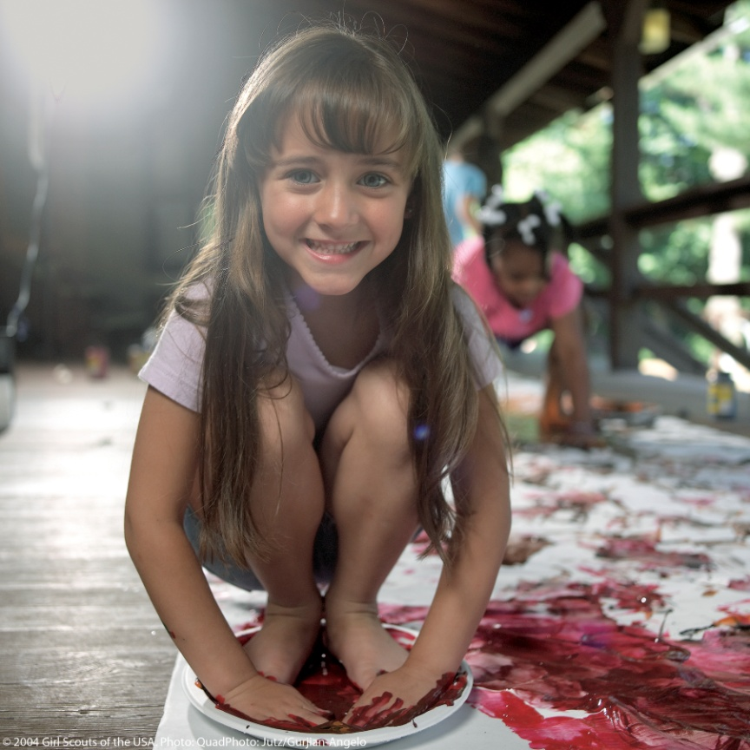
Whether girls are painting, knitting, bookbinding, sculpting, making origami or jewelry, or doing any one of a number of arts-and-crafts projects, the options for artistic and self-expression are endless. Girls are encouraged to plan details of arts-and-crafts activities, and it’s important that activities are appropriate to each girl’s age, experience with tools, attention span, and the complexity of the project. Also keep environmentalism in mind; for instance, when doing arts and crafts outdoors, don’t use materials such as glitter that will pollute campgrounds.
Know where to do arts and crafts. Connect with your Girl Scout council for site suggestions. Ensure that the location is well-ventilated.
Include girls with disabilities. Communicate with girls with disabilities and/or their caregivers to assess any needs and accommodations. Learn more about the resources and information that The National Institute of Art and Disabilities and National Arts and Disability Center provide to people with disabilities.
Arts and Crafts Gear
Basic Gear
- Age-appropriate materials (for example, with younger girls, use water-based paints and products that are easily removed from clothes, and scissors with blunt ends)
- Clothing appropriate for the activity, such as gloves for handling hot objects
- Long hair is tied back; girls do not wear loose clothing or jewelry when using machinery or tools with moving parts
Specialized Gear
- Protective face- and eye-safety equipment, such as masks, shatterproof lenses, eyeglass guards, or goggles are worn when appropriate, for protection against sparks, dust, fumes, and debris.
- Due to a potential for extreme allergic reactions to latex, Girl Scouts recommends the use of vinyl or nitrile gloves when such gloves are necessary for an arts-and-crafts project.
Prepare for Arts and Crafts
- Communicate with council and parents. Inform your Girl Scout council and girls’ parents/guardians about the activity, including details about safety precautions and any appropriate clothing or supplies that may be necessary. Follow council procedures for activity approval, certificates of insurance, and council guidelines about girls’ general health examinations. Make arrangements in advance for all transportation and confirm plans before departure.
- Girls plan the activity. Keeping their grade-level abilities in mind, encourage girls to take proactive leadership roles in organizing details of the activity.
- Arrange for transportation and adult supervision. The adult-to-girl ratios are two non-related adults (at least one of whom is female) to every:
- 12 Girl Scout Daisies
- 20 Girl Scout Brownies
- 25 Girl Scout Juniors
- 25 Girl Scout Cadettes
- 30 Girl Scout Seniors
- 30 Girl Scout Ambassadors
Plus one adult to each additional:
- 6 Girl Scout Daisies
- 8 Girl Scout Brownies
- 10 Girl Scout Juniors
- 12 Girl Scout Cadettes
- 15 Girl Scout Seniors
- 15 Girl Scout Ambassadors
Supervision is increased when advanced equipment, such as soldering irons, burners, or power saws, is used. Use of cutting tools, hammers, and spray paints is carefully supervised.
- Verify instructor knowledge and experience. For activities beyond those described in Girl Scout publications, the instructor must have documented experience and skill in teaching arts and crafts according to your council’s guidelines, as outlined in Volunteer Essentials. The instructor teaches girls the basic skills and demonstrates the safe use and care of equipment—for example, cutting tools are used with the blade away from the body.
- Compile key contacts. Give an itinerary to a contact person at home; call the contact person upon departure and return. Create a list of girls’ parents/guardian contact information, telephone numbers for emergency services and police, and council contacts—keep on hand or post in an easily accessible location.
- Select a safe arts-and-craft site. Ensure that girls have sufficient space to move around while working; there is space for table work for each girl, when appropriate. Work sites are well ventilated for activities involving hazardous materials and spray paints (for example, turpentine, spray fixatives, varnishes) or ceramic dust. Flammable material is used only in work spaces away from ignition sources such as open flames, heaters, and candles. Provision is made for proper and safe disposal of all waste materials. Fire exits are clearly marked, and fire safety equipment is on hand. Food and beverages are not consumed in activity areas.
- Prepare for emergencies. When specialized equipment, power machinery, or chemicals are being used, ensure the presence of a first-aider with a current certificate in First Aid, including Adult and Child CPR or CPR/AED; also ensure a first-aid kit is available. Emergency procedures are clearly posted for swallowing a chemical, getting a chemical in the eyes, skin contact with a chemical, and so on. See Volunteer Essentials for information about first-aid standards and training.
- Use safe equipment and materials. Art materials are purchased from reputable sources, such as school-supply houses. Product labels clearly indicate what the material is and how to write or call the manufacturer. Girls never use donated or discarded material whose ingredients are not known; very old or unlabeled materials may be toxic and are not used. Care is taken to protect children from dyes, pigments, preservatives, and other chemicals that may provoke allergies. Children who are physically or psychologically disabled, or who are on medication, may be at greater risk from toxic materials. Kilns are ventilated, and children using them are directly supervised.
- Educate about potentially hazardous materials. The following materials may be used only after girls have received adequate safety instruction:
- Dusts or powders that can be inhaled or that can get in the eyes
- Organic solvents, volatile glues, or solvent-containing products such as aerosol sprays
- Anything that stains the skin or clothing (or that cannot be washed out of clothing)
- Acids, alkalis, bleaches, or other irritating or corrosive chemicals
Also be sure that girls wash their hands after using supplies that are labeled as hazardous. If transferring hazardous materials to another container, ensure this container is labeled “hazardous.”
On the Day of the Arts-and-Crafts Activity
- Get a weather report. If the arts-and-crafts activity takes place outdoors, on the morning of the activity, check weather.com or other reliable weather sources to determine if conditions are appropriate. If weather conditions prevent the activity, be prepared with a backup plan or alternate activity, or postpone the activity. Write, review, and practice evacuation and emergency plans for severe weather with girls. In the event of a storm, take shelter away from tall objects (including trees, buildings, and electrical poles). Find the lowest point in an open flat area. Squat low to the ground on the balls of the feet, and place hands on knees with head between them.
- Use the buddy system. Girls are divided into teams of two. Each girl chooses a buddy and is responsible for staying with her buddy at all times, warning her buddy of danger, giving her buddy immediate assistance if safe to do so, and seeking help when the situation warrants it. If someone in the group is injured, one person cares for the patient while two others seek help.
- Safeguard valuables. Secure equipment in a dry, locked storage area.
- Exercise caution when handling and storing equipment and supplies. Equipment and supplies are locked in a storage area whenever possible. Safety and operating instructions for dangerous equipment (for example, power tools and kilns) are reviewed and posted. Scissors, knives, and other cutting tools are cleaned, oiled, and sharpened, as needed. Flammable materials, such as paints and solvents, are labeled and stored in a dry, well-ventilated area out of the reach of young children. Equipment and supplies are used for their intended purpose only. Turpentine or paint thinner may be used as a paint solvent with adequate ventilation. Gasoline is never used as a paint solvent. Solvent- or oil-soaked rags are kept in waste cans that meet fire safety codes and are emptied daily. Containers of solvents are covered. They evaporate quickly, and inhalation can be hazardous. Manufacturers’ labels on paints, chemicals, and aerosol cans are read before product use; use these substances in well-ventilated areas only and do not expose to a flame. When transferring substances into other containers, label each container as to content and procedures for use and disposal. When girls gather natural materials (such as leaves), conservation principles are taught and practiced.
Arts-and-Crafts Links
- National Safety Council: www.usc.org
Arts-and-Crafts Know-How for Girls
- Select cool craft projects. What kinds of projects have you never participated in, but have always wanted to try? After discussing themes, available supplies, and techniques, create a list of potential projects and begin researching how to create the project. Perform keyword searches for the craft projects. These sites (among others) provide arts-and-craft projects: Girl Scout council of the Catawba Valley Area (www.cvgirlscouts.org/adults/crafts/index.htm), http://familyfun.go.com/crafts, and www.enchantedlearning.com/crafts.
Arts-and-Crafts Jargon
- Assemblage: An artistic process in which a three-dimensional piece of art is made from assembling found objects
- Mosaic: Artistic images and designs created by putting together small pieces of glass, stone, and other materials

